Name: _________________________________

**Part 2 of the Task - Identifying the Process that Shape the Earth’s Surface**

**THIS IS A TEAM TASK!!!**

In Part 1 of this Task (the Geology Lab Stations), you learned about different processes that shape the Earth’s surface. In your final comic book, you are going to find an image of a feature on the Earth’s surface and model and explain the process that formed it.

Here’s the thing though, these processes take a LOOOOOOONG time to happen. How long? Some can take up to millions of years to form a feature that we see today!

**Why you are doing this:**

In your final comic book, you will find a picture of a feature on the Earth’s surface. You will need to explain what process formed this feature, and how you know what process formed that feature. The notes you take for this Task will help you figure out what process formed the features you are looking at.

YOUR ASSIGNMENT NOW:

1. Put your pencils down
2. Look at the pictures for the first process (water erosion) on the next two pages.
3. DISCUSS the similarities you see between the pictures. Identify three similarities.
4. Pick up your pencils and write down the name of the process and the three similarities.
5. Put down your pencils and repeat this process for all the other groups of pictures.



Time to be a science detective!

**Water Erosion**

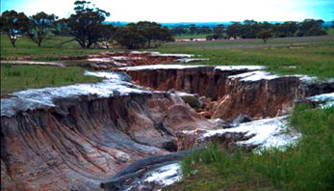

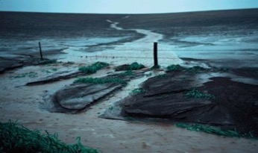

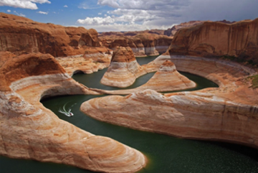

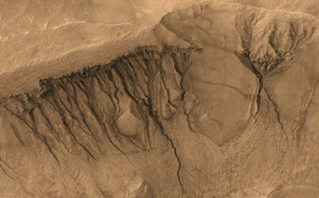

This is a satellite picture of Mars. The dark lines show where water used to run down mountains on the surface of Mars.

**Wind Erosion**

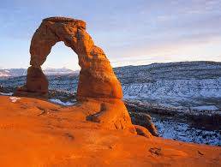

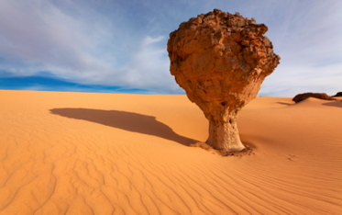

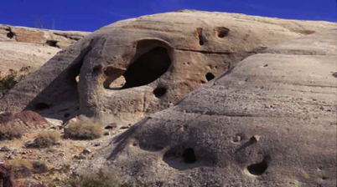

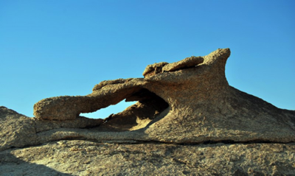

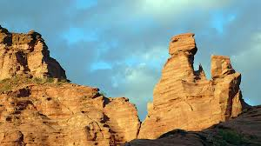

**Wave Erosion**

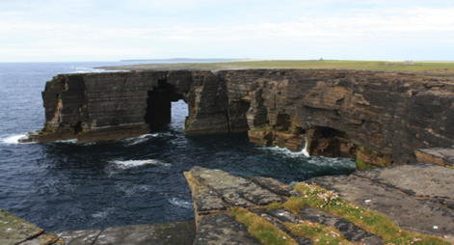



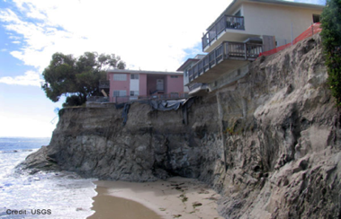

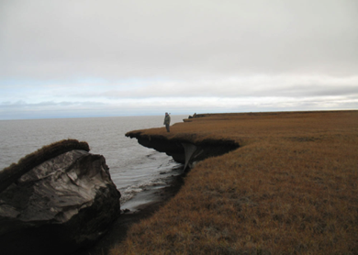

**Mechanical Weathering**

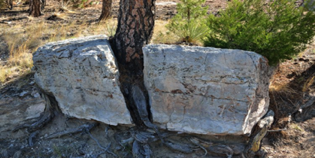

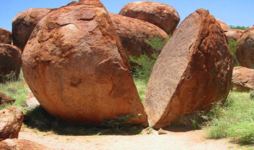

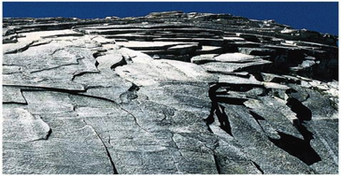

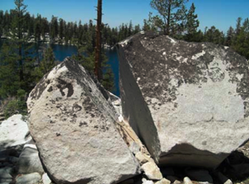

**Chemical Weathering**

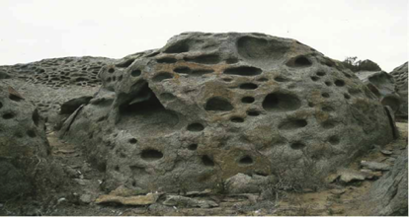

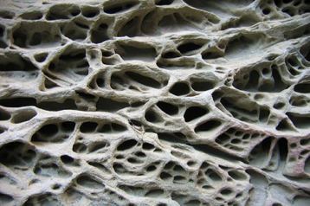

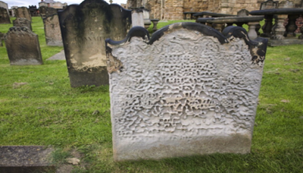

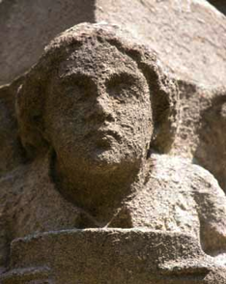

**Convergent Plate Boundary**

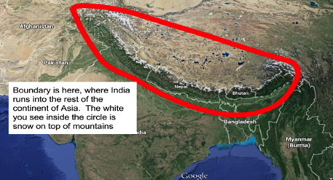

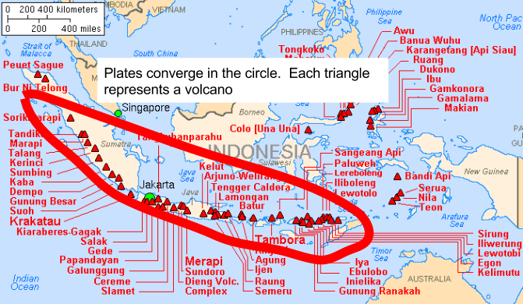

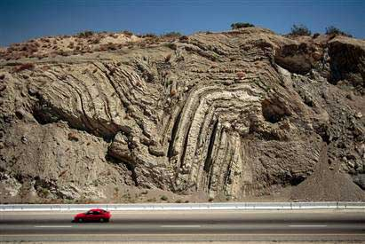

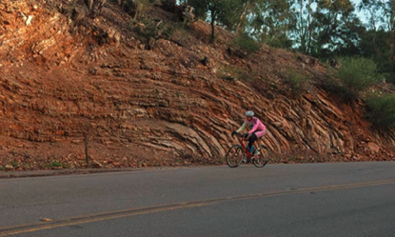

Visible rock layers in the Bay Area

**Divergent Plate Boundary**

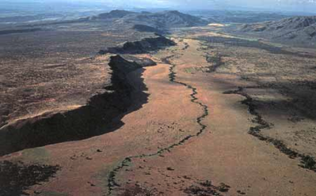

The Great Rift Valley, Eastern Africa

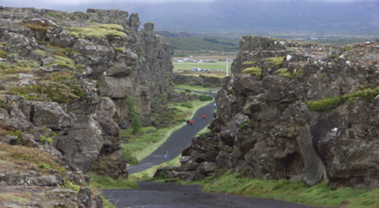

This road marks the place in Iceland where two plates are moving away from each other.

**Transform Plate Boundary**

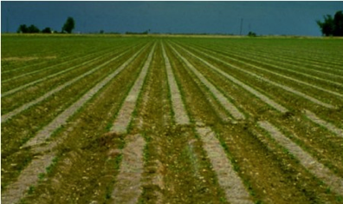

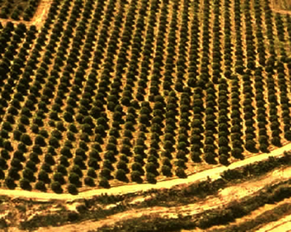

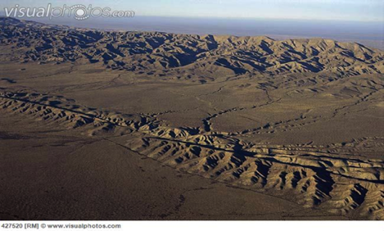

The San Andreas Fault, about 200 miles south of San Jose

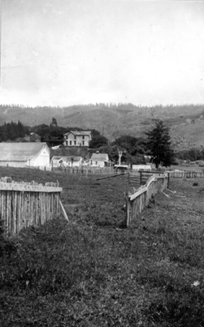

This fence used to be connected in one line. Where it broke marks a transform boundary that moved in an earthquake.