# New Melt Record for Greenland Ice Sheet*

Article from the Science Daily News at <http://www.sciencedaily.com/releases/2011/01/110121144011.htm>

* Retrieved July 31, 2011

# Your task:

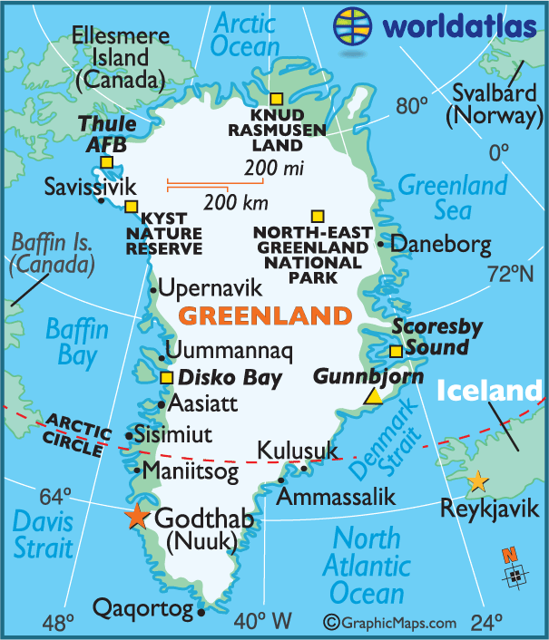Read this Internet article about ice melting in Greenland. Where is Greenland? First, look at the attached map and find where Greenland is located. Second, read the article and discuss the questions in the following table with your group. Lastly, write your best answers in the table on the following page.

|  |  |
| --- | --- |
| **Questions** | **Notes and Answers** |
| 1. What is the main claim of the article about Greenland? |  |
| 2. What evidence does the author use to support the claim? |  |
| 3. What organizations supported the research that is described in the article? |  |
| 4. Write down scientific terms mentioned in the article that you are not yet familiar with, and use the Internet to find information about these concepts and terms. |  |

**Impact of Global Warming on the Extent of the Arctic Sea Ice\***

* The information in the graph below is based on information published in: <http://nsidc.org/arcticseaicenews/>on August 10, 2011.

**Arctic Sea Ice Extent**

**(Area of ocean with at least 15% sea ice)**

18

16

14

12

10

8

2011

1979-2010

6

4

2

0

April

May

June

July

August

**Extent (millions of square kilometers)**

Please note that the data for 1979 - 2010 (i.e., the top line) represents the *average value* of the ice area during that period of 31 years.

# Your task:

Observe the graph and try to make sense of it – then discuss the following questions with your group and write your best answers in this booklet:

* 1. What can you learn from this graph about the general pattern of change in the arctic sea ice during the summer months?
  2. What does the graph tell you about changes in the Arctic sea ice during 2011?

# Effects of Global Warming

Article from National Geographic at   
[http://environment.nationalgeographic.com/environment/global-](http://environment.nationalgeographic.com/environment/global-warming/gw-effects/) [warming/gw-effects/](http://environment.nationalgeographic.com/environment/global-warming/gw-effects/)

# Your task:

Read this Internet article and select ONE impact from those mentioned (e.g., impact on sea levels, impact on penguins, impact on butterflies migration, etc) to further explore.

Use the Internet to do your research (some guidelines are included in Appendix A). You should collect information from at least **three** different sites.

Use the following Graphic Organizer to summarize and organize your research notes.

# Graphic Organizer for the Internet Research

|  |  |
| --- | --- |
| **Questions** | **Notes and Answers** |
| 1. Present the topic of your research and write a clear statement about it. |  |
| 2. Cite* one sources of information and what you learned from it. |  |
| 3. Cite second sources of information and what you learned from it. |  |
| 4. Cite third sources of information and what you learned from it. |  |
| 5. What is your conclusion? |  |

*follow your school guidance on citing Internet sources.

Appendix A

# Effective Use of the Internet for Science Teaching and Learning

The Internet is like a giant, continuously growing library that contains any information that you want. But because this library is a little disorganized, researchers must use good judgment on how to use it. Unlike textbooks that are reviewed and edited by professionals, content on Internet pages is not always reviewed; therefore there are no guarantees that the information one finds is accurate and objective. Also, some sites pay a fee so that their web pages will pop at the top of the list when you use different search engines; therefore sites on the top of the search list are not always the most relevant and important.

You can use any of the following search engines to conduct your search:

|  |  |  |  |  |
| --- | --- | --- | --- | --- |
| Google | Yahoo | Safari | Firefox | Bing |

You may also wish to use portals such as Ask.com or AJkids.com

Use the list below to assess the credibility of your sources:

* **.com** - commercial business site
* **.edu** - educational site (usually a university or college)
* **.gov** - U.S. governmental/non-military site
* **.mil** - U.S. military sites and agencies
* **.net** - networks, Internet service providers, organizations
* **.org** - U.S. non-profit organizations and others

As a rule of thumb, you can generally rely on the GOV and EDU hostnames to present accurate information. The NET, ORG, MIL, and COM domains are more likely to host pages with their own personal or organizational agendas and require additional verification. For each article you choose, consider who owns the website and whether that has an impact on the credibility of the information provided. The owner of the website should be listed on the site, or you can go to the following link to assess the credibility of the source <http://www.whois.net/>

### Appendix B: The STS Research and Expository Essay Tasks

### How to write an expository essay

Expository (the root is “expose”) essay is an objective writing in which the writer explains and informs the readers about a specific topic, without offering a personal opinion or developing a specific position on the issue. The goal of an expository essay is to provide the reader with a full understanding of a complex process or situation. The expository paper should include concise, clear and objective descriptions of facts and evidence that are relevant to the topic of the paper.

### The Expository Essay Format

Your expository essay should include three paragraphs:

Paragraph 1 – Introduction: The introduction is a statement of the essay’s thesis and the sub-topics that will be developed within the essay. The thesis needs to be well defined and narrow.

Paragraph 2 – Body: The body includes the major points that are related to the thesis, each point followed by factual information and citation of the source of the information. Make sure that there are easy to follow transition from one point to another.

Paragraph 3 – Conclusion: Conclude your expository essay by restating your thesis and summarizing the points that lead to your conclusion.

# Writing Prompt

In the last couple of days you explored the issue of Polar Ice Melting and its impact on the environment and the animals that live there. Based on your Internet search and the articles you read in class, write a **short expository essay** describing what you know about Polar Ice Melting and its impacts. Your paper should include the following paragraphs:

1. **Paragraph 1** – Introduction: Describe what you know about Polar Ice Melting and present the topic of your research. Make a clear statement about the impact of the ice melting on the topic you researched.
2. **Paragraph 2** – Body: The body of the paper should include the major claims (points) that are related to your research, each claim followed by factual information and citation of the source of the information.
3. **Paragraph 3** – Conclusion: Based on your research, write a strong conclusion about the impact of Ice melting on your research subject, and follow it with one or two possible ways to improve the situation.