**DOCUMENT C: *Leaflet* (Modified)**

*Here, Jo Ann Robinson explains how she and others wrote and delivered the leaflet calling for a boycott in time for thousands of African Americans to stay off the buses on Monday morning, December 5, 1955. Just before she began this work, Robinson and E.D. Nixon had decided over the phone to call for a boycott. E.D. Nixon was a former President of the Car Porters Union and leader of the National Association for the Advancement of Colored People (NAACP) in Montgomery.*

I sat down and quickly wrote a message and then called a good friend who could use the college’s copying equipment. When I told him that the WPC [Women’s Political Council] was staging a boycott and needed to run off the leaflets, he told me that he too had suffered embarrassment on the city buses. Along with two of my most trusted students, we quickly agreed to meet right away in the middle of the night, at the college’s copying room. We were able to get three messages to a page in order to produce the thousands of leaflets we needed. By 4 a.m. Friday, the sheets had been copied and cut in thirds.

Between 4 and 7 a.m., the two students and I mapped out delivery routes for the leaflets. We had planned before how and where to deliver thousands of leaflets in case of a boycott, and those plans now came in handy.

After class my two students and I quickly finalized our plans for distributing the thousands of leaflets so that one would reach every black home in Montgomery. I took out the WPC membership roster and called them. I asked for their help in giving out the leaflets.

Throughout the late morning and early afternoon hours we dropped off tens of thousands of leaflets. Some of the leaflets were dropped off at schools. Leaflets were also dropped off at business places, stores, beauty parlors, beer halls, factories, barber shops, and every other available place. Workers would pass along notices both to other employees as well as to customers.

By 2 o’clock thousands of the copied leaflets had changed hands many times. Practically every black man, woman, and child in Montgomery knew the plan and was passing the word along.

**Source:** Excerpt from Jo Ann Robinson’s memoir, *The Montgomery Bus Boycott and the Women Who Started It*, pp. 45-47, 1987. Knoxville, Tennessee.

**DOCUMENT D: *Abernathy* (Modified)**

*Here, Reverend Ralph Abernathy remembers the first mass meeting of the Montgomery Improvement Association (MIA) at a local Baptist church on the first day of the boycott. After this, the MIA held regular weekly meetings until the boycott ended.*

* 1. King and I went to the meeting together. I was given instructions: one, to call off the protest, or two, to continue the protest until our requests were granted. We had had a successful “one-day protest,” but we feared that if we extended it beyond the first day, we might fail; it might be better to call the protest off, and then we could hold this “one-day boycott” as a threat for future talks. However, we were to decide whether to continue the protest by the size of the crowds.

When we got about 20 blocks from the church we saw cars parked solid. As we got closer to the church we saw a great mass of people. The *Montgomery Advertiser* estimated the crowd at about 7,000 persons all trying to get in a church that will fit less than 1,000. It took us about 15 minutes to work our way through the crowd by pleading: “Please let us through—we are Reverend King and Reverend Abernathy.”

Those inside the church applauded for at least ten minutes.

It was obvious that the people were with us. It was then that all of the ministers who had previously refused to take part in the program came up to Reverend King and me to offer their services. This expression of togetherness on the part of the masses was obviously an inspiration to the leadership.

We began the meeting by singing *Onward Christian Soldiers, Marching as to War.*

Mrs. Rosa Parks was presented to the meeting because we wanted her to become symbolic of our protest movement. Following her we presented Mr. Daniels, who happily for our meeting had been arrested on that day. The appearance of these persons created enthusiasm, thereby giving momentum to the movement.

We then heard the motions calling for the continuation of the boycott, unanimously and enthusiastically adopted by the 7,000 people both inside and outside the church.

**Source:** Excerpt from Ralph Abernathy’s Thesis for his Master’s degree, *The Natural History of a Social Movement,* 1958. Atlanta, Georgia.

# 

**DOCUMENT E: *King* (Modified)**

*At this Montgomery Improvement Association [MIA] weekly meeting, King speaks to the crowd.*

Democracy gives us this right to protest and that is all we’re doing. We can say honestly that we have not promoted violence, have not practiced it and have gone courageously on with a Christian movement. Ours is a spiritual movement depending on moral and spiritual strength. The protest is still going on. (Applause)

Freedom doesn’t come on a silver platter. With every great movement toward freedom there will always be trials. Somebody will have to have the courage to sacrifice. You don’t get to the Promised Land without going through the Wilderness. You don’t get there without crossing over hills and mountains, but if you keep on keeping on, you can’t help but reach it. We won’t all see it, but it’s coming and it’s because God is for it. . .

We won’t back down. We are going on with our movement.

Let us continue with the same spirit, with the same order, with the same discipline, with the same Christian approach. I believe that God is using Montgomery as his proving ground. God be praised for you, for your loyalty, for your determination. God bless you and keep you, and may God be with us as we go on.

**Source:** Excerpts from a speech by Martin Luther King, Jr., given at Holt Street Baptist Church, March 22, 1956. Montgomery, Alabama.

# 

**Document F: *Freedom is Rising***

## This political cartoon appeared in The Militant a socialist newspaper.

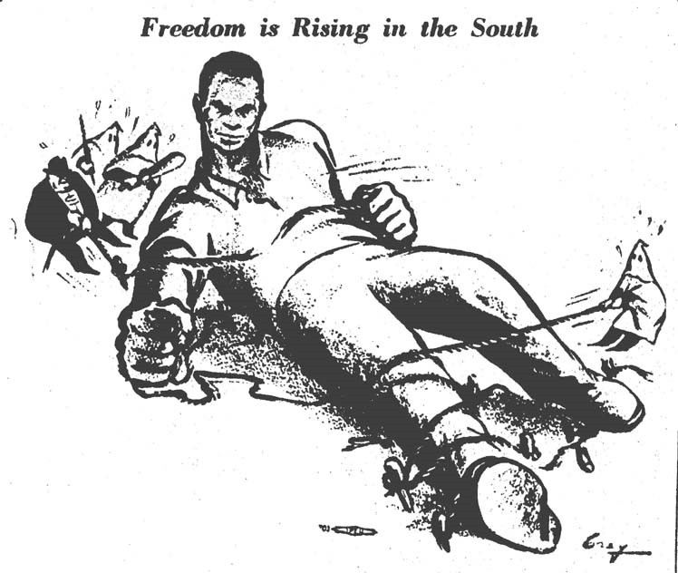

**Source:** Published in *The Militant*, March 26, 1956. Drawn by Laura Gray.

# 

**DOCUMENT G: *Rustin* (Modified)**

*Bayard Rustin, an African American civil rights activist, traveled to Montgomery to advise Dr. King and support the bus boycott. He kept a diary of what he found.*

February 24

42,000 Negroes have not ridden the buses since December 5. On December 6, the police began to harass, bully, and arrest Negro taxi drivers who were helping get these people to work. The Negro leaders had to find an alternative—the car pool. They set up 23 centers where people gather to wait for free transportation.

This morning Rufus Lewis, director of the pool, invited me to attend the meeting of the drivers. On the way, he explained that there are three methods in addition to the car pool, for moving the Negro population:

* + 1. Hitch-hiking.
    2. The transportation of servants by white housewives.
    3. Walking.

Later he introduced me to two men, one of whom has walked 7 miles and the other 14 miles, every day since December 5.

“The success of the car pool is at the heart of the movement,” Lewis said at the meeting. “It must not be stopped.”

I wondered what the response of the drivers would be, since 28 of them had just been arrested on charges of plotting to destroy the bus company. One by one, they pledged that, if necessary, they would be arrested again and again.

**Source:** Excerpt from Bayard Rustin’s *Montgomery Diary*, February 24, 1956. Montgomery, Alabama.

# 

**DOCUMENT H: *“Me, too”* (Modified)**

*Researchers from Fisk University visited Montgomery, Alabama, during the boycott to learn more and to document the movement. Here a woman shares her ideas about the boycott during an interview at a car pool dispatch center.*

Maid: This stuff has been going on for a long time. To tell you the truth, it’s been happening ever since I came here before World War II. But here in the last few years they’ve been getting worse and worse.

When you get on the bus they yell: “Get on back there.” Then they make you get up so white men could sit down where there were no seats in the back.

And you know about a year ago they put one of the high school girls in jail ‘cause she wouldn’t move. They should have boycotted the buses then. But we are sure fixing ‘em now and I hope we don’t ever start back riding.

We are people, we are not dogs or cats. All we want ‘em to do is treat us right. They shouldn’t make me get up for some white person when I paid the same fare and I got on first. And they should stop being so nasty. We pay just like the white folks.

The bus companies are the ones losing the money and our preachers say we will not ride unless they give us what we want. You see the business men are losing money too, because people only go to town when they have to. When you do something to my people you do it to me, too.

**Source:** Excerpt from an interview conducted by Willie Lee, January 1956. Montgomery, Alabama.