APPENDIX 1
Manifest Destiny Cartoons

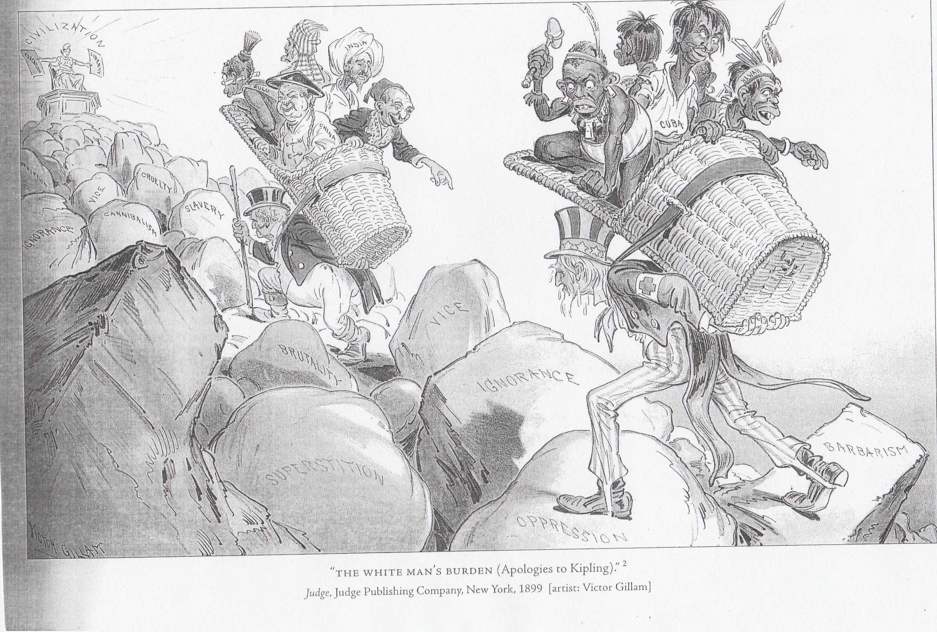
APPENDIX 2:
Example of a graphic organizer to teach and find examples of the 6 L’s of Colonialism
OVERVIEW:
Colonialism is a system of oppression that allows a dominant group of people (i.e. typically represented by a nation) to gain and maintain control over another group of people and their resources. In this system, there are two basic roles: 1) the colonizer and 2) the colonized. The basic elements of Colonialism can be broken down into the 6L’s:
- Land: The colonizer takes control over the land of the colonized and claims that land on behalf of his home country.
- Language: The colonizer enforces the language of his home country, while making the language of the colonized seem inferior, sometimes to the point of eliminating that language.
- Labor: The colonizer controls the people by having them work in order to bring wealth to the colonizer’s home country.
- Life: In the attempts to control a people, physical violence is used, resulting in the loss of lives.
- Liberty: The colonizer takes away the freedom of the colonized by taking away their previous ways of life and identity.
- Legacy: The colonizer attempts to erase the history and cultural identity and practices of the colonized, which affects all future generations. The colonizer also creates an inferiority complex within the colonized so that they accept the dominance and value of the colonizer’s ways.

DIRECTIONS:
Reread the book Encounter by Jane Yolen. Use the spaces below to identify one example in writing of each of the 6 Ls and create an illustration representing it.
LAND | LANGUAGE
LABOR | LIFE
LIBERTY | LEGACY

