**DOCUMENT A**: ***The New Colossus***

*The French gave the Statue of Liberty to the American people. The Statue was meant to honor the Declaration of Independence and it arrived in New York harbor in 1885. Emma Lazarus wrote this poem to raise money to build the Statue‘s base. In 1903 the poem was written on a plaque in the Statue.*

*(The word “Colossus” refers to a large statue of a Greek god that was one of the seven wonders of the ancient world.)*

THE NEW COLOSSUS

Not like the brazen giant of Greek fame,

With conquering limbs astride from land to land; Here at our sea-washed, sunset gates shall stand A mighty woman with a torch, whose flame

Is the imprisoned lightning, and her name Motherof Exiles. Fromherbeacon-hand

Glowsworld-widewelcome; hermildeyescommand The air-bridged harbor that twin cities frame. "Keep, ancient lands, your storied pomp!" cries she With silent lips. "Give me your tired, your poor, Your huddled masses yearning to breathe free,

The wretched refuse of your teeming shore. Send these, the homeless, tempest-tost to me, I lift my lamp beside the golden door!"

**Source:** Excerpt from *The New Colossus,* written by Emma Lazarus, 1883 in New York City.

**Document B: *The Chinese Exclusion Act* (Modified)**

*The Chinese Exclusion Act was the nation’s first law to keep out immigrants based on the country they came from. Below is an excerpt from this law that kept Chinese workers out for ten years. The law was extended in 1892 and remained in effect until 1943.*

Preamble. Whereas, in the opinion of the Government of the United States the coming of Chinese laborers to this country endangers the good order of certain localities within the territory:

Therefore, Be it enacted [passed] by the Senate and House of Representatives of the United States of America in Congress, that ninety days after the passage of this act, and until the expiration of ten years after the passage of this act, the coming of Chinese laborers to the United States be suspended; and during such suspension it shall not be lawful for any Chinese laborer to come, or, having come after the expiration of said ninety days, to remain within the United States.

. . . .

SEC. 14. That hereafter no State court or court of the United States shall admit Chinese to citizenship;

SEC. 15. That the words "Chinese laborers", whenever used in this act, shall be construed [understood] to mean both skilled and unskilled laborers and Chinese employed in mining.

Approved, May 6, 1882.

**Source:** Excerpt from the Chinese Exclusion Act, approved May 6, 1882 by the Forty-Seventh United States Congress. Session I.

**Document C: *Workingmen’s Ticket***

*"The Chinese Must Go!" was the slogan of the Workingmen's Party of California. The image below comes from a listing of the party's candidates for an election in California in 1879.*

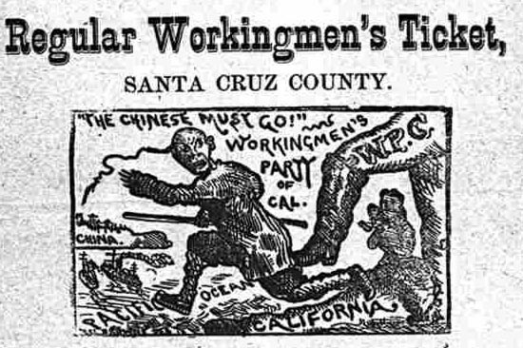

**Source:** Excerpt from *Workingmen’s Party Ticket*, 1879, Santa Cruz County, California.

**DOCUMENT D: *Which Color?***

*This political cartoon appeared in one of the most widely read magazines in the 1880s. It is titled, “Which Color is to be Tabooed [forbidden] Next?” At the bottom of the cartoon, Fritz says to Pat, “ If the Yankee Congress can keep the* yellow *man out, what is to hinder [prevent] him from calling us* green *and keeping us out too?” Fritz is a German name and Pat is an Irish name.*

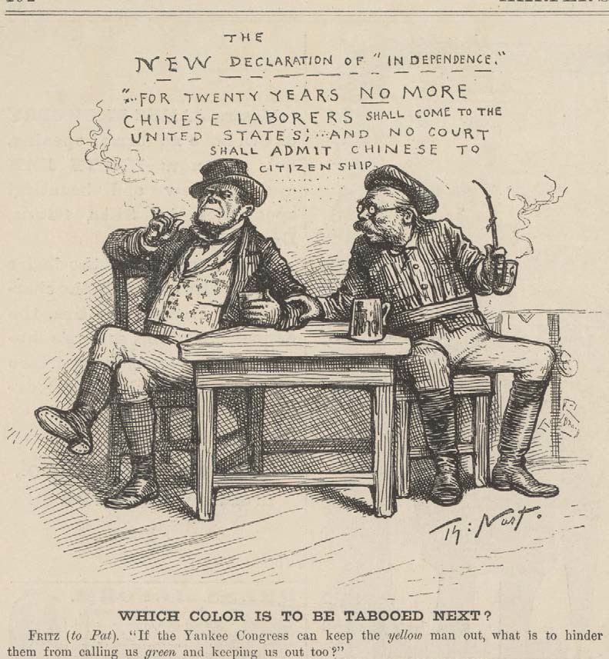

**Source:** Published in *Harper’s Weekly*, March 25, 1882. Drawn by Thomas Nast.

**DOCUMENT E: *Appeal from California* (MODIFIED)**

*Many Chinese immigrants lived and worked in California. Dennis Kearney was an Irish immigrant and President of the Workingman’s Party of California, a labor group and political party. Below he asks readers in Indiana to support his cause.*

Our moneyed men have ruled us for the past thirty years. Under the flag of the slaveholder they hoped to destroy our liberty. Failing in that, they have rallied under the banner of the millionaire, the banker and the land monopolist, the railroad king and the false politician, to effect [reach] their purpose.

We have permitted them to become immensely rich . . . and they have turned upon us to sting us to death . . . . .

We, here in California, feel it as well as you . . . Here, in San Francisco, the palace of the millionaire looms up above the hovel [shack] of the starving poor with as wide a contrast as anywhere on earth.

To add to our misery and despair, a bloated aristocracy has sent to China . . . for a cheap working slave. . . .

These cheap slaves fill every place. Their dress is scant and cheap. Their food is rice from China. They hedge twenty in a room, ten by ten. They are wipped curs [dogs] . . . mean, contemptible and obedient in all things. They have no wives, children or dependents.

They are imported by companies, controlled as serfs, worked like slaves, and at last go back to China with all their earnings. They are in every place . . . .

We are men, and propose to live like men in this free land, without the contamination of slave labor, or die like men, if need be, in asserting the rights of our race, our country, and our families.

California must be all American or all Chinese. We are resolved that it shall be American, and are prepared to make it so. May we not rely upon your sympathy and assistance?

With great respect for the Workingman’s Party of California. Dennis Kearney, President

H.L Knight, Secretary

**Source**: Excerpts from “*Appeal from California. The Chinese Invasion. Workingmen’s Address*,” written by Dennis Kearney, President, and H. L. Knight, Secretary, published in the *Indianapolis Times* newspaper on February 28, 1878.

**Document F: *Memorial* (MODIFIED)**

*The Board of Supervisors of San Francisco held a convention to support extending the Chinese Exclusion Act beyond it’s ten year*

*renewal. The convention adopted this “memorial” or petition to the U.S. Congress and President.*

The purpose, no doubt, for enacting the exclusion laws for periods of ten years is because Congress intends to observe the progress of those people under American institutions, and now it has been clearly demonstrated that they cannot, for the deep and ineradicable [stubborn] reasons of race and mental organization, assimilate [blend in] with our own people, and be molded as are other races into strong and composite American stock.

Civilization in Europe has been frequently attacked . . . by the barbaric hordes of Asia. . . . . But a peaceful invasion is more dangerous than a warlike attack. We can meet and defend ourselves against an open foe [enemy], but an insidious foe [deceitful enemy], under our generous laws, would be in possession of the citadel [fort] before we were aware. The free immigration of Chinese would be for all purposes an invasion by Asiatic barbarians . . .. It is our inheritance to keep [civilization] pure and uncontaminated, as it is our purpose and destiny to broaden and enlarge it. We are trustees for mankind. "

**Source:** *For the re-enactment of the Chinese Exclusion Law: California’s Memorial to the President and Congress of the United States* adopted by the Chinese Exclusion Convention called by the Board of Supervisors of the City and County of San Francisco, San Francisco, CA, around 1901. Star Press., pages 4-5 and 8-9.

**Document G: *Autobiography of a Chinese Immigrant***

**(MODIFIED)**

The treatment of the Chinese in this country is all wrong and mean . . .

There is no reason for the prejudice against the Chinese. The cheap labor cry was always a falsehood. Their labor was never cheap, and is not cheap now. It has always commanded the highest market price.

But the trouble is that the Chinese are such excellent and faithful workers that bosses will have no others when they can get them. If you look at men working on the street you will find an overseer for every four or five of them. That watching is not necessary for Chinese. They work as well when left to themselves as they do when some one is looking at them.

It was the jealousy of laboring men of other nationalities — especially the Irish—that raised the outcry against the Chinese. No one would hire an Irishman, German, Englishman or Italian when he could get a Chinese, because our countrymen are so much more honest, industrious, steady, sober and painstaking. Chinese were persecuted, not for their vices [sins], but for their virtues [good qualities]. . . .

There are few Chinamen in jails and none in the poor houses. There are no Chinese tramps or drunkards. Many Chinese here have become sincere Christians, in spite of the persecution which they have to endure from their heathen countrymen. More than half the Chinese in this country would become citizens if allowed to do so, and would be patriotic Americans. But how can they make this country their home as matters now are! They are not allowed to bring wives here from China, and if they marry American women there is a great outcry. . .

Under the circumstances, how can I call this my home, and how can any one blame me if I take my money and go back to my village in China?

**Source:** Excerpt from Lee Chew, “The Biography of a Chinaman,”

*Independent,* 15 (February 19, 1903), 417–423.