**Subject area/course**: Science

**Grade level/band**: 8th Grade

**Task source**: Achieve - This task is adapted from Earth Science Puzzles: Making meaning from data, by Kim Kastens and Margie Turrin, 2010, NSTA Press, pages 123-143.

**Where Did the Water Go? Watershed Study**

**TEACHER'S GUIDE**

1. **Task overview**:

In this task, students will demonstrate their understanding of the water cycle by considering the inputs and outputs of water as it moves through a watershed in New York state. The students start with a simple model dominated by one input and one output. Students begin by calculating the volume of water entering a small watershed as precipitation over the course of one year and the amount of water that exited from that watershed via the outflow stream over the same amount of time. Through their calculations, students find that that some of the water has gone “missing”, and reconsider their model throughout the task to account for the missing water by including outputs not initially included in the starting model, such as loss of water to evapotranspiration.

1. **Aligned standards:**
2. **Primary Common Core State Standards**

6.RP.3.C Find a percent of a quantity as a rate per 100 (e.g., 30% of a quantity means 30/100 times the quantity); solve problems involving finding the whole, given a part and the percent.

6.EE.B.9 Use variables to represent two quantities in a real-world problem that change in relationship to one another; write an equation to express one quantity, thought of as the dependent variable., in terms of the other quantity, thought of as the independent variable. Analyze the relationship between the dependent and independent variables using graphs and tables, and relate these to the equation.

7.G.B.6 Solve real-world and mathematical problems involving area, volume and surface area of two- and three-dimensional objects composed of triangles, quadrilaterals, polygons, cubes, and right prisms.

8.G.9 Know the formulas for the volumes of cones, cylinders and spheres and use them to solve real-world and mathematical problems.

8.SP.A.2 Know that straight lines are widely used to model relationships between two quantitative variables. For scatterplots that suggest a linear association, informally fit a straight line, and informally assess the model fit by judging the closeness of the data points to the line.

1. **Secondary Common Core State Standards (optional)**

WHST.6-8.1 Write arguments focused on discipline-specific content.

WHST.6-8.1.b Support claim(s) with logical reasoning and relevant, accurate data and evidence that demonstrate an understanding of the topic or text, using credible sources.

1. **Critical abilities**

Analysis of Information: Integrate and synthesize multiple sources of information (e.g., texts, experiments, simulations) presented in diverse formats and media (e.g., visually, quantitatively, orally) in order to address a question, make informed decisions, understand a process, phenomenon, or concept, and solve problems while evaluating the credibility and accuracy of each source and noting any discrepancies among the data.

Modeling, Design, and Problem Solving: Use quantitative reasoning to solve problems arising in everyday life, society, and the workplace, e.g., to plan a school event or analyze a problem in the community, to solve a design problem or to examine relationships among quantities of interest. Plan solution pathways, monitoring and evaluating progress and changing course if necessary, and find relevant external resources, such as experimental and modeling tools, to solve problems. Interpret and evaluate results in the context of the situation and improve the model or design as needed.

1. **Next Generation Science Standards (NGSS)**

MS-ESS2-4 Develop a model to describe the cycling of water through Earth's systems driven by energy from the sun and the force of gravity.

1. **Time/schedule requirements:**

The entire task could take between 4-10 class periods (45-50 minutes each) spread out over the course of an instructional unit, with the divisions listed below:

* Task Component A: 1 class period
* Task Components B & C: 1-2 class periods
* Task Component D: up to 1 class period, or used as homework
* Task Component E: up to 1 class period, or used as homework
* Task Component F: 1-2 class periods, depending on whether the explanation is used as homework
* Task Component G: 1-2 class periods, depending on whether the evaluation is used as homework
* Task Component H: up to 1 class period, or 1-2 class periods if used in conjunction with the explanation in Task Component D

1. **Materials/resources:**

* It might be helpful for students who live outside of the northeastern United States to see photographs of the terrain, environment, and climatic conditions of southeastern New York state. The site used in the task is located at coordinates (LAT: 41.394816, LONG: -74.0062516), which can be used on terrain imaging programs (e.g. GoogleEarthTM). Alternatively, this task can be easily altered to include more local watersheds.
* See <http://techalive.mtu.edu/meec/module01/whatiswatershed.htm> for a good animation to illustrate the concept of a watershed and the parts of the water cycle.
* Instructors may also find it useful to provide graphic organizers, word banks, translator tools, apps that reproduce verbal language into written language, and opportunities for collaborative group work to aid students as necessary.

1. **Prior knowledge:**

Students need to know or be familiar with the following:

* + What a watershed is and where the watershed fits within the model of the water cycle.
  + How to read a topographic map and how to use a map scale and compass rose.
  + A basic knowledge of topography and topographic contours and know how symbols are used on topographic maps.
  + The “rule of Vs”: Topographic contour lines crossing a stream valley form a sharp pointed V shape, with the stream channel passing through the point of the V. The V points in the upstream direction.
  + A model of the water cycle as a system of flows or pathways by which water moves through the Earth system.

1. **Connection to curriculum:**

This assessment task is intended for students at the 8th grade level in math and would best fit within a science instructional unit on the water cycle and/or on rivers (particularly in a place in the unit where students have already had some instruction on the components and processes of the water cycle). The task assesses material covered in 6th and 7th grade math standards but also assesses some material covered in the 8th grade standards, such as the more advanced plotting standards.

1. **Teacher instructions:**
2. Task A. Students will use the provided topographic map (Attachment 1) to visualize the watershed. Students describe the geometry of the watershed in terms of (1) the amount of relief in the watershed, (2) the steepness of the slope over which the stream is flowing, and (3) the direction of streamflow. They use the scale provided to estimate the actual measurements. Be sure they show their work and include units in the answer.
3. Task B. Students estimate the two-dimensional mapped area (in square meters) of the watershed that feeds into the stream monitoring station. Ask students to consider various models they have experience with; for example, they may want to consider modeling the area as a combination of smaller shapes (circles, squares, rectangles and/or triangles) and adding those segments in order to find the total area. Each square in the grid on the map represents 100 m by 100 m. Student will consider each square that is more than 50% inside the watershed. Be sure they show their work and include units in the answer.
4. Task C. Using the area students found in Task Component B, ask them to write an equation that would allow them to calculate the volume of water in cubic meters falling within this area. Once they have their equation, they will calculate the volume of water that fell into the watershed during a year in which the region received a total of 129 cm of precipitation. Be sure they show their work and include units in the answer.
5. Task D. Using the volume of water falling on the watershed that students calculated in Task Component C, ask students to make a prediction for how much of that water will flow out of the watershed in the stream during the same year, as measured by the stream monitoring station. Ask students to consider a way to represent the Cascade Brook watershed on paper. They will draw and label their model with arrows to show the ways that the water enters and leaves the watershed (inputs and outputs), and where the water goes while it is in the watershed (including storage in the watershed). Be sure students consider any changes or differences in the state and behavior of the water from season to season. Students will label their diagrams to show what state of matter the water is in as it moves into, through, and out of the Cascade Brook watershed. They will use labels or arrows to indicate what is driving the movement of the water and any water transformations: energy from gravity and/or energy from the sun. Students may use a single model, or a series of models to show the differences across seasons over time. They will use this model as evidence to support their prediction for the volume of water that will leave the watershed in the stream.
6. Task E. Students calculate the total annual volume of water that flowed through Cascade Brook at the stream monitoring station over the entire year using the data table provided (Attachment 2 and 3). They compare this number with the annual volume of water entering the watershed as precipitation that they calculated in Task Component D, and express the difference as a percentage. Based on what students learned from the comparisons, they will make revisions to their model of the Cascade Brook watershed as they think of other pathways for water to move through the different parts of the watershed. Be sure students use arrows and labels to show any additional water movement, states, and processes that may be part of their revised models.
7. Task F. Using the equation they made in Task Component C and the average precipitation values for southeast New York in the given data table (Attachment 3), students will calculate the volume of water that would be entering the watershed from precipitation for each month of the year. Ask students to compare that number with the total amount of water leaving the watershed every month as streamflow by calculating a percentage for the amount of water from precipitation leaving the watershed in the stream. Students will complete the data table in Attachment 3, and use the data to create the following graphs:
   1. a line graph showing the water volume per month, with one set of points showing the “Volume of Water Passing Through Stream Monitoring Stations per Month” and a different set of points showing the “Volume of Water Entering the Watershed from Precipitation per Month” (Attachment 4)
   2. a line graph showing the “Percent of Water from Precipitation Leaving as Water in the Stream” (Attachment 5)

Students use these graphs and their watershed model to construct an explanation for why they think the percentage of water from precipitation leaving the watershed in the stream is so different from month to month. Be sure students take into account the climate of New York, including seasonal changes, and the environment around the stream. In their explanation, ask students to consider

* 1. the state (e.g., liquid vs. gas) the water is in as it enters, travels through, is stored in, and exits the watershed;
  2. what drives the movement of water; and
  3. how the inputs and outputs of the watershed might change from month-to-month.

1. Task G. Students will use the data in Attachment 3 to create the following plots:
2. a bar graph or line graph showing the mean temperature per month. (Attachment 6)
3. a bar graph or line graph showing the average total precipitation per month. (Attachment 7)
4. a scatterplot comparing the average total monthly precipitation versus the monthly mean temperature (Attachment 8). Students are to draw a trendline (a line of best fit) that represents the relationship between precipitation and temperature.

Ask students to use these graphs and the scatterplot as evidence to evaluate the claim that “there are differences in the percentage of precipitation leaving the watershed in the stream from month to month because the climate is hot and very dry in the summer months”. Students will make revisions to the explanation they constructed in Task Component F if they feel that their explanations have changed in light of the new evidence provided by the temperature and precipitation plots.

1. Task H. Ask students to redraw their water cycle sketch for the Cascade Brook watershed taking into account the calculations and plots they have made. Students will label their models with arrows to show the ways that the water enters and leaves the watershed (inputs and outputs) and where the water goes while it is in the watershed. Students will label their diagram to show what state (e.g., liquid) the water is in as it moves into, through, and out of the Cascade Brook watershed and to indicate what is driving the movement of the water: gravity and/or energy from the sun. Be sure they include and describe all inputs, outputs, and processes that might occur at any time during the year.
2. Students will then use the revised model to evaluate the claim that “all of the water that enters the watershed as precipitation is pulled downhill by gravity and flows out of the watershed as streamflow”. In their evaluation, ask students to create and explain their own evidence-based claim for how and why water moves through the watershed, including what state (e.g., liquid) the water is and what is driving the movement (gravity and/or energy from the sun). Students will use the provided water cycle diagram to inform their ideas (Attachment 9).
3. **Student support:**

* To accurately measure three dimensional learning of the NGSS along with CCSS for mathematics, modifications and/or accommodations should be provided during instruction and assessment for students with disabilities, English language learners, and students who are speakers of social or regional varieties of English that are generally referred to as “non-Standard” English. Some accommodations could include giving verbal and visual directions, providing exemplars and graphic organizers, and allowing work in small groups.
* Task Components A, B and C could be simplified for students in lower levels of the grade range by not having students calculate relief and slope and not having them create the scatterplot, but teachers should be aware that with such changes the task may no longer fully assess the NGSS performance expectation of MS-ESS2-4.
* Students may work in pairs or groups to support one another where skills and knowledge are varied.

1. **Extensions or variations:**

In a blended math/science course or in a setting where there is collaboration between teachers of different classes, the students could mathematically model the area and create the plots within a math-focused component of the class and then follow with the water cycle model development and other related parts of the task as part of the science unit.

1. **Scoring:**

This task is not accompanied by a specific rubric. The Scientific Practices rubric is provided as an option. Otherwise, feel free to identify an appropriate rubric or scoring system based on the task, your classroom, and any school/district scoring practices.

**Attachment 1- Topographic Map of Cascade Brook Watershed**;

*(Watershed divide connects the high points surrounding the watershed; contour interval is 20 ft)*

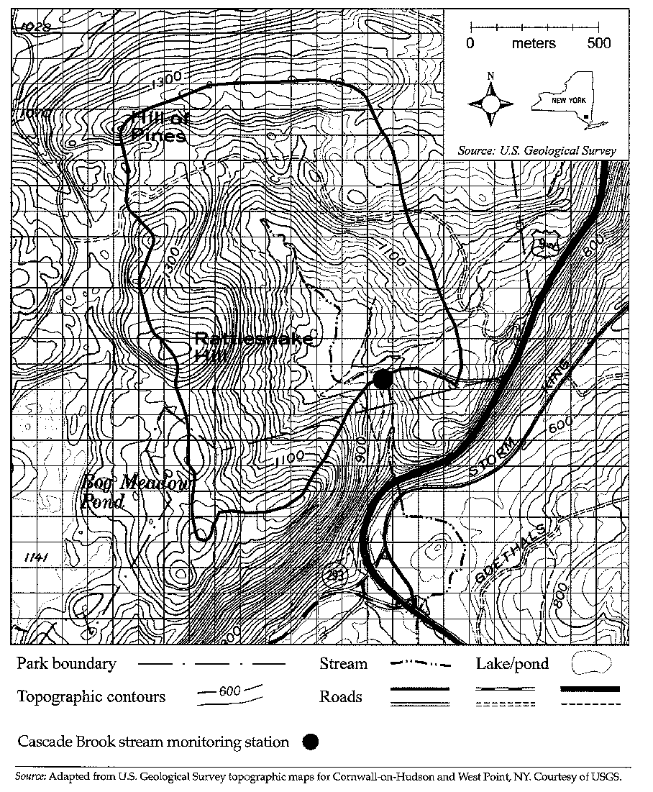

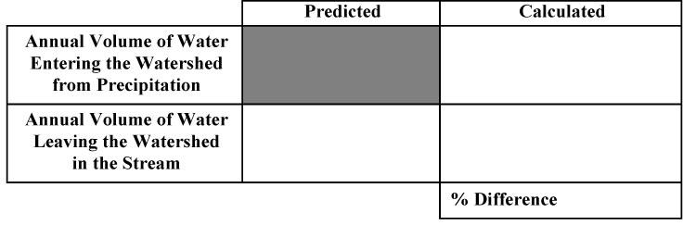**Attachment 2- Chart for Comparing Total Annual Water Volumes.**

**Attachment 3- Climate Data for Southeast New York State**.

|  |  |  |  |  |  |
| --- | --- | --- | --- | --- | --- |
| **Month** | **Monthly Mean Temp. (degrees F)** | **Volume of Water Passing Through Stream Monitoring Station per Month (cubic meters)** | **Average Total Precipitation per Month (cm)** | **Volume of Water Entering the Watershed from Precipitation per Month (cubic meters)** | **Percent of Water from Precipitation Leaving as Water in the Stream** |
| Jan | 28 | 99,094 | 9.30 |  |  |
| Feb | 31 | 70,992 | 8.13 |  |  |
| Mar | 39 | 81,842 | 9.88 |  |  |
| Apr | 51 | 115,930 | 10.49 |  |  |
| May | 61 | 146,614 | 10.44 |  |  |
| Jun | 70 | 84,127 | 11.58 |  |  |
| Jul | 75 | 262 | 11.66 |  |  |
| Aug | 73 | 0 | 11.71 |  |  |
| Sept | 65 | 0 | 11.35 |  |  |
| Oct | 54 | 76,429 | 12.67 |  |  |
| Nov | 44 | 163,473 | 11.00 |  |  |
| Dec | 33 | 130,619 | 10.67 |  |  |

Data on the chart are from:

- source material (*Earth Science Puzzles: Making meaning from data)*

- <http://www.usclimatedata.com/climate.php?location=USNY1567>

- http://www.weather.com/weather/wxclimatology/monthly/10996

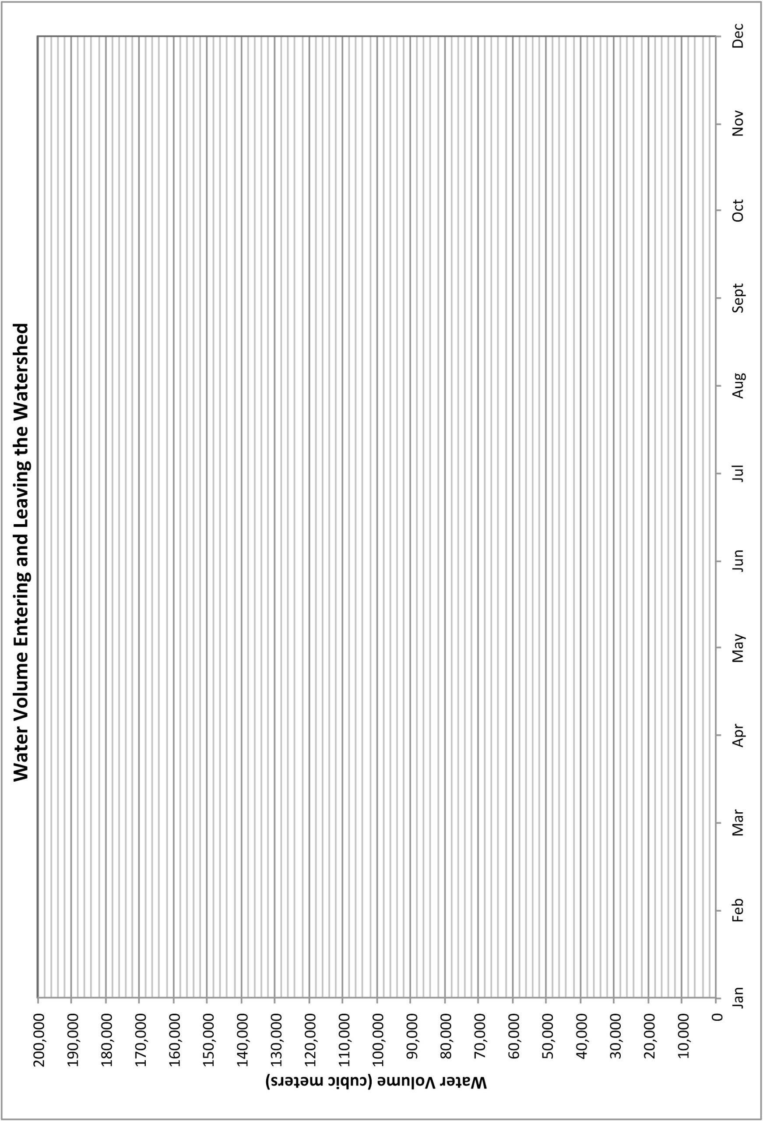**Attachment 4. Water Volume per Month Line Graph**   
*Note: Teachers may choose to have their students design their own graph rather than be given the graph below.*

**Attachment 5. Graph for the Percent Water from Precipitation Leaving the Watershed as Streamflow per Month**   
*Note: Teachers may choose to have their students design their own graphs rather than be given the graph below.*

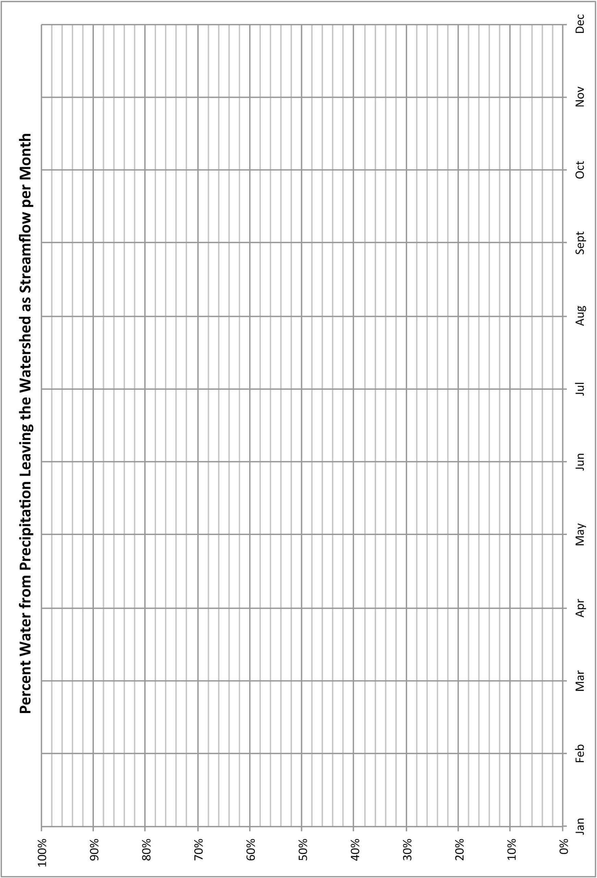

**Attachment 6. Graph Showing the Mean Temperature per Month**  
*Note: Teachers may choose to have their students design their own graphs rather than be given the graph below.*

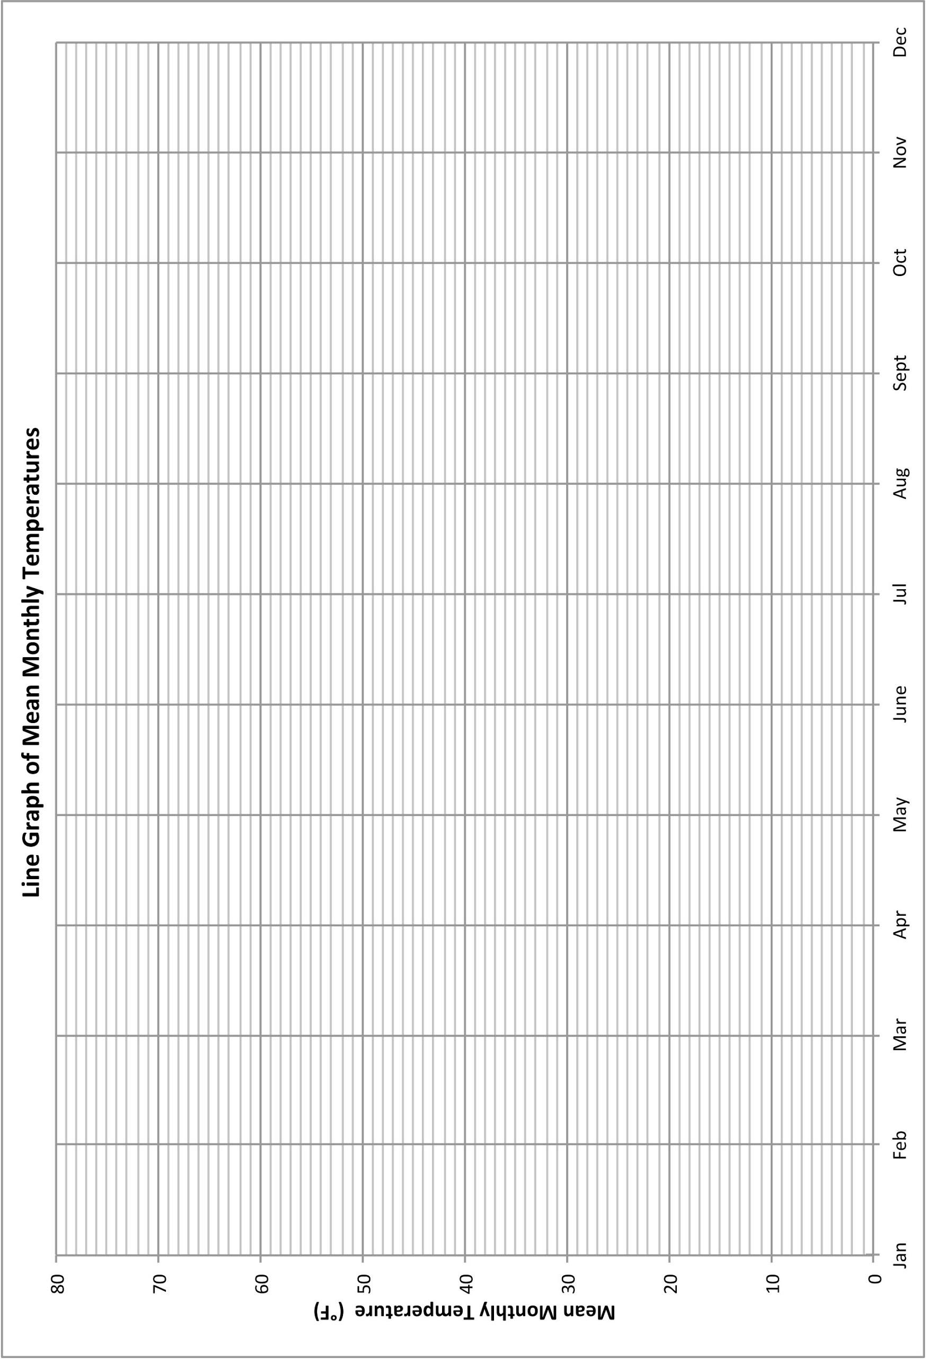

**Attachment 7. Average Total Precipitation per Month Graph**   
*Note: Teachers may choose to have their students design their own graphs rather than be given the graph below.*

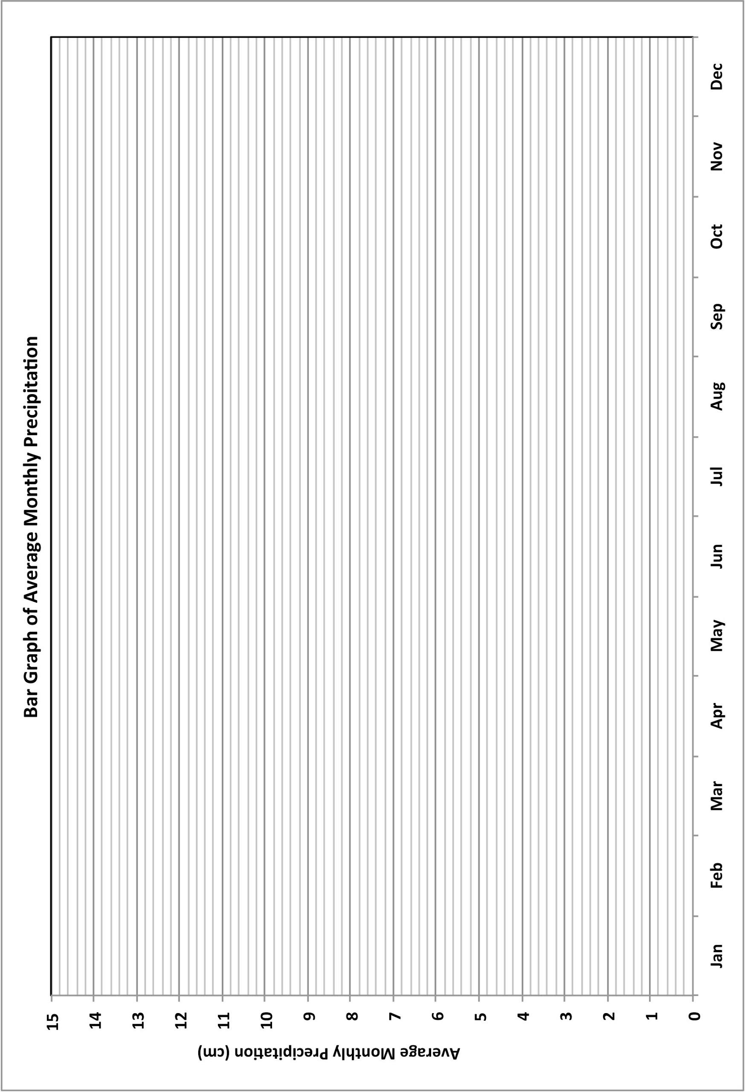

**Attachment 8. Total Monthly Precipitation vs. Monthly Mean Temperature Scatterplot**  
*Note: Teachers may choose to have their students design their own plots rather than be given the plot below.*

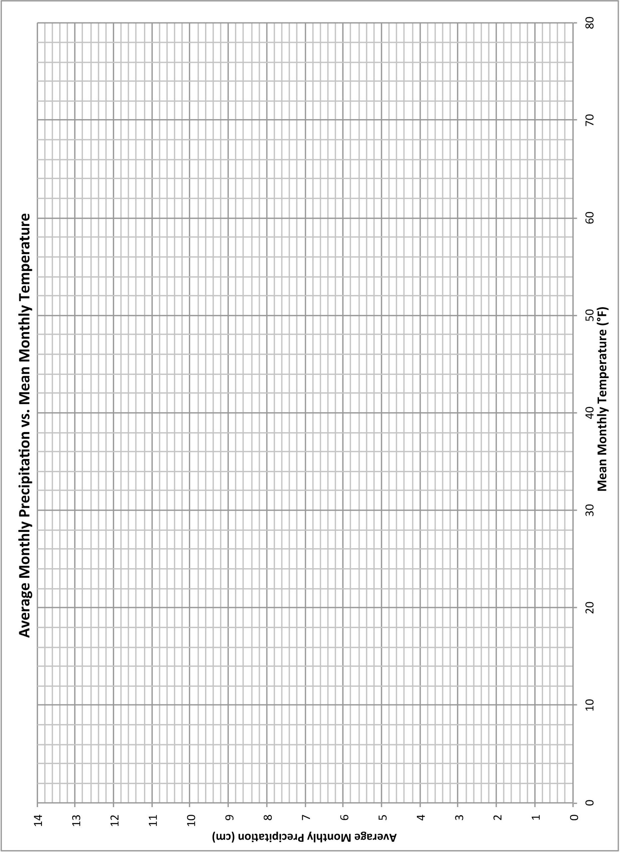

**Attachment 9. Model of the Water Cycle**

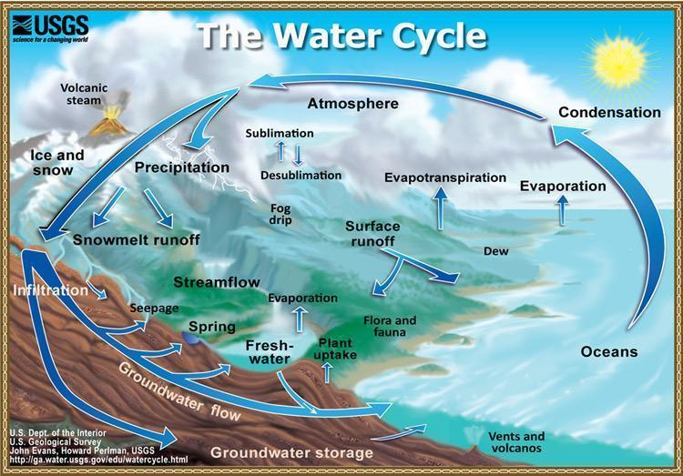

*Image Source:* [*http://ga.water.usgs.gov/edu/graphics/watercyclesummary.jpg*](http://ga.water.usgs.gov/edu/graphics/watercyclesummary.jpg)

*Last accessed: February 8, 2014*

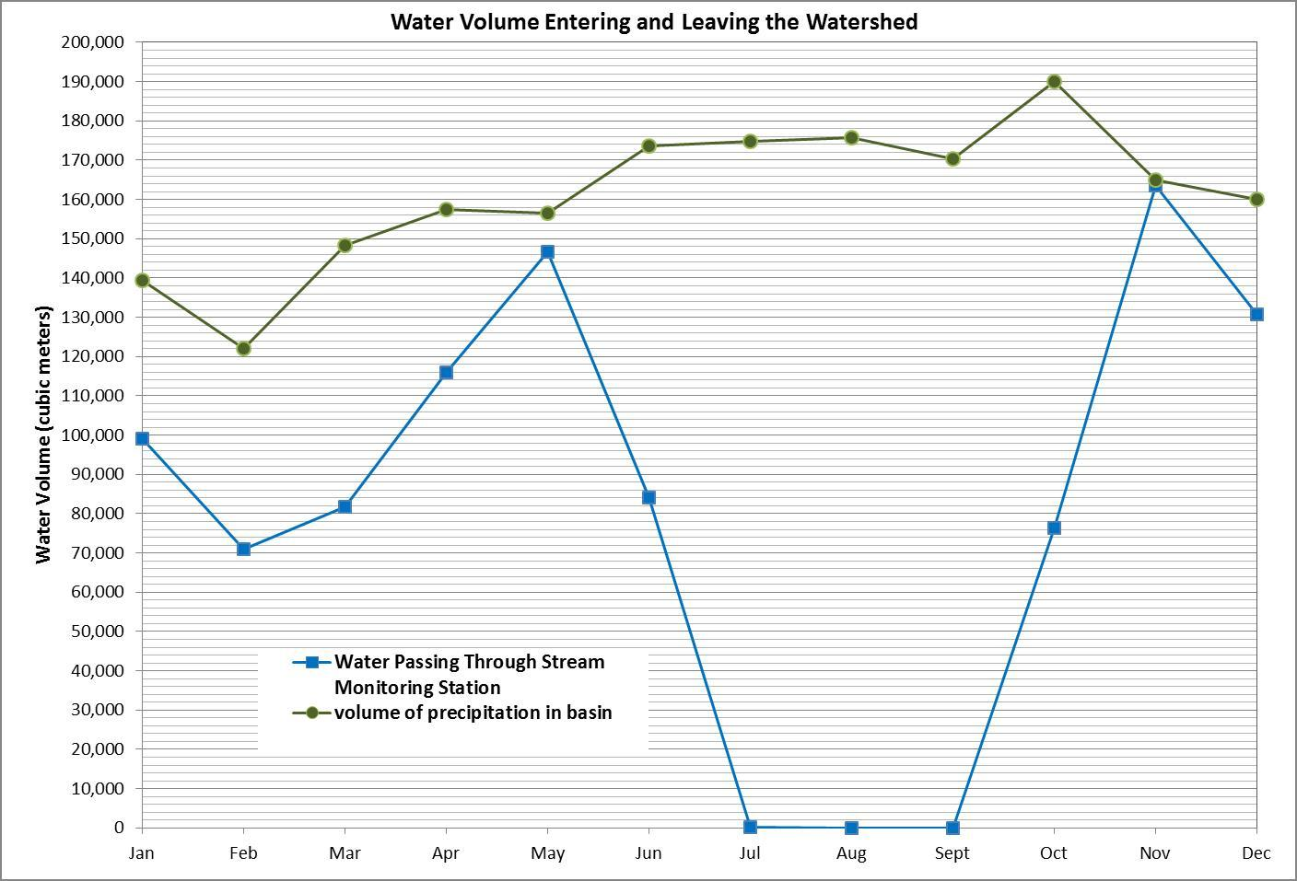***Sample Answer Graphs and Scatterplots:***

