***Suspension Bridges***

***STUDENT INSTRUCTIONS***

Once called "the bridge that couldn't be built," today it is one the seven wonders of the modern world. The Golden Gate Bridge is perhaps San Francisco's most famous landmark, opened in 1937 after a four-year struggle against relentless winds, fog, rock and treacherous tides.

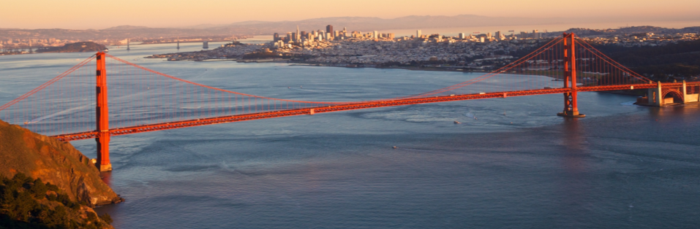

The single-suspension span is anchored by twin towers that reach skyward 746 feet, and was once taller than any building in San Francisco.

The Golden Gate Bridge has 250 pairs of vertical suspender ropes that are spaced 50 feet apart across both sides of the Bridge. All of the ropes were replaced between 1972 and 1976, with the last rope replacement completed on May 4, 1976.

Bridge Facts:

* Distance between towers: 4200 feet
* Height of tower above the roadway: 500 feet
* Shortest distance between the main cable and the roadway: 10 feet.

Examine the diagram of the Golden Gate Bridge.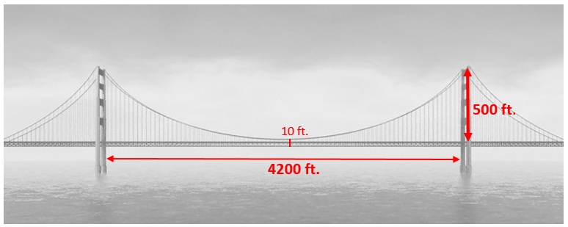

**The Golden Gate Bridge Activity**

*Group Activity*

Names: __________________________________ Period: ____________

Maintenance and repairs on the Golden Gate Bridge are incredibly dangerous. A group of ironworkers and painters battle wind, sea air and fog to repair corroding steel.

Jana noticed that the seventh vertical suspender rope from the left tower is showing signs of corrosion. She is making a plan to replace this rope. There is 50 feet between the tower and the first suspender rope. All ropes have the same distance between them.

What is the length of the seventh vertical suspender rope?

*(Show all work and describe how you calculated the length.)*

***Suspension Bridges***

***Individual Performance Assessment***

Name: _________________________________ Date: ________ Period: ______

A state park has two sets of hiking trails. Accessing the second set of trails currently requires wading across a large creek. Park visitors who do not like hiking the trails with wet shoes and clothing have been submitting requests for a suspension bridge over the creek.

One motivated park visitor – probably an engineer – submitted a diagram of a possible suspension bridge.

**Figure. 1** Suspension Bridge Diagram (**Not Drawn to Scale**)

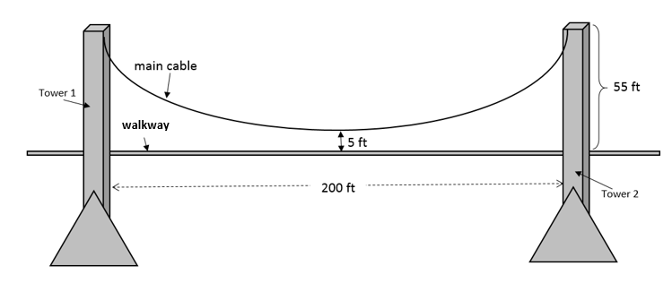

In her request, the visitor stated that the main cable creates a parabolic curve once the suspender ropes are connected to the walkway and the weight of the walkway is added.

1. In this design, ropes attach from the main cable to the floor of the walkway every 5 feet between the towers. The ropes form parallel line segments connecting the main cable and the roadway. Figure 1 shows one main cable; but there will actually be 2 parallel main cables.



How many suspender ropes are needed to connect the main cable to the floor of the walkway between the two towers?

Support your answer.

1. Maria says the equation $y= \frac{1}{200}x^{2}+5$ is the only equation that can be used to represent the main cables in Figure 1. Describe where Maria had to placed the vertex of the parabola in order for this equation to be true and the coordinates of the tops of the towers.
2. Do you agree or disagree with Maria’s claim in question 2 that there is only one equation that can represent the main cable? Support your decision.
3. After analyzing the proposed design, park officials conclude that the expenses associated with the park visitor’s design is excessive. The distance between the towers must equal 200 feet. Show how decreasing the height at which the main cable is connected to both towers can reduce the expense of building the bridge. Based on your research, what other features that might need changing if you change the height of the towers?
4. The main cable must be a parabolic curve and there must be a minimum of 5 feet between the walkway and the main cable. At what height do you recommend connecting the main cable to each tower in order to minimize the amount of rope needed to connect the main cable to the roadway?
   1. Sketch a new design and label the height at which the main cable connects to the towers.
   2. Write an equation for the main cable and describe where the origin is located for your equation to be true.
5. Show that your design in question 5 reduces the total length of rope that is necessary to connect the main cable to the roadway.
6. Write your results in the form of a letter to your supervisor describing the original plan and the alternate plan and show how much material it could save assuming the same size rope could be safely use in both the suggested plan and your alternate plan.