**Student Ideas Discussion Tool**

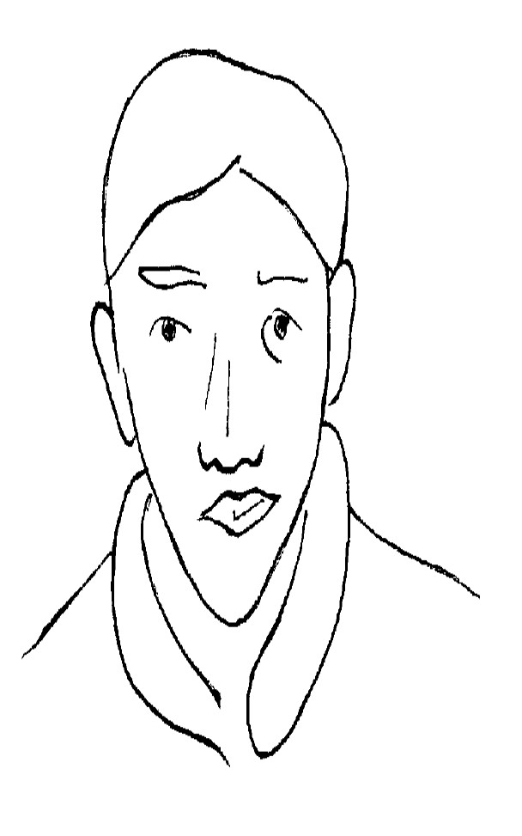

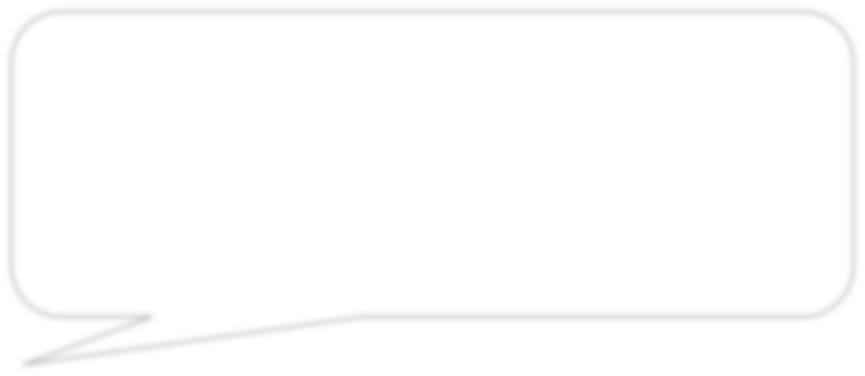

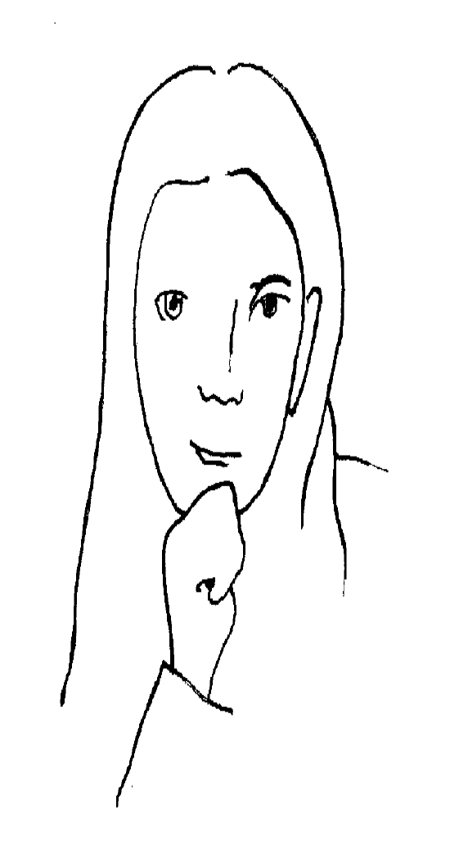

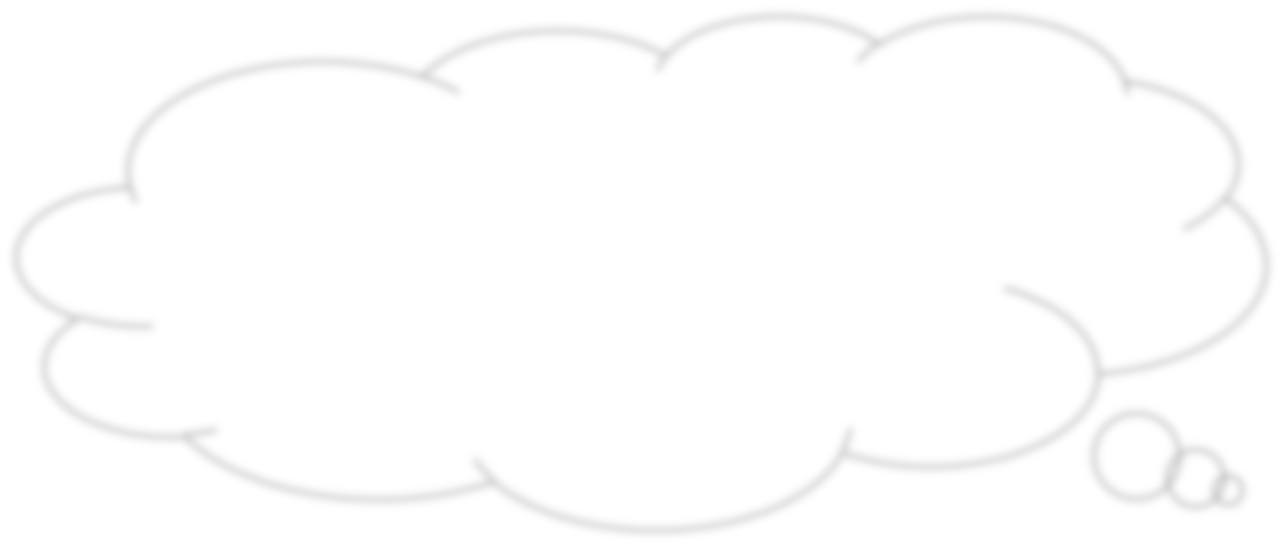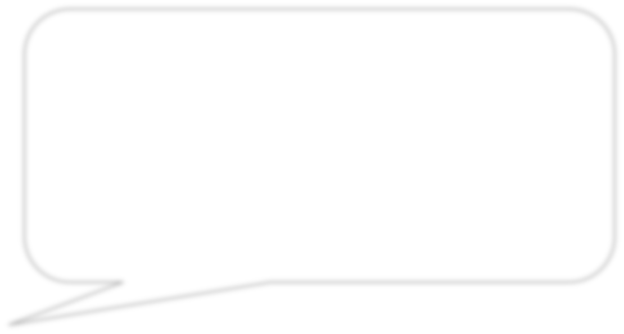

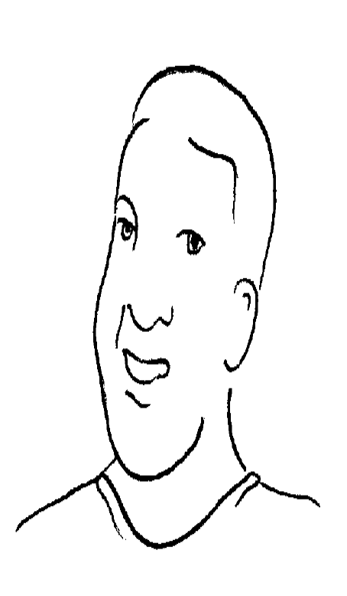

  
© 2015 by The Board of Trustees of The Leland Stanford University. This work is licensed under a [Creative Commons Attribution 4.0 International Public License](https://creativecommons.org/licenses/by/4.0/legalcode) and should be attributed as follows: “*Stopping Distance* was authored by Kari Kokka and Vinci Daro at Stanford Center for Assessment, Learning, & Equity (SCALE).”