#### The Situation

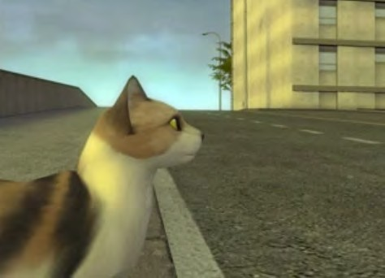

You are driving home one day when Tibbles the cat darts into the road and freezes in fear directly in your path.

Can you stop in time before hitting him?

What do you need to know to begin to develop an approach (not a solution) to this problem? Make some notes and be prepared to share your ideas.

#### The Problem

Can you avoid hitting Tibbles?

* You are a conscientious driver, and are driving 25 mph.
* Tibbles is 63 feet ahead of you when you see him.
* It takes 0.7 seconds from the moment you see Tibbles to the moment you hit the brakes (your ‘reaction time’).

The table below shows the relationship between your speed and the average braking distance for your car.1

|  |  |  |  |  |  |  |
| --- | --- | --- | --- | --- | --- | --- |
| Speed (mph) | 10 | 20 | 30 | 40 | 50 | 60 |
| Braking distance (feet) | 5.87 | 23.44 | 52.71 | 93.69 | 146.38 | 210.77 |

Get as far as you can in solving this problem on your own. Represent your solution strategy as clearly as possible. You will have further opportunities to work on your solution after today.

#### The Problem, Again

Can you avoid hitting Tibbles?

* You are a conscientious driver, and are driving 25 mph.
* Tibbles is 63 feet ahead of you when you see him.
* It takes 0.7 seconds from the moment you see Tibbles to the moment you hit the brakes (your ‘reaction time’).

The table below shows the relationship between your speed and the average braking distance for your car.2

|  |  |  |  |  |  |  |
| --- | --- | --- | --- | --- | --- | --- |
| Speed (mph) | 10 | 20 | 30 | 40 | 50 | 60 |
| Braking distance (feet) | 5.87 | 23.44 | 52.71 | 93.69 | 146.38 | 210.77 |

Discuss possible approaches to this problem with a partner, and get as far as you can in solving it together. Represent your solution strategy as clearly as possible.

#### Making Sense of Others’ Ideas

These students are trying to use the table to write a function that models the car’s stopping distance.

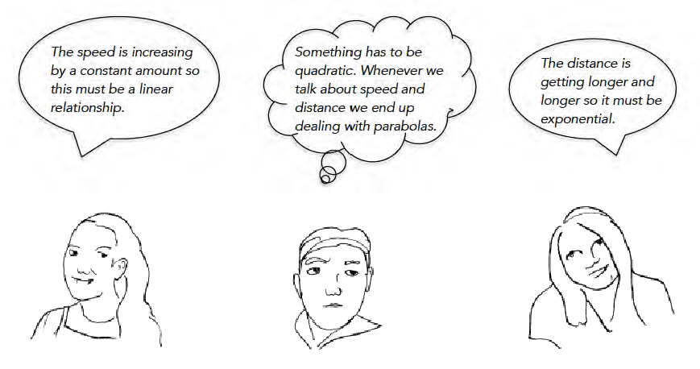

Try to understand each student’s idea on your own first.

Then discuss with your partner: Which of these ideas are correct, and which are incorrect? How do you know?

Make some notes about which ideas make sense to you and which do not.

#### Building on Others’ Ideas

Choose one or two ideas to develop into more coherent arguments. Pick the ideas from Handout 3 or from your teacher.

For each idea you develop, begin by identifying any errors in reasoning.

Then develop each idea by correcting it as needed, and adding explanation, examples, diagrams and/or graphs to support it.

Idea #1

Idea #2

  
© 2015 by The Board of Trustees of The Leland Stanford University. This work is licensed under a [Creative Commons Attribution 4.0 International Public License](https://creativecommons.org/licenses/by/4.0/legalcode) and should be attributed as follows: “*Stopping Distance* was authored by Kari Kokka and Vinci Daro at Stanford Center for Assessment, Learning, & Equity (SCALE).”

## Diagram

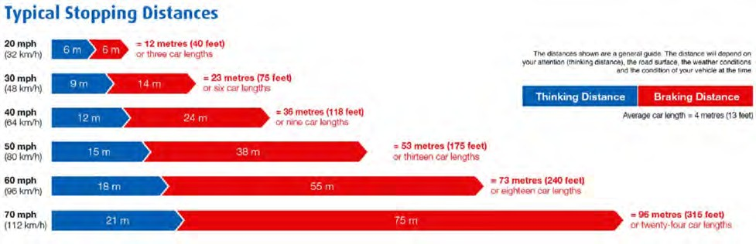

Source: <http://www.cyberphysics.co.uk/graphics/graphs/highwaycodeSD.png>

## Formula

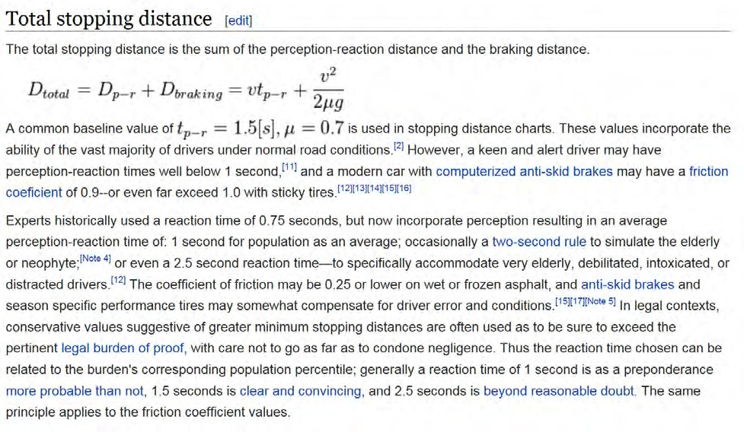

Source: <http://en.wikipedia.org/wiki/Braking_distance>

#### Culminating Product: A Recommendation

The Departments of Motor Vehicles in CA and in NY both publish guidelines for ‘following distance’. Their guidelines are different. Which state’s guidelines do you recommend, based on your study of the mathematics of stopping distance?

Prepare a recommendation to one state’s DMV or the other about changing their published guidelines so that the two states’ guidelines for following distance are consistent.

* Support your recommendation with your own mathematical work (calculations, formulas, diagrams, graphs) and with relevant findings from your research (diagrams, graphs, formulas).
* Be sure to make clear how any diagrams, graphs, and formulas you use represent the important quantities in the situation.
* Your recommendation should be 1-­‐2 pages long, including 2-­‐3 short paragraphs of text and supporting mathematical work.
* Use the feedback you have received so far from your teacher on your individual and group work to inform your final product.

  
© 2015 by The Board of Trustees of The Leland Stanford University. This work is licensed under a [Creative Commons Attribution 4.0 International Public License](https://creativecommons.org/licenses/by/4.0/legalcode) and should be attributed as follows: “*Stopping Distance* was authored by Kari Kokka and Vinci Daro at Stanford Center for Assessment, Learning, & Equity (SCALE).”

Handout 6: Culminating Product – Individual Writing

# California DMV Three Second Rule

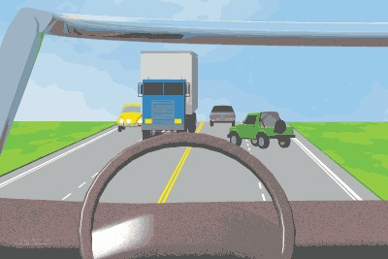**Do not be a tailgater!** Many drivers follow too closely (tailgate) and are not able to see as far ahead as they should because the vehicle ahead blocks their view.

The more space you allow between your vehicle and the vehicle ahead, the more time you will have to see a hazard, and stop or avoid that hazard.

Most rear end collisions are caused by tailgating. To avoid tailgating, use the “three-­‐second rule”: when the vehicle ahead of you passes a certain point such as a sign, count “one-­‐ thousand-­‐one, one-­‐thousand-­‐two, one-­‐thousand-­‐three.” Counting these numbers takes approximately three seconds. If you pass the same point before you finish counting, you are following too closely.

You should allow a four-­‐second or more cushion when:

* + Being crowded by a tailgater. Allow extra room ahead, do not brake suddenly. Slow down gradually or merge into another lane to prevent being hit from behind by the tailgater!
  + Driving on slippery roads.
  + Following motorcyclists on wet or icy roads, on metal surfaces (e.g., bridge gratings, railroad tracks, etc.), and on gravel. Motorcyclists can fall more easily on these surfaces.
  + The driver behind you wants to pass. Allow room in front of your vehicle so the driver will have space to move in front of you.
  + Towing a trailer or carrying a heavy load. The extra weight makes it harder to stop.
  + Following large vehicles that block your view ahead. The extra space allows you to see around the vehicle.
  + You see a bus, school bus, or a placarded vehicle at railroad crossings. These vehicles must stop at railroad crossings; so, slow down early and allow plenty of room.
  + Merging onto a freeway.

If you follow too closely and another driver “cuts” in front of you, just take your foot off the gas. This gives you space between your vehicle and the other driver, without having to slam on your brakes or swerve into another lane.

# New York DMV Two Second Rule

### ALLOW YOURSELF SPACE

[http://dmv.ny.gov/about-­‐](http://dmv.ny.gov/about-)dmv/chapter-­‐8-­‐defensive-­‐driving#all-­‐spc

Four of every 10 crashes involve rear-­‐end collisions, normally because a person is following too closely (tailgating). Leave enough room between your vehicle and the one ahead so you can stop safely if the other vehicle stops suddenly. Brake early and gently when you prepare to stop or turn. It gives drivers behind you plenty of warning that you plan to decrease your speed.

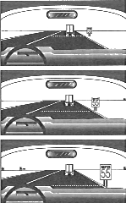For a good "space cushion," use the two-­‐second rule: Select an object near or above the road ahead like a sign, tree or overpass. As the vehicle ahead passes it, count slowly, "one thousand one, one thousand two." If you reach the same object before

you finish the count, you are following too closely. In bad weather and when following large trucks,

increase the count to at least three or four seconds for additional space.

If a driver follows you too closely (tailgates) move to another lane if possible, or reduce speed and pull off the road to let the driver go by you. Make sure

to signal when you drive off the road and when you return to it. Do not press your brakes to warn the driver behind you -­‐ this could make a difficult condition become even more dangerous. In case you must change lanes quickly or pull over to avoid a hazard, leave some "escape" room to your left and right.

#### Three Scenarios to Consider

**Scenario #1**

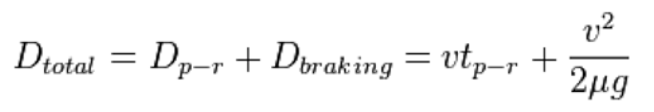

Imagine you are driving *behind* a car that suddenly brakes to avoid hitting Tibbles the cat.

* + - Both you and the driver you are following are driving 22 mph.
    - Tibbles is 55 feet ahead of the car you are following.
    - You are using the “two-­‐second rule” to determine the distance between your car and the car ahead of you. (You learned to drive in New York.)
    - It takes 0.7 seconds for the driver ahead of you to hit the brakes once she sees Tibbles.
    - It takes 0.7 seconds for you to hit the brakes once you see the brake lights ahead of you.
    - You can use the formula1 below to compute the total stopping distance for your car and the car ahead of you.

This formula shows the *total stopping distance* as the sum:

*distance traveled during perception-­‐reaction time* + *distance traveled while braking*

In order to use this formula, suppose the following:

▪▪ Both you and the driver ahead of you have a ‘perception-­‐reaction time’, *tp-­‐r*, of

0.7 seconds.

▪▪ For both cars, the friction coefficient, *,* is 0.6.

▪▪ For both cars, the standard acceleration due to gravity, *g* = 32 ft/sec.

1 Source: <http://en.wikipedia.org/wiki/Braking_distance>



**Scenario #2**

Just like Scenario #1, except:

* You and the driver ahead of you are both driving 55 mph.
* You are using California’s ‘three-­‐second rule’ to determine your following distance.



**Scenario #3**

Just like Scenario #1, except:

* The friction coefficient, **, for your car is 0.5 instead of 0.6.
* You are distracted for a moment by a friend in your car, and your perception-­‐reaction time, *tp-­‐r*, is 1.5 seconds.

  
© 2015 by The Board of Trustees of The Leland Stanford University. This work is licensed under a [Creative Commons Attribution 4.0 International Public License](https://creativecommons.org/licenses/by/4.0/legalcode) and should be attributed as follows: “*Stopping Distance* was authored by Kari Kokka and Vinci Daro at Stanford Center for Assessment, Learning, & Equity (SCALE).”

Handout 8: Three Scenarios to Consider