Inquiry Lab 9th Grade Biology: Pillbugs

Publisher: Envision Schools

Author: Erica Magnusson

Description:

How do the changes I make to the environment impact living things? An inquiry lab designed to connect themes of Ecology, Evolution and Genetics while using the scientific method to create a formal lab report.

Purpose: Certification

Topic: Inquiry Lab; Biology; Animal Behavior; Ecology

Instruction Level: Intermediate

Grade Levels: Grade 9

Standards: There are no standards aligned to this content

Category: Sciences > Biology

Licensing: Creative Commons Attribution-NonCommercial-ShareAlike 3.0 Unported License

**Directions**

Essential Questions

*How do the changes I make to the environment impact living things?*

Background Context

*Ethology is the study of animal behavior. This involves observing an organism’s behaviors, interpreting what is observed, and research different organisms. Ethologists study and observe an organism’s reaction to the environment around them. Biotic and abiotic factors are limiting factors that control the maximum size of a given population. Favorable conditions are desired by an organism of its home environment. Because of this, an animal must search for the environment to fit its structure and lifestyle. This is called habitat selection. An animal can display many different types of behaviors, two being taxis and kinesis. Taxis behaviors are deliberate movements toward or away from a stimulus. Kinesis is a random movement that is not oriented toward or away from a stimulus. Taxis behaviors are exemplary of the physiological needs of an organism. Other behaviors are agonistic, aggressive or submissive actions toward another organism; or mating behaviors. To observe animal behavior in this lab, isopods will be isolated in a controlled environment. Isopods, more commonly known as pill bugs, are crustaceans with a hard exoskeleton, seven pairs of legs, and antenna. In Unit 5, Ecology, we have been studying the relationship of living things and this lab will combine all of the themes we have been learning (abiotic/biotic, energy transfer in food webs, biogeochemical cycles, succession, symbiotic relationships and how humans and climate change impact our environment. This lab will require you to think like a scientist to design your own lab procedures to study the behavior of these fascinating little Pillbugs.*

Task Prompt

*As an ethologist (animal behavior scientist) you have been asked to identify what are the consequences of environmental changes to living things? You have been hired to study an elusive detritivore, the pillbug also known fondly as rolly polly bugs. Pillbugs are not insects they actually are crustaceans (ex. Lobster, crab) that live only on land! They feed on dead or decaying material and have developed the adaptation of having gills so they can breathe while they are deep in wet leaves of the forest. Why do we care about the behaviors of pill bugs? By studying animal behavior, a scientist can learn not only about that species but they can also use that information to learn about the environmental and social circumstances that caused the behavior to evolve. Scientists observe organisms response to stimuli to then determine how natural selection and their genes play a role in that behavior. Think for a minute about your own behaviors and responses to stimuli. How do you react? Do you react in the same way as your friends or family would? These are the types of big questions that ethologist’s ask before taking it a step further to determine how much of that behavior is impacted by hereditary. In your collaborative lab groups you will first observe the Pillbugs in their natural environment before developing an experimental question that you want the answer to. You will conduct reliable research to then create a model of your experiment and a scientific sketch of the Pillbug. Once you have developed an Experimental Question and determined variables (independent and dependent) you will accurately follow the steps of the scientific method to make conclusions about how environmental changes impact the Pillbugs behavior.*

Task Requirements

You will write an inquiry lab report that fulfills the following criteria:

* Conduct reliable research on the habitat, structure and function, and food webs that the Pillbug relies on.
* Observe Pillbugs in their natural environment to develop a Scientific Question you wish to investigate with your group.
* Create an accurate scientific sketch of a Pillbug to demonstrate how the isopod’s adaptation fit it’s habitat (see table A below)
* Choose on the factors below to investigate as your independent variable or discuss with Ms. Magnusson an alternative variable (see table B below)
* Identify Independent and Dependent Variables, control, and constants in your lab
* Create a Hypothesis using the form (If, Then, Because)
* Design a model of the experimental design (sketch up or on paper) that will guide you in the design of your experiment (See example C)
* Develop a procedure that is detailed, clear, and able to be done again by a 5th grader (replicable). Include all materials you will need
* Collect Data from several trials of the experiment in a data table. • Create a graph in google drive to best represent your data. Be sure to include: Title, Independent Variable on x-axis, Dependent Variable on y-axis with axis titles and units, accurate scaling of data.
* Analysis of the data and graphs to compare results to hypothesis and identify experimental error.
* Design a Conclusion that uses prior research, data collection, data analysis to make scientific inferences about conclusions.
* Lab Reports must use follow the rules of scientific writing: Third person perspective (no I or you statements), past Tense verb conjugation and lab format with subtitles.

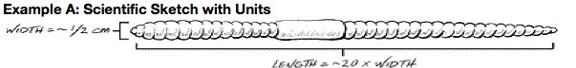

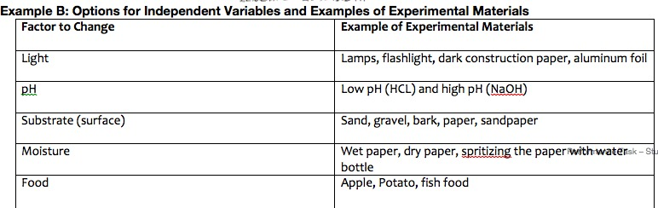

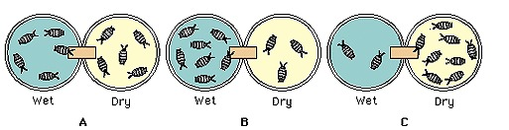

How will you be assessed?

*Scientific Inquiry CSP Rubric to a Proficient*

*How will we get there?*

**I can use data to ask questions**

* I can formulate a specific and testable scientific question - I can research a topic and from that research I can create a specific question to further study

**I can Develop and Using Models**

* I can construct accurate models to represent the experimental design of the lab - I can explain limitations and precision of model as a representation of the lab procedure

**I can Create a Hypothesis**

* I can compose a hypothesis in the accurate format about the scientific question using specific variables (If… then…because)

**I can Designing an Investigation**

* I can create an experimental procedure to match the scientific question - I can explain how the model was used to guide the design of the lab procedure

**I can Identify Variables**

* I can identify the independent and dependent variables in the lab - I can develop controls and explain how they are relevant to the independent and dependent variable.

**I can Develop Procedures**

* I can create a detailed, clear, and replicable lab procedure with materials and methods - I can provide a rationale for replicating the experiment

**I can Collect Data**

* I can gather data from several repetitions of the experiment that are not consistent within a reasonable range -I can provide a rationale for the amount of data needed to produce reliable measurements

**I can Represent the Data using charts/graphs/tables**

* I can use spreadsheets, data tables, charts or graphs to accurately summarize and display data to examine relationships between variables - I can construct accurately labeled and organized data tables, graphs and charts (title, key, labeled axis, units and appropriate scaling)

**I can Use Mathematics and Computational Thinking**

* I can accurately use units - I can make note of whether mathematical computation results make sense without reference to the expected outcome.

**I can Analyze the Data**

* I can analyze the data in using appropriate methods to identify patterns - I can compare outcome with initial hypothesis and identify possible sources of error.

**I can Generate Interpretations**

* I can explain strengths of weaknesses of the inferences using data - I can explain interactions between variables and ask a future question related to the lab.

**I can Constructing Evidence Based Arguments**

* I can construct a scientific argument, explain how data and acceptable scientific theory support the claim - I can identify a counterclaim using evidence

**I can Communicate Findings using Scientific Writing**

* I can use multiple representations (words, charts, graphs or diagrams) to explain conclusions with the evidence - I can explain conclusions with specific discussions of limitations

**I can Follow Conventions of Scientific Writing**

* I can use language and tone appropriate to the purpose of the audience
* I can follow the norms of scientific writing