Here is a suggested entry activity for a text. There are multiple other activities that you can do to help students gain access to a text (nonfiction readings, PowerPoints about historical context, other media analysis, etc.) but Four Corners is easily adaptable for any text or primary themes.

Objective:
SWBAT articulate their opinions about controversial topics regarding race, culture, and discrimination.
SWBAT gain access to the primary themes of the text, Black Boy.
Agenda:
Do Now - 5
Four Corners Activity - 15
Four Corners Debrief - 10
Four Corners Activity
“I am dividing the four corners of the room into four sections. Each corner represents a specific opinion. Look closely at the board to make sure you remember each corner.”
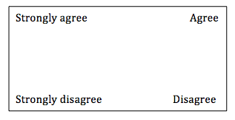
“In a second, I am going to project a statement on the board. I want you to think about that statement for 30 seconds in your head, and then silently move into the corner that correctly identifies how you feel about that statement. Once you arrive in your corners, I will call on a few people to share out their reactions to the statements.”

Project one statement at a time.
Ask students to share responses.
Project next statement and have students move silently to a new corner if they have changed their response.
1.People will always choose to sit next to people of their own race.
2.Racism no longer exists in America.
3.Neighborhoods should be segregated by race or socioeconomic class to ensure order.
4. People make assumptions about me because of my race.
Four Corners Debrief
“I am going to ask you to think very honestly about your feelings and responses to the statements that I just asked you to agree or disagree with.”

Share out.
1. How did you feel about the questions that I asked?
2. Did you notice that certain people gravitated toward certain corners?
3. Why do people feel uncomfortable discussing race?
4. Why is it important for us to learn about the racist history of our country and continue to discuss the problem of race in America?

