**Subject area/course**: Science/Earth Science

**Grade level/band**: 7th

**Task source**: Summit Public Schools

**Geology Comic Book**

**TEACHER'S GUIDE**

1. **Task overview**:

Students will select two images that represent examples of weathering, erosion, or plate tectonics anywhere in the world, and use evidence from these features to model and provide a written explanation of their formation through a comic book.

1. **Aligned standards:**
2. **Primary Common Core State Standards :**

**[CCSS.ELA-LITERACY.RST.6-8.7](http://www.corestandards.org/ELA-Literacy/RST/6-8/7/)** Integrate quantitative or technical information expressed in words in a text with a version of that information expressed visually (e.g., in a flowchart, diagram, model, graph, or table).

**CCSS.ELA-LITERACY.RST.6-8.8** Distinguish among facts, reasoned judgment based on research findings, and speculation in a text.

**[CCSS.ELA-LITERACY.RST.6-8.9](http://www.corestandards.org/ELA-Literacy/RST/6-8/9/)** Compare and contrast the information gained from experiments, simulations, video, or multimedia sources with that gained from reading a text on the same topic.

1. **NGSS:**

**Developing and Using Models**: Models include diagrams, physical replicas, mathematical representations, analogies, and computer simulations. Although models do not correspond exactly to the real world, they bring certain features into focus while obscuring others. All models contain approximations and assumptions that limit the range of validity and predictive power, so it is important for students to recognize their limitations. In science, models are used to represent a system (or parts of a system) under study, to aid in the development of questions and explanations, to generate data that can be used to make predictions, and to communicate ideas to others. Students can be expected to evaluate and refine models through an iterative cycle of comparing their predictions with the real world and then adjusting them to gain insights into the phenomenon being modeled. As such, models are based upon evidence. When new evidence is uncovered that the models can’t explain, models are modified.

**Constructing Explanations**: The goal of science is to construct explanations for the causes of phenomena. Students are expected to construct their own explanations, as well as apply standard explanations they learn about from their teachers or reading. An explanation includes a claim that relates how a variable or variables relate to another variable or a set of variables. A claim is often made in response to a question and in the process of answering the question, scientists often design investigations to generate data.

**Analyzing and Interpreting Data:** Analyzing data builds on prior experiences and progresses to collecting, recording, and sharing observations and progresses to introducing quantitative approaches to collecting data and conducting multiple trials of qualitative observations and distinguishing between correlation and causation, and basic statistical techniques of data and error analysis.

1. **Critical abilities**

**Research:** Conduct sustained research projects to answer a question (including a self-generated question) or solve a problem, narrow or broaden the inquiry when appropriate, and demonstrate understanding of the subject under investigation. Gather relevant information from multiple authoritative print and digital sources, use advanced searches effectively, and assess the strengths and limitations of each source in terms of the specific task, purpose, and audience.

**Analysis of Information:** Integrate and synthesize multiple sources of information (e.g., texts, experiments, simulations) presented in diverse formats and media (e.g., visually, quantitatively, orally) in order to address a question, make informed decisions, understand a process, phenomenon, or concept, and solve problems while evaluating the credibility and accuracy of each source and noting any discrepancies among the data.

**Communication in Many Forms:**  Use oral and written communication skills to learn, evaluate, and express ideas for a range of tasks, purposes, and audiences. Develop and strengthen writing as needed by planning, revising, editing, and rewriting while considering the audience.

**Use of Technology:** Present information, findings, and supporting evidence, making strategic use of digital media and visual displays to enhance understanding. Use technology, including the Internet, to research, produce, publish, and update individual or shared products in response to ongoing feedback, including new arguments or information.

1. **Time/schedule requirements:**

This task is designed to take place over 10 instructional days, with pieces of the task to be completed at certain checkpoints along the way. However, this may also depend on how long your instructional periods are and whether you are operating on a block schedule.

1. **Materials/resources:**

* Instructional Materials for each part of the task
  + Introduction – Project Scavenger Hunt
  + Modeling Practice – Modeling Deposition Student Instructions & copy of Modeling Workshop PPT slides
  + Part 1: Geology Lab – Geology Stations PPT and Lab Station Task Cards (see task cards for more detail about materials for each station)
  + Part 2: Making Inferences & Connections PowerPoint, Task Cards, and Whodunit? Handout
  + Part 3: Finding Images - Student Directions
  + Rough Draft: Comic Book Storyboard Handout, Rough Draft Peer Review & Self-Assessment guidelines
  + Presentation & Gallery Walk: Gallery Walk & Project Reflection PPT, Gallery Walk Report, and Presentation Sheet

1. **Prior knowledge:**

Not provided.

1. **Connection to curriculum:**

Not provided.

1. **Teacher instructions:**

This task has several steps leading up to the final product:

1. Introduction: Handout/Project Calendar
2. Assignment: Modeling Practice
3. Assignment: Geology Lab/Modeling Practice (Part 1 of Task)
4. Assignment: Making Connections & Inferences (Part 2 of Task)
5. Assignment: Finding Images (Part 3 of Task)
6. Handout: Final Product Requirements
7. Assignment: Rough Draft

Sample Instructional Plan, with key checkpoints on certain instructional days:

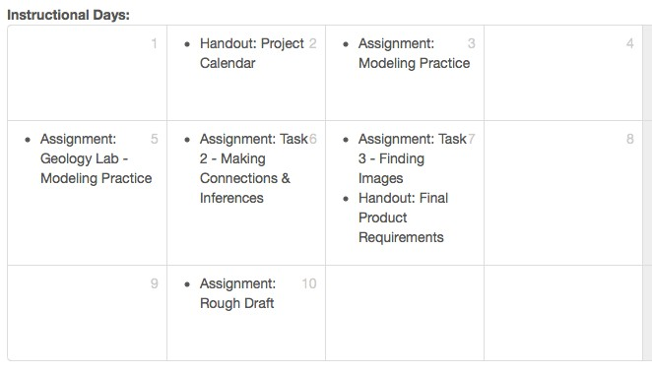***See the Instructional Materials for more details about each component.***

**Details for Introducing the Project:**

* Introduction to Objectives, Agenda, Project Expectations (5 minutes)
* Project Scavenger Hunt (20 minutes)
  + Introduce activity, give students 10 minutes to hunt, and then use the rest of the time to review answers and answer any student questions
  + May want to do the first couple of questions together until students become familiar with the activity
* Review project skills (10 minutes):
  + Modeling - creating a strong visual representation of a concept
  + Narrative - telling a story
  + Precision - accuracy, correct information
  + MC&I - making educated guesses based on past knowledge
* Go over materials and project calendar (15 minutes - may want to make accessible on Google Drive or otherwise organize for them)
* Geeking Out Over Comics (15 minutes): What is a better way to prepare to make a comic than to look at comics? At your table, you have pages of popular comics. In a group, decide how the skills we will be practicing in our project are represented in the comics at your table.
* Comic Rush activity in Journal (10 minutes): 5 square comic strip of a volcanic eruption from the perspective of the lava
* Share out (5 minutes) - students share comic strips in groups or as a class.
* Clean Up/What’s Next in calendar? (5 minutes)

**Details for Part 1 & Part 2 of the task – see Instructional Materials.**

**Details about Part 3 of the task: Finding Images**

In Part 1 of the task, students reviewed different processes that shape the Earth’s surface to understand how they work and what they do. In Part 2 of the task, students learned how to look at a feature on the Earth’s surface and identify what process formed that feature. Because we can’t see these processes happening, the only way to figure out what happened is by looking at evidence and clues that are left behind by the process. Students will look at images of the following processes:

* Water erosion
* Wind erosion
* Wave erosion
* Mechanical weathering
* Chemical weathering
* Convergent plate boundaries
* Divergent plate boundaries
* Transform plate boundaries

They will identify common features of the images within a group to figure out what clues the processes leave behind. After finishing the team task, students should take a check for understanding to see how well they can do this. They can use their notes: <http://tinyurl.com/task2cfu>.

In the next step, when students choose their own images to model and explain in their comic books, they will use the knowledge they gained from this part of the task.

**Details for final product and presentation – see Instructional Materials.**

1. **Student support:**

Not provided.

1. **Extensions or variations:**

Not provided.

1. **Scoring:**

Student work can be scored using the Scientific Practices rubric.