Muscles of Mastication
Muscle | Origin | Insertion | Action
Masseter  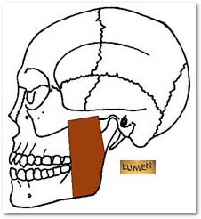 | Zygomatic Arch | - Mandibular angle  - Mandibular ramus
Temporalis  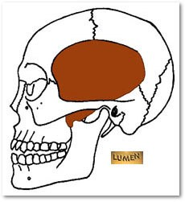 | Temporal fossa of the temporal bone | Coronoid process of the mandible
Muscles of the Neck
Muscle | Origin | Insertion | Action
Sternocleidomastoid  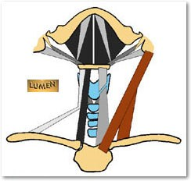 | - Manubrium of sternum  - Medial clavicle | Mastoid process of the temporal bone
Scalenes – anterior, middle, posterior  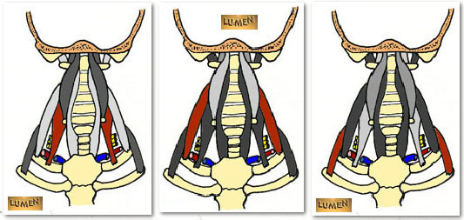 | Transverse processes of the cervical vertebrae | Anterior surface of ribs 1-2

Muscles of the Thoracic Wall
Muscle | Origin | Insertion | Action
Pectoralis minor  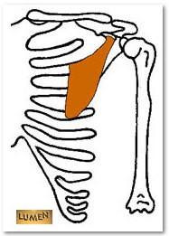 | Ribs 3-5 | Coracoid process of the scapula
External intercostals  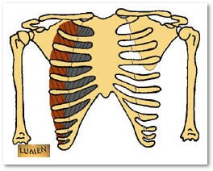 | Inferior border of ribs | Superior border of ribs
Muscles of the Thoracic Wall
Muscle | Origin | Insertion | Action
Internal intercostals  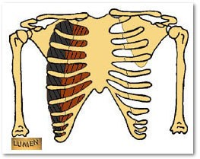 | Superior border of ribs | Inferior border of ribs
Serratus anterior  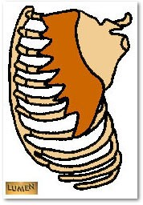 | Ribs 1-8 | Vertebral border of the scapula

Muscles of the Abdominal Wall
Muscle | Origin | Insertion | Action
External oblique  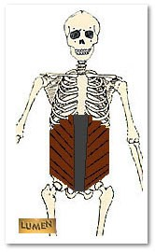 | Ribs 5-12 | - Linea alba  - Pubic crest  - Pubic tubercle  - Iliac crest
Internal oblique  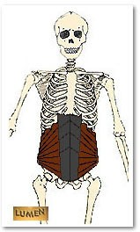 | - Lumbar fascia  - Iliac crest  - Inguinal ligament | - Linea alba  - Pubic crest
Rectus abdominis  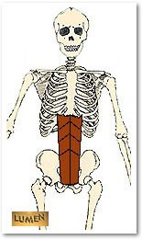 | - Pubic crest  - Pubic symphysis | - Xiphoid process  - Ribs 5-7
Muscles of the Pectoral Girdle
Muscle | Origin | Insertion | Action
Trapezius  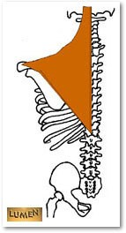 | - Occipital bone  - Spinous processes of C7-T12 | - Lateral 1/3 of clavicle  - Spine of scapula  - Acromion process of scapula

Muscles of the Pectoral Girdle
Muscle | Origin | Insertion | Action
Deltoid  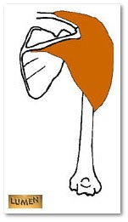 | - Lateral 1/3 of clavicle  - Spine of scapula  - Acromion process of scapula | - Deltoid tuberosity of the humerus
Latissimus dorsi  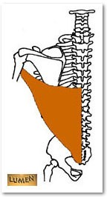 | - Spinous processes of T7-T12  - Ribs 9-12  - Iliac crest  - Inferior angle of scapula | - Intertubercular groove of the humerus
Pectoralis major  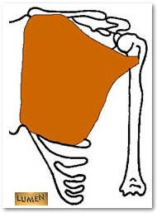 | - Sternal end of the clavicle  - Ribs 1-6 | - Greater tubercle of humerus
Muscles associated with the Scapula
Muscle | Origin | Insertion | Action
Levator scapula(e)  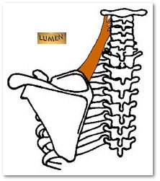 | Transverse processes of C1-C4 | Vertebral border of the scapula
Rhomboid minor  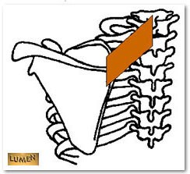 | Spinous processes of C7-T1 | Vertebral border of the scapula
Rhomboid major  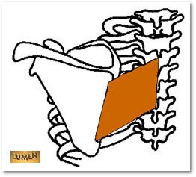 | Spinous processes of T2-T5 | Vertebral border of the scapula
Muscles of the Pectoral Girdle
Muscle | Origin | Insertion | Action
Supraspinatus  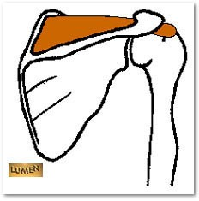 | - Supraspinous fossa of the scapula | - Greater tubercle of the humerus
Infraspinatus  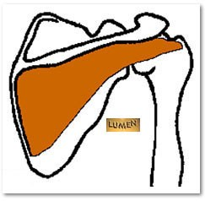 | - Infraspinous fossa of the scapula | - Greater tubercle of the humerus
Teres minor  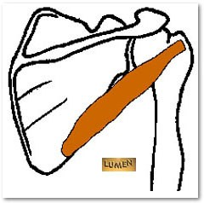 | - Lateral border of the scapula | - Greater tubercle of humerus

Teres major  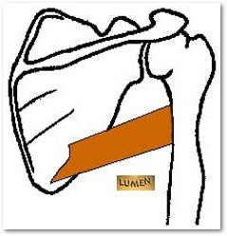 | - Inferior angle of the scapula | - Lesser tubercle of the humerus
Subscapularis  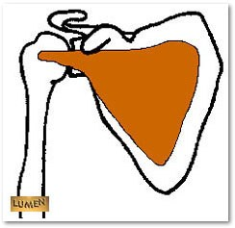 | - Subscapular fossa of the scapula | - Lesser tubercle of the humerus
Muscles of the Anterior compartment of the Arm
Muscle | Origin | Insertion | Action
Biceps brachii  Long head  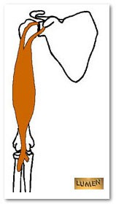  Short head | Supraglenoid tubercle of the scapula  Coracoid process of the scapula | Radial tuberosity of the radius

Muscles of the Anterior compartment of the Arm
Muscle | Origin | Insertion | Action
Brachialis  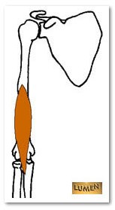 | - Anterior humerus | - Coronoid process of the ulna
Coracobrachialis  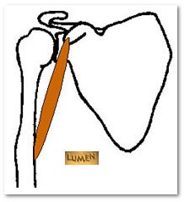 | - Coracoid process of the scapula | - Medial humerus
Muscles of the Posterior compartment of the Arm
Muscle | Origin | Insertion | Action
Triceps brachii  Long head 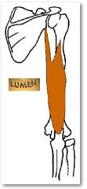 Lateral head  Medial head | Infraglenoid tubercle of the scapula  Posterior humerus Posterior humerus | Olecranon process of the ulna

Muscles of the Anterior compartment of the Forearm
Muscle | Origin | Insertion | Action
Pronator teres  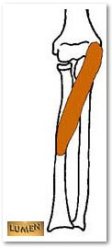 | Medial epicondyle of the humerus | Lateral radius | - Pronates forearm
Flexor carpi radialis  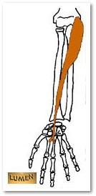 | Medial epicondyle of the humerus | 2nd and 3rd metacarpals
Muscles of the Anterior compartment of the Forearm
Muscle | Origin | Insertion | Action
Palmaris longus  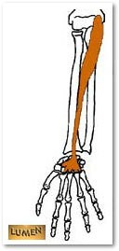 | Medial epicondyle of the humerus | Palmar aponeurosis
Flexor carpi ulnaris  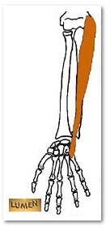 | - Medial epicondyle of the humerus  - Olecranon process of ulna  - Shaft of ulna | - Pisiform  - Hamate  - 5th metacarpal

Flexor digitorum superficialis  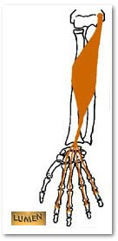 | - Medial epicondyle of the humerus  - Coronoid process of ulna  - Shaft of radius | Middle phalanges of 2nd to 5th digit
Flexor digitorum profundus  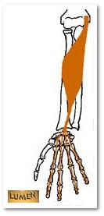 | - Ulna  - Interosseous membrane | Distal phalanges of 2nd to 5th digit
Flexor pollicis longus  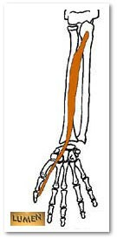 | - Anterior radius  - Interosseous membrane | Distal phalanx of pollex
Muscles of the Anterior compartment of the Forearm
Muscle | Origin | Insertion | Action
Pronator quadratus  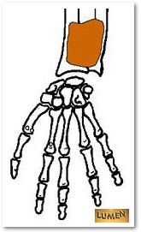 | Distal and anterior ulnar shaft | Distal and anterior radius

Muscles of the Posterior compartment of the Forearm
Muscle | Origin | Insertion | Action
Brachioradialis  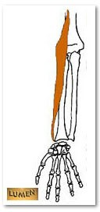 | - Lateral supracondylar ridge of the humerus | - Styloid process of the radius
Extensor carpi radialis longus  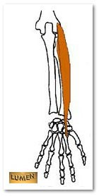 | - Lateral supracondylar ridge of the humerus | 2nd metacarpal
Extensor carpi radialis brevis  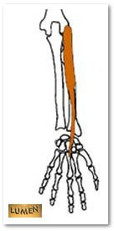 | - Lateral epicondyle of the humerus | 3rd metacarpal
Extensor digitorum  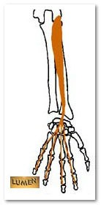 | - Lateral epicondyle of the humerus | Distal phalanges of 2nd to 5th digit

Muscles of the Posterior compartment of the Forearm
Muscle | Origin | Insertion | Action
Extensor carpi ulnaris  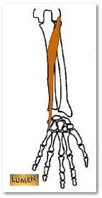 | - Lateral epicondyle of the humerus  - Posterior ulna | 5th metacarpal
Supinator  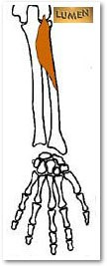 | - Lateral epicondyle of the humerus  - Proximal ulna | Proximal end of radius
Abductor pollicis longus  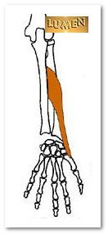 | - Posterior radius  - Posterior ulna  - Interosseus membrane | - Trapezium  - 1st metacarpal
Extensor pollicis brevis  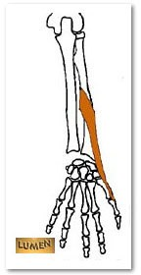 | - Posterior radius  - Posterior ulna  - Interosseus membrane | Proximal phalanx of pollex
Extensor pollicis longus  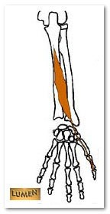 | - Posterior radius  - Posterior ulna  - Interosseus membrane | Distal phalanx of pollex
Muscles of the Posterior compartment of the Forearm
Muscle | Origin | Insertion | Action
Extensor indicis  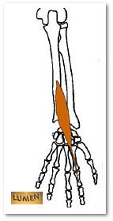 | - Posterior ulna  - Interosseus membrane | Distal phalanx of 2nd digit
Extensor digiti minimi  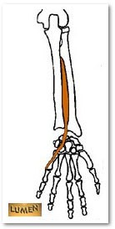 | - Lateral epicondyle of humerus | Distal phalanx of 5th digit

Intrinsic Muscles of the Hand
Muscle | Origin | Insertion | Action
Abductor pollicis brevis  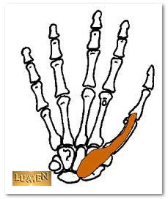 | - Scaphoid  - Trapezium  - Flexor retinaculum | Proximal phalanx of pollex
Opponens pollicis  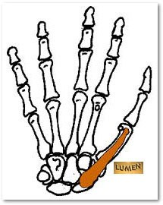 | - Trapezium  - Flexor retinaculum | 1st metacarpal
Flexor pollicis brevis  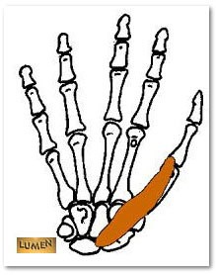 | - Trapezium  - Flexor retinaculum | Proximal phalanx of pollex
Adductor pollicis  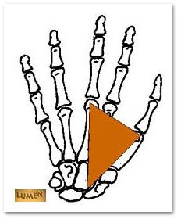 | - Capitate  - 2nd - 4th metacarpals | Proximal phalanx of pollex

Muscles associated with the Anterior compartment of the Thigh
Muscle | Origin | Insertion | Action
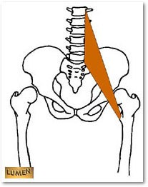  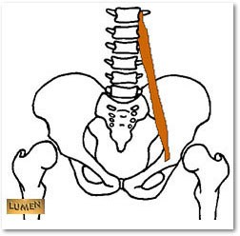  Iliopsoas | - Iliac fossa  - Ala of the sacrum  - Transverse processes of T12-L5 | Lesser trochanter of the femur
Sartorius  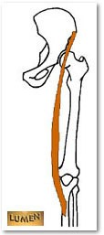 | - Anterior superior iliac spine | Medial tibia
Quadriceps femoris |  | All four:
Rectus femoris  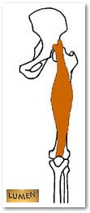 | - Anterior inferior iliac spine | Patella and tibial tuberosity via tendon of quadriceps femoris and patellar ligament
Vastus lateralis  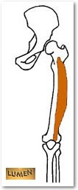 | - Greater trochanter of the femur  - Intertrochanteric line  - Linea aspera of femur
Vastus medialis  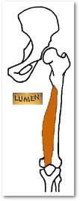 | - Linea aspera of femur  - Intertrochanteric line
Vastus intermedius  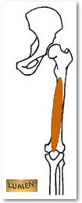 | - Shaft of the femur
Pectineus  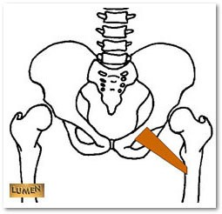 | - Superior ramus of pubis | Linea aspera of femur
Muscles associated with the Anterior compartment of the Thigh
Muscle | Origin | Insertion | Action
Tensor fascia latae  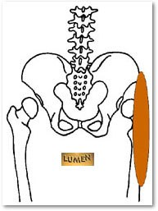 | - Anterior superior iliac spine  - Iliac crest | Iliotibial tract
Muscles associated with the Medial compartment of the Thigh
Muscle | Origin | Insertion | Action
Gracilis  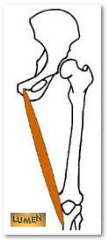 | - Inferior ramus of pubis  - Body of the pubis | Medial surface of tibia
Adductor longus  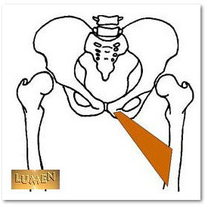 | - Pubis – near pubic symphysis | Linea aspera of femur

Adductor brevis  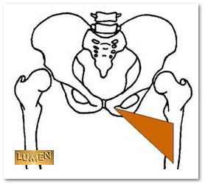 | - Inferior ramus of pubis  - Body of the pubis | Linea aspera of femur
Adductor magnus  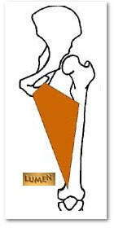 | - Inferior ramus of pubis  - Ischial ramus  - Ischial tuberosity | Linea aspera of femur
Muscles associated with the Gluteal region and Posterior compartment of the Thigh
Muscle | Origin | Insertion | Action
Gluteus maximus  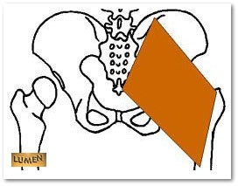 | - Posterior ilium  - Sacrum  - Coccyx | - Iliotibial tract  - Gluteal tuberosity of femur
Muscles associated with the Gluteal region and Posterior compartment of the Thigh
Muscle | Origin | Insertion | Action
Gluteus medius  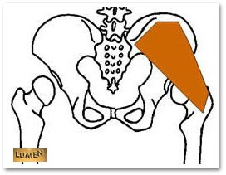 | - Lateral surface of ilium | Greater trochanter of femur
Gluteus minimis  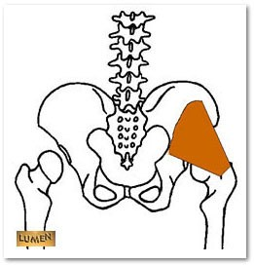 | - Lateral surface of ilium | Greater trochanter of femur

Biceps femoris  Long head  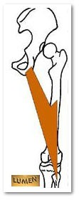 Short head | - Ischial tuberosity  - Linea aspera | - Head of fibula  - Lateral condyle of tibia
Semitendinosus  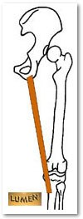 | - Ischial tuberosity | Medial tibia
Semimembranosus  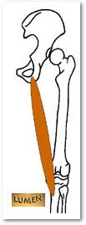 | - Ischial tuberosity | Medial condyle of tibia
Piriformis  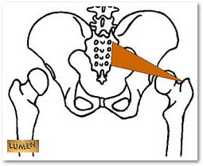 | - Lateral surface of sacrum | Greater trochanter of femur
Quadratus femoris  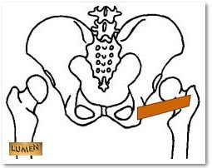 | - Ischial tuberosity | Intertrochanteric crest of the femur

Muscles associated with the Anterior compartment of the Leg
Muscle | Origin | Insertion | Action
Tibialis anterior  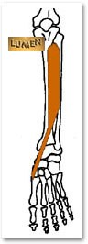 | - Lateral condyle of tibia  - Interosseous membrane | - Medial cuneiform  - 1st metatarsal
Extensor hallucis longus  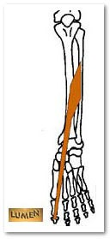 | - Anterior fibula  - Interosseous membrane | Distal phalanx of hallux
Extensor digitorum longus  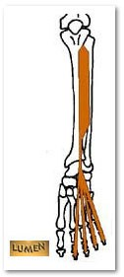 | - Lateral condyle of tibia  - Proximal fibula  - Interosseous membrane | Middle and distal phalanges of 2nd-5th digits
Fibularis (peroneus) tertius  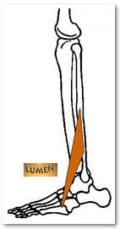 | - Anterior fibula  - Interosseous membrane | 5th metatarsal

Muscles associated with the Lateral compartment of the Leg
Muscle | Origin | Insertion | Action
Fibularis (peroneus) longus  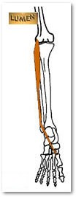 | - Head of fibula | - Medial cuneiform  - 1st metatarsal
Fibularis (peroneus) brevis  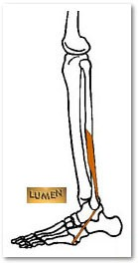 | - Distal fibula | 5th metatarsal
Muscles associated with the Posterior compartment of the Leg
Muscle | Origin | Insertion | Action
Gastrocnemius  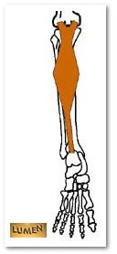 | - Lateral condyle of femur  - Medial condyle of femur | Calcaneus
Soleus  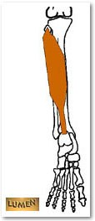 | - Proximal tibia  - Proximal fibula  - Interosseous membrane | Calcaneus

Flexor digitorum longus  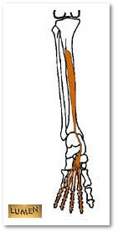 | - Posterior tibia | Distal phalanges of 2nd-5th digits
Flexor hallucis longus  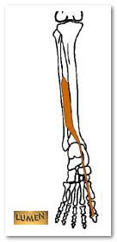 | - Middle shaft of fibula  - Interosseous membrane | Distal phalanx of hallux
Tibialis posterior  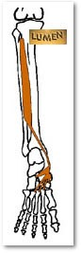 | - Proximal tibia  - Proximal fibula  - Interosseous membrane | - Navicular bone  - 2nd-4th metatarsals

Intrinsic Muscles of the Back
Muscle | Origin | Insertion | Action
Erector spinae (group)
Iliocostalis  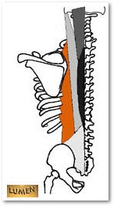 | - Iliac crest  - Ribs 3-12 | - Inferior border of ribs  - Transverse processes of C4-C6
Longissimus  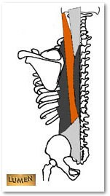 | - Transverse processes of C4-L5 | Mastoid process of temporal bone
Spinalis  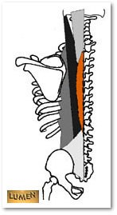 | - Spinous processes of T7-L3 | Spinous processes of C4-T6
Splenius capitis  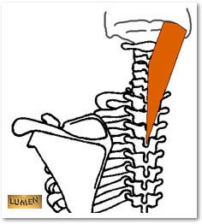 | - Spinous processes of C6-T7 | - Mastoid process of temporal bone  - Occipital bone
Semispinalis capitis  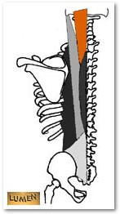 | - Transverse processes of C7-T12 | Occipital bone

