# 

**Bacteria Are Prokaryotes**

Medical Mysteries Resource Card 2

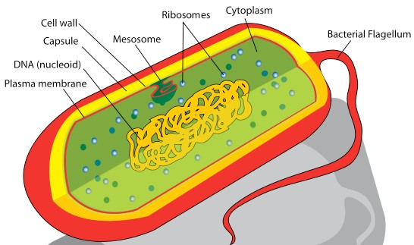

## Unicellular

* **Reproduce asexually**

* **Composition** 
  + Protected interior (cytoplasm) that contains genetic material (one circle of DNA) as well as complexes of protein enzymes to carry out necessary functions of gathering energy, manufacturing proteins (ribosomes), etc.

## Size

– 0.2-­‐10 micrometer (µm)

## 

* **Composition** 
  + Phospholipid membrane, many contain cell wall composed of peptidoglycan (positive for chemical Gram stain), those with little or no peptidoglycan called Gram negative

# Protozoa Are Eukaryotic

Medical Mysteries Resource Card 2

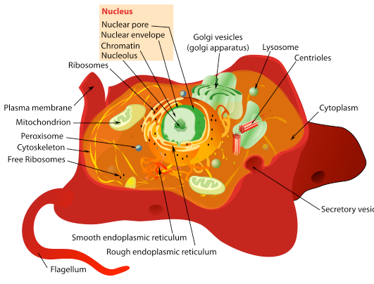

## Uni-­‐ or multicellular

* **Reproduce asexually & sexually**
* **Composition:**
  + Genetic material (long linear strands of DNA chromosomes) especially isolated and enclosed in membrane (nucleus)
  + Some have cell walls (plants have cellulose, fungi ß-­‐glucan)

## Size:

– 10-­‐100 (µm)

## Composition:

* + Phospholipid membrane outside, as well as inside.
  + Interior membranes separate functions such as gathering and transforming cellular energy and manufacturing macromolecules.

Medical Mysteries Resource Card 2



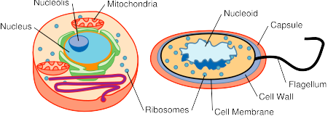

DNA

|  |  |
| --- | --- |
| linear strands within membrane-­‐bound nucleus | single circle in “nucleoid region |
| 5-­‐100 µm | 0.2-­‐10 µm |
| often multicellular,  some have cell walls (no peptidoglycan) | usually single-­‐celled, some have peptidoglycan cell walls |
| usually need oxygen to exist | may not need oxygen to exist |
| membrane bound organelles like mitochondria | no organelles, different ribosomes |
| plants, animals, protists, fungi | bacteria, archaea |

Size Organization

Metabolism

Organelles

Examples

# Blood Tests for Samuel Harris

## White Blood Count

Medical Mysteries Resource Card 3

Patient’s White Blood Count = 2,500 cells per micoliter (mcL) of blood

## CD4 cells

CD4 cells are a type of lymphocyte (white blood cell) and they are an important part of the immune system. CD4 cells are sometimes called T-­‐cells or helper cells because they lead the attack against infections. When something has been attacking the immune system for a long time, there is a significant decline in the number of CD4 cells, indicating a compromised immune system.

## Absolute CD4 Count

The number of functional CD4 cells circulating in the patient’s blood.

Patient’s Absolute CD4 = 90 cells per cubic millimeter (cmm) of blood

## CD4 Percentage

The percentage of CD4 cells compared to all the functional lymphocytes that are in the patient’s blood. The CD4 percentage takes in consideration the total lymphocyte count when assessing immune system health.

Patient’s CD4 Percentage = 15%

Medical Mysteries Resource Card 3

# Microscope Images for Samuel Harris

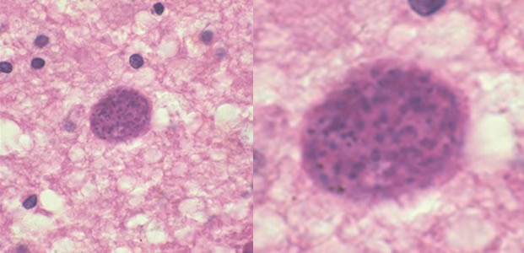

Brain Cyst stained with hematoxylin and eosin

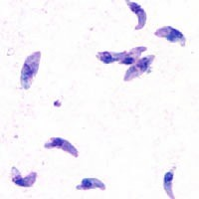

Foreign body found in body fluids stained with giemsa