## 

**Preliminary Autopsy of Samuel Harris**

Medical Mysteries Resource Card 1

* EXTERNAL EXAMINATION: The body is that of a 21-­‐year-­‐old well-­‐developed, well-­‐nourished male. The patient has no major surgical scars.
* HEART: The heart is large with a normal shape and a weight of 400 grams. The pericardium is intact. The epicardial fat is diffusely firm. Upon opening, the heart was normal with slightly raised white plaques in the left ventricle wall lining. The left ventricle measures 2.2 cm, the right ventricle measures 0.20, the pulmonic right measures 8 cm, and the aortic ring measures 7 cm. The circulation is left dominant. Examination of the great vessels of the heart reveals minimal atherosclerosis.

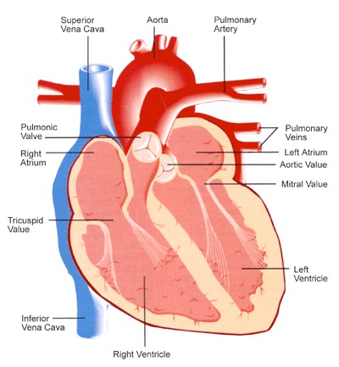

* AORTA: There is minimal atherosclerosis with no measurable plaques along the full length of the ascending and descending aorta.
* LUNGS: The right lung weighed 630 grams, the left weighed 710 grams. The lung parenchyma is pink without evidence of congestion or hemorrhage. The bronchi are grossly normal.
* GASTROINTESTINAL SYSTEM: The esophagus and stomach are normal in appearance without evidence of ulcers. The stomach contains approximately 800 ml, without evidence of any pills or other non food stuff material. The liver weighs 2850 grams and the cut surface reveals a normal liver with no fibrosis present. The gallbladder is in place with a probe patent bile duct through to the ampulla of Vater.

Medical Mysteries Resource Card 1

* LYMPHATIC SYSTEM: The lymph nodes throughout the body are swollen. Largest nodes (ranging from 1 to 2 cm) in the head, neck, armpits, and groin areas. Evidence of long-­‐term infection or compromised immune system. Further tests required.
* ENDOCRINE SYSTEM: The adrenal glands are in the normal position and weigh 8.0 grams on the right and 11.6 grams on the left. The cut surface of the adrenal glands reveals a normal appearing cortex and medulla. The thyroid gland weighs 12.4 grams and is grossly normal.

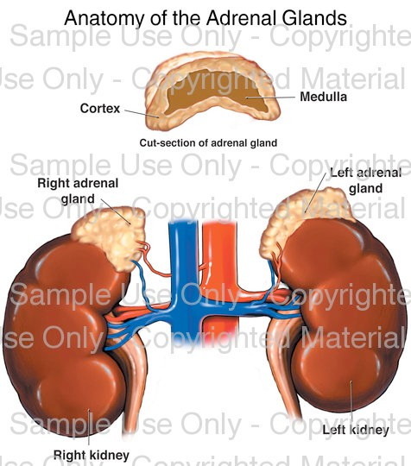

* URINARY SYSTEM: The right kidney weighs 200 grams, the left weighs 210 grams. The left kidney contains a 1.0 x 1.0 x 1.0 simple cyst containing a clear fluid. The cut surface reveals a normal appearing cortex and medulla with intact calyces. The prostate and seminal vessels were cut, revealing normal appearing prostate and seminal vesicle tissue without evidence of inflammation.
* BRAIN: A comparative study MRI of the brain and pathology was performed. Post-­‐mortem lab tests revealed decreased glucose and elevated protein level. MRI showed multiple lesions in the basal ganglia (a group of nuclei in the human brain that controls motor functions and executive functions such as heart rate and breathing). High intensity images with an enhanced MRI revealed massive membrane involvement. Post-­‐mortem examination disclosed that the T2-­‐ weighted lesions found in the basal ganglia were aggregated small cystic lesions with inflamed Virchow-­‐Robin spaces, a characteristic finding of meningoencephalitis. The basal ganglia lesions and infected membranes lead to a preliminary diagnosis of meningoencephalitis, but the underlying cause is currently undetermined. A definitive diagnosis may be ascertained with other laboratory tests. Awaiting a thorough patient history from the family.

Medical Mysteries Resource Card 2

# Graphic Organizer for Distinguishing Characteristics Between Viruses, Bacteria, and Protozoa

|  |  |  |  |
| --- | --- | --- | --- |
| **CHARACTERISTIC** | **Virus** | **Bacteria** | **Protozoa** |
| Type and shape of the genetic material |  |  |  |
| Structure that provides an outer protective barrier |  |  |  |
| Reproduction |  |  |  |
| Size |  |  |  |
| Methods to treat infections |  |  |  |

To learn more about:

Virus <http://micro.magnet.fsu.edu/cells/virus.html>

Bacteria <http://micro.magnet.fsu.edu/cells/bacteriacell.html> Protozoa <http://micro.magnet.fsu.edu/cells/animalcell.html>

Medical Mysteries Resource Card 2



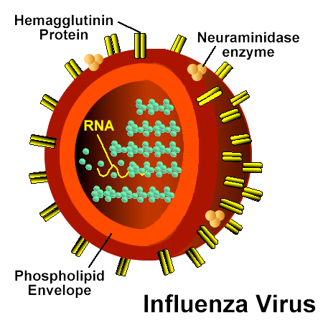

* Not cells
* Cannot reproduce alone
  + Hijacks a host cell to replicate itself
* Composition
  + Outer shell: repetitive protein often inserted into a lipid envelope (responsible for recognition and infection of host cell)
* Size
  + Smallest organisms (50nm)
  + 100 times smaller than bacteria
* Composition
  + Protected interior that contains genetic material (DNA or RNA) with important protein enzymes required for duplication

* + **Virus hijacking host system**

Medical Mysteries Resource Card 2

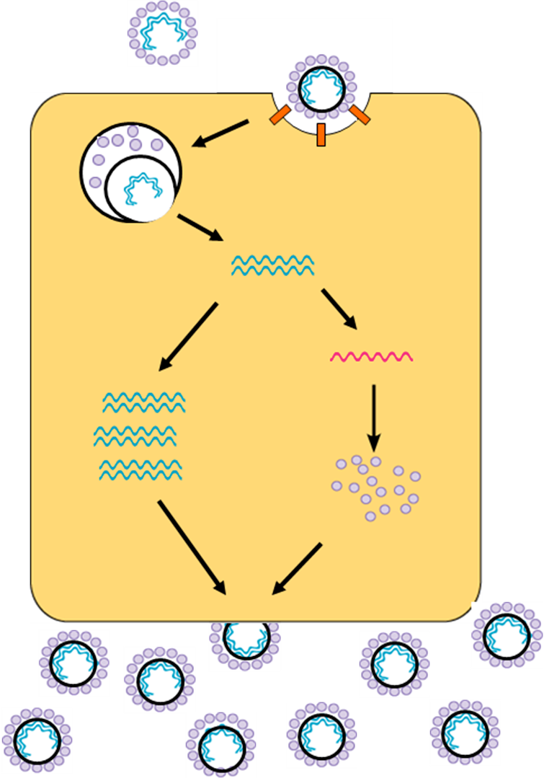

* + - **Treatment – Drug Tamiflu**: Blocks neuraminidase enzyme made by all influenza A strains (cause the “flu” and avian flu). Viruses are unable to remove sticky sialic acid, and can’t escape.

