Subject area/course: Mathematics/Precalculus
Grade level/band: 10-12
Task source: Envision Schools

Optimization Project

STUDENT INSTRUCTIONS

- Task context:
Fozzils (http://www.fozzils.com) is a company that specializes in making foldable dishes, bowls, cups, and spoons for ultralight, ultracompact camping and backpacking. Below is an example of their folding products.

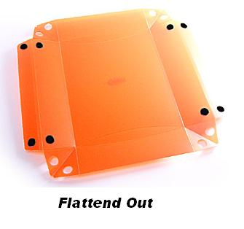  Flattened Out | 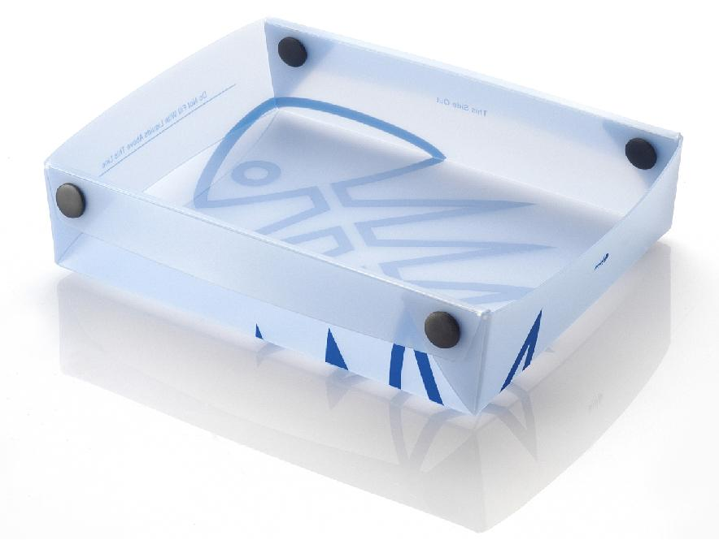

Fozzils is looking for an efficiency expert to advise them on how to optimize their product designs. This is where you come in! Currently, there are two main product lines they want to optimize – dishes with a rectangular base, and dishes with a square base.

Dishes with a rectangular base that must be made from a sheet of plastic of the following sizes:  - 5” by 7”  - 8.5” by 11”  - 8.5 by 14”  - 11” by 14”  - 11” by 17” | Dishes with a square base that must be made to hold the following volumes:  - 50 cubic inches  - 65 cubic inches  - 80 cubic inches  - 100 cubic inches  - 130 cubic inches  - 150 cubic inches

Your task is to do an inquiry to figure out the best possible design for these products in terms of their dimensions, in depth, width, and height. Your goal is to write a proposal to this company for the ideal design of these dishes, along with a mathematical analysis to convince them that you are correct. Each student in the class will be randomly assigned to investigate one of the rectangular base dishes and one of the square base dishes, and these assignments are below. Note: although the sides require extra material to fold over and snap, your analysis will not include this. You may assume it is already taken into account by the company.

For your project write-up, you will use WolframAlpha in order to create your graphs, diagrams, and mathematical analyses of your equations. You will be given access to computers for the write-up and instruction on how to use these resources. If you use your time in class effectively, it is very possible to complete this entire project without working on it at home or on the weekend.

- Final product:
You will do a project write up that includes the following sections:
- Context: Description of what the company makes, including a couple of pictures of the dishes from Fozzils’ website. This should be a paragraph.
- Objectives: State which designs you are working with, and what you are trying to show in this write-up.
- Math Inquiry Questions: State what it means to find the most efficient design for each product, in terms of volume and area of the material. This should be a few complete sentences.
- Volume Optimization Process & Proposal: This segment should be a VERY complete explanation of your entire process. It needs to include a diagram of the rectangular plastic sheet, a table showing your trial designs, an explanation of how you got the entries in your table, and a clear description of how you arrived at a general equation for the volume of your boxes. The proposal section should include pictures from WolframAlpha showing how you are using the local maxima or minima function to analyze your equation to find the optimal dimensions and volume. Then, once you can identify the ideal height, depth, and width for your box, use the cuboid function on WolframAlpha to draw your 3-D box.
- Area Optimization Process & Proposal: Include the same info as the volume process, but this time for your square base design.
- Reflection: This should be in three paragraphs.
  - Know: Explain goals, purpose, and academic skills used in this project
  - Do: Explain the process, decisions, and leadership skills used in this project
  - Reflect: Describe impact of this project on yourself, on your future, and on your growth as a mathematician.

Additional Information

- Knowledge and skills you will need to demonstrate on this task:
- Ability to model a physical situation with mathematics.
- Ability to visualize three-dimensional objects.
- Ability to use computer software to graph and solve equations.
- Ability to read graphs.
- Ability to analyze and interpret mathematical information.
- Knowledge of surface area and volume.

- Materials needed:
- Project Day 1 handout
- WolframAlpha Boot Camp Cheat Sheet handout
- Computer with word processing software for completing your project write-up
- Internet access to access WolframAlpha

- Time requirements:
You will have approximately 3 weeks to work on this project. Your teacher will provide you with specifics and due dates.

- Scoring:
Your work will be scored using the Envision Schools Problem Solving Application (Analysis or Inquiry) rubric. You should make sure you are familiar with the language that describes the expectations for proficient performance.

