American Literature Literary Analysis – Kindred

Publisher: Envision Schools Author: Melissa Fully   
Duration: 4 weeks Grouping: Individual

Description: Your task is to write a literary analysis on Kindred around the theme of mental slavery.

Purpose: Student Assessment Work Products: Kindred Literary Analysis Grade Levels: Grade 11 Standards: Common Core Standards for English Language Arts (2010) Category: Language Arts > Reading Fiction; Language Arts > Literary Analysis; Language Arts > Literature Licensing: Creative Commons Attribution 4.0 International Public License

**Directions**

Essential Questions How does the mind become enslaved? *How do people respond to society’s attempts to enslave them?* How does the mind become liberated? *How does society respond to people’s attempts to free themselves?*

Background Context We began this unit by looking at different multiple texts that address the idea of mental slavery. You then came up with your own definition of the term. We read Kindred and tracked examples in your book and on your bookmark of where mental slavery was occurring, whether it was of someone being enslaved or someone enslaving someone else. As we read we also participated in literary discussion circles, discussing mental slavery in the book as well as other themes and how they related to our lives.

Task Prompt Your literary analysis should examine mental slavery in Kindred. You will create your own thesis that examines this issue without a direct prompt, but you should use the Essential Questions to guide you. In the literary analysis essay, you are exploring and analyzing mental slavery in Kindred. It is NOT a review of the story, characters, themes or main ideas. It is NOT a summary of the plot. Your literary analysis essay should reflect your viewpoint or interpretation of the book as elucidated in your thesis.

Task Requirements 1. Present a clear, controlling thesis statement analyzing mental slavery in Kindred 2. Examine the ideas and language presented in the text as they relate to mental slavery 3. Provide relevant textual evidence to support your claims and ideas (using at least five quotes to support your argument) 4. Organize your ideas in a unified and coherent manner 5. At least two sophisticated body paragraphs (minimum three body paragraphs) 6. Give your essay an original title that reflects your viewpoint 7. 4 – 6 pages typed 8. Use academic formatting: double- spaced, 12 point font

How will you be assessed?

*What domains from the CSP rubric will be assessed in this task?*

How will we get there?

* I can make a clear and well developed argument that demonstrates engaged reading  and critical thinking
* I can use sufficient and detailed textual evidence to support my argument
* I can effectively analyze evidence
* I can organize and structure ideas for effective communication
* I can use language to skillfully communicate ideas

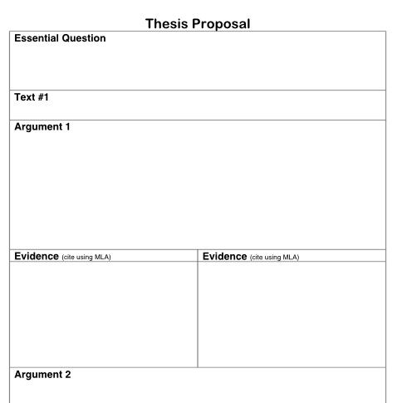

**OUTLINE**

