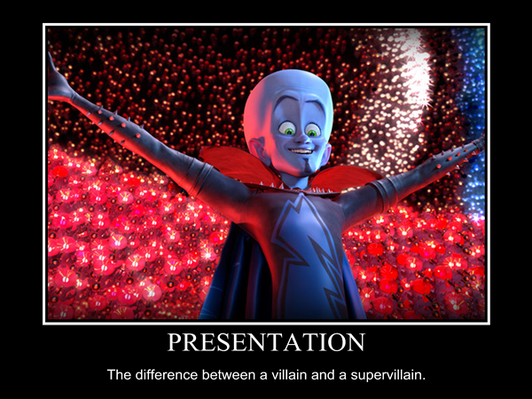

**Planning your Presentation**

**Purpose**

The purpose of the presentation is to share different ways of thinking about conservation of energy with your peers.

You will give the presentation many times (so much opportunity for growth and improvement!) to only two to three peers at a time. It is an academic presentation, but it also can be informal.

**Planning your Presentation**

You presentation should address all of the following:

1) What scenario you have and what types of energy are present.

2) How energy flows through the system.

3) Explain how your model models the essential elements of conservation of energy in your scenario.

4) Why you chose to model energy this way.

5) An explanation for any symbols or representations you used.

6) At the end of your presentation, your peers will have the opportunity to ask you questions about anything they are curious or confused about so be ready to answer questions!

The presentation should be about 2-3 minutes long. It’s okay if it’s a little shorter or longer if you’ve covered everything you’re supposed to cover.

**Tips**

When beginning, think about what is unique or creative about your project. That is what you want to share the most with your peers so they are challenged to think about this idea in a different way.

It is okay to use note-cards, but your presentation should NOT be scripted.

Good note-cards will only have a few words for each point, reminding you what to say. Eye contact is critical and you won’t be able to maintain that if you are reading off your cards.

Be prepared to answer questions about your model! The best way to do this is to think anticipate what questions people might ask. Or think about what you would ask your peers when they are presenting their version to you?