**Phase 1: Intro to Modeling a Periodic Function**

**The Situation**

British Airways announced in 1996 its plans to fund construction of the world’s largest Ferris wheel. The wheel was designed to measure approximately 500 feet in diameter and to carry up to 800 passengers in 32 capsules. The wheel was designed to turn continuously and to be slow enough for people to hop on and off while it turns, completing a single rotation once every 20 minutes.

**Essential Question**

|  |  |
| --- | --- |
|  |  |
|  | |  | | --- | | How can we figure out how high off the ground you are at any time? | |

With your group, you should:

* + Try to answer all the questions below with the math knowledge you already have
  + Label and draw on the given diagram
  + Represent the situation with tables and graphs (most important)

**Directions**

With your team you will complete sections A – F below. All team members will need to complete their own work in order to move on to the final portion of this project.

**Play roles to help your conversation**:

**Time Keeper** – Keep the group on task and focused on the situation and the end product.

**Facilitator**– Make sure the group is thinking about all parts of the problem. Keep the conversation moving and everyone involved.

**Resource Manager** – Keep your group organized and all of the work in the middle of the table. If someone is writing, make sure everyone knows what it is.

**Recorder/Reporter** – All of the important information from your conversation gets on your group’s paper. Everyone is responsible for writing on his or her own individual project which includes all sections below.

Recall **The Situation:**

British Airways announced in 1996 its plans to fund construction of the world’s largest Ferris wheel. The wheel was designed to measure approximately 500 feet in diameter and to carry up to 800 passengers in 32 capsules. The wheel was designed to turn continuously and to be slow enough for people to hop on and off while it turns, completing a single rotation once every 20 minutes.

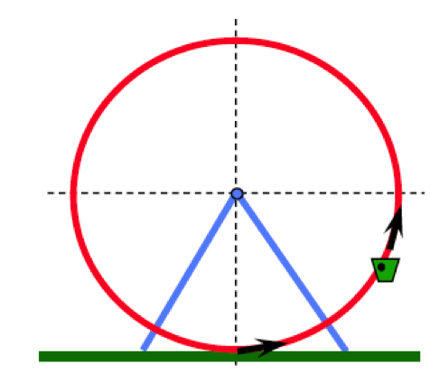

Suppose you board this Ferris wheel at ground level. Let t represent the time since you boarded (in minutes) and let h represent your height above the ground (in feet).

A. Complete this table with your group:

|  |  |  |  |  |  |  |  |  |  |
| --- | --- | --- | --- | --- | --- | --- | --- | --- | --- |
| t(min) | 0 | 5 | 10 | 15 | 20 | 25 | 30 | 35 | 40 |
| h(feet) |  |  |  |  |  |  |  |  |  |

B. Label the above representation with the information from the table in part A and answer the following questions:

1. Generalize the behavior of the values of *h*. Is there a pattern? If so, how do you know? Extend your table to include four of these repeated cycles.

1. What would this look like if graphed? Consider what is your **independent** and **dependent** variable in this situation? Please graph below and then answer the observation questions. *(You may attach a graph if you choose not to do it below.)*

C. Observations:

1. What would be a good description of the shape of the graph if the data points were connected with a smooth curve? *Try connecting your points you made on your graph.*

1. What about the Ferris wheel do you think impacted the way the graph looked?

1. What other phenomena in the real-world may be represented with a similar graph?

D. Label the **period**, **midline**, **amplitude**, and **phase (or horizontal) shift** on the graph created in Part B #2. Then answer the following questions:

1. Does this phenomenon represent a trigonometric function? If so, which?

1. Find an equation for the graph. Follow these steps for reference:
2. Determine the amplitude ______________
3. Determine the midline ________________
4. Determine the frequency ______________
5. Determine the period _________________
6. Determine *the phase shift (horizontal shift) _______________*

Check by graphing your function on desmos.com. Be sure that it is in radian mode!

E. Comparing/Using your Model

1. Compare your equation with another student or group. Is your solution unique? If not, how are your solutions alike?
2. What is your predicted height above the ground when you are 12 minutes into the ride?
3. Under what circumstances would this Ferris Wheel model not be periodic? What are the limitations of this model?

F. Reflection/Check for Understanding

1. Look back at the initial Ferris Wheel problem and the equation you created to represent it. Write your equation below and relate its parts to the information given in the original situation.
2. What is a periodic function?
3. What are more examples of this in the real-world? How?
4. What are some examples of situations that are not represented by periodic functions? Why?