**Proposal**

**Problem Statement**

***Context:*** *What are you analyzing? What is the purpose? Who might this affect?*

***Measurements/Variables:*** *What measurements are given in the problem? What variables are left to identify/quantify?*

***Relationship Between Variables:*** *How are the remaining variables related? As the design is changed, how do the variables change? How are the variables related to each other?*

***Optimization Question:*** *What are you able to change and what are you trying to maximize or minimize?*

*Example:*

*Context: A house has a butterfly roof to catch rainwater and store it for later use. We want to increase the volume of this collection space so that it doesn’t overflow in a heavy rain. A better design will allow the people in the house to collect more rainwater and conserve natural resources.*

*Measurements/Variables: The metal sheets of the butterfly roof measure 6 feet wide and 24 feet long. The angle between the sheets, the height of the end of the sheet from the roof, and the distance between the ends of the sheets (base) can all be changed to optimize volume.*

*Relationship Between Variables: Changing the angle between the metal sheets changes both the height and the base. As the height increases, the base decreases. The height, base, and width of the sheets are related by the Pythagorean Theorem.*

*Optimization Question: What height and base measurements will maximize the volume of the butterfly roof?*

Use the example above to write the four parts of your problem statement below.

1. **Context:**
2. **Measurements/Variables:**
3. **Relationship Between Variables:**
4. **Optimization Question:**

**Diagram and Model**

Identify significant components of a complex concept and develop an accurate visualto represent the key features/variables. Include any constraints/limitations for your specific problem. This diagram should show the relationships of the components to the whole product and explain the relationships among components/variables.

Your model should include mathematical equations that identify and explain significant/relevant patterns and the relationships among patterns. This should include a written explanation for how changing one variable affects the other variables in the system.

***Diagram Checklist***

* *Drawing of components*
* *All known measurements are clearly labeled with correct units*
* *All variables are clearly labeled*
* *Any limitations/constraints are labeled or explained*

**Graph**

Include a graph of your optimization equation and explain in a written paragraph how changing a variable affects the optimization variable. This explanation should reference specific parts of the graph and include relevant vocabulary (slope, concavity, maxima, minima, etc).

*Example: Butterfly Roof*

*V = 12b(36-b2)½*

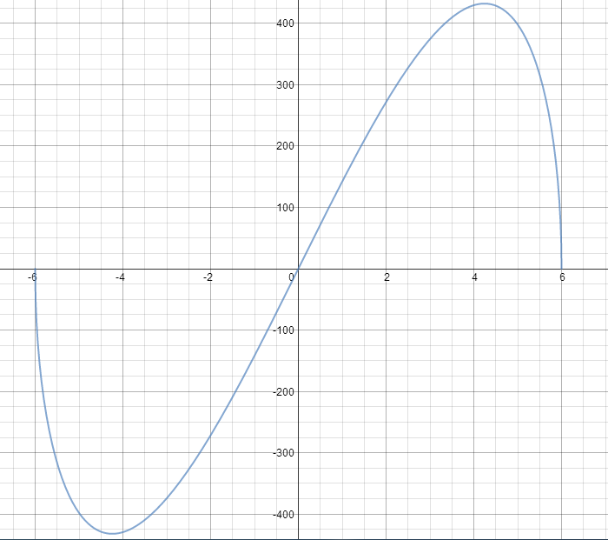

*The function that is graphed above shows the relationship between volume and base. When the base is zero, there is no volume because the roof is a plane rather than a triangular prism. As the base increases, the triangle opens up and the volume increases. After the graph reaches the maximum shown, the volume begins to decrease again. This is because the increase in the base is offset by the decrease in height. When the base increases to 12 feet, both metal sheets are flat on the roof and once again represent a plane with no volume. The maximum appears to be around 4 ft.*

**Peer Feedback: Present Proposal**

You will be placed into Peer Feedback Groups of 3-4 students for the duration of this project. When your proposals are complete, you will present them to your Peer Feedback Group and they must unanimously sign off that your proposed topic is adequate and fits the parameters of this project.

Presenter: Clearly and effectively communicate your proposed topic. Precisely identify all relevant variables and constraints. Explain how your graph accurately represents your problem by identifying key graphical features (intercepts, slope, maxima/minima) to variables and patterns represented in your topic. Identify what variable will be maximized and how it relates to other variables in the system.

Peer Reviewers: You want to make sure this project is complex enough to require calculus in the analysis, but isn’t overly complex or rely on too many variables.

Is the diagram clearly labeled?

Are the relationships between variables clearly expressed?

Does the graph match the expected behavior of the system?

Does the graph show a maximum/minimum?