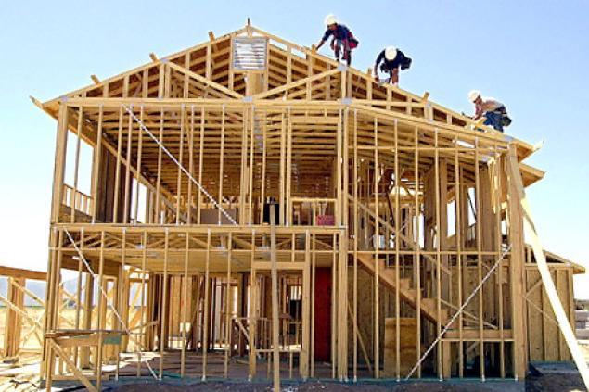

Building Your Model

**Project Requirements:**

1) Your model must be visual. This does not mean it HAS to be a drawing, though it can be. But it shouldn’t have any words though symbols are okay.

2) It has to show all the essential elements of Conservation of Energy that we talked about yesterday.

- Energy converts from one object to another.

- Energy converts from one type to another.

- The total amount of energy in the system stays the same.

**Guiding questions:**

Think back to Day 1, what forms can a model take?

How can I visually show energy conversion?

How can I visually show energy transformations?

How can I visually show that the total energy stays the same?

Feel free to make a quick sketch and get feedback before you spend a lot of time making your model.