**Entry Events for “Book of Limits” Project**

1) "Human Lines"

As a class, we are going to construct a coordinate plane. Use black tape to construct the coordinate axes and circular pieces of paper as place holders for the coordinates. Your first task is to graph the line y=x+1 with each person in the room representing a point on the line. Once you have done this, your goal is to interlock hands and pass a hula-hoop from one end of the line to the other end of the line without falling out of line and without unlocking hands.

For your second task, I'm going to ask the student who is located at the point (4, 5) to leave the line. Your goal is the same: interlock hands and pass the hula-hoop from one end of the line to the other end of the line without falling out of line and without unlocking hands [note: the persons located at the points (3, 4) and (5, 6) will not be able to interlock hands...let them figure it out!].

Reflection: What twist did I introduce in the second task? [I "removed" a student from the line.] Were you still able to get the hula-hoop from one end to the other? [Yes.]

For your third and final task, I'm going to divide the class into three parts. One third of you will form the graph of the line y=x+1 on the domain from negative six to one. One third of you will form the graph of the line y=2 on the domain from one to eight. One third of you will graph the line y=-x-1 on the domain from eight to fifteen. Your goal is the same: interlock hands and pass the hula-hoop from the leftmost end of the graph to the rightmost end of the graph without falling out of place and without unlocking hands [note: the persons located at the points (8, 2) and (8, -9) will not be able to interlock hands NOR get the hula hoop across...let them try to figure it out!]. For one final extension: Have one person start at the left end of the graph and have one person start at the right end of the graph and have them move toward each other, being sure to always "stay on the graph." What do they physically have to do in order to "move along the graph?" [Jump.]

Purpose: This will give them a physical representation of the notions of "removable discontinuity" and "jump discontinuity."

2) "Bounce"

Suppose you drop a ball from 10 feet high in such a way that the ball rebounds exactly half the distance it came down from with each bounce. Can you figure out how many total feet the ball travels?

Purpose: From the rules of physics, the ball eventually comes to a stop. Mathematically, you can keep cutting a number in half and never stop, but eventually the numbers become so infinitely small that they are negligible, thus allowing the students to find the finite distance the ball travels.

(This activity will allow the students to see how what can be interpreted as an infinite process...cutting a number in half...can actually lead to a finite value.)

3) World Population Growth

Consider the graph depicting the world population through the year 2000.

What type of graph does this appear to be?

How might one use this graph to make predictions for the world population in the year 3000?

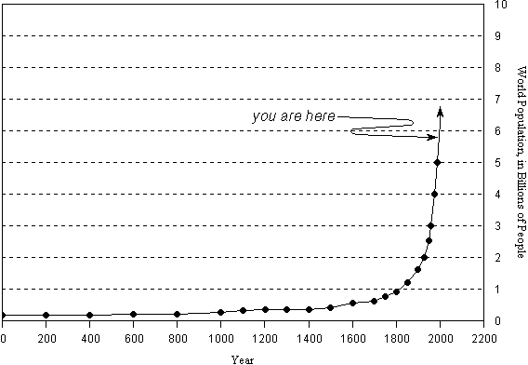

Now, consider this graph of the world population from 1950 to the projected world population in 2100. What appears to be happening? How does this compare to the first graph you looked at?

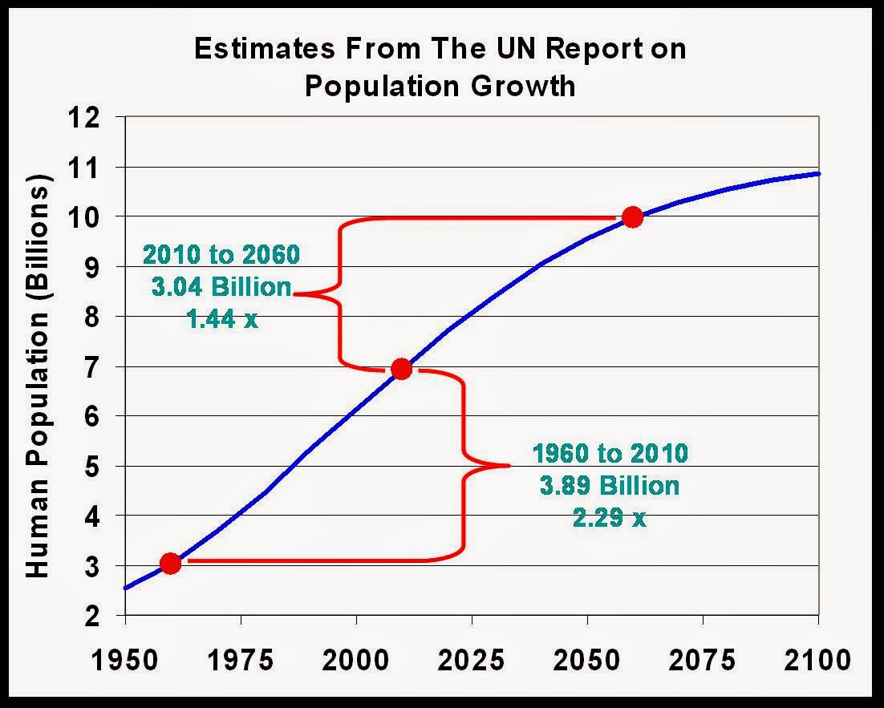

Discussion: How much can the earth sustain? What about resources? If the world population were to continue increasing exponentially, what would happen?