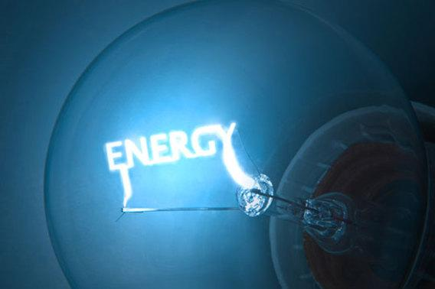

**Energy Analysis**

**Warm Up**

1) What does Conservation of Energy mean?

2) What are the essential components or parts of Conservation of Energy that need to be represented in your model?

**Your scenario**

You will be assigned one of the following scenarios and then build a model that shows the conservation of energy through this system.

- A slingshot shoots a pebble.

- A car accelerates forward from rest.

- A moving car crashes into a telephone pole.

- An incandescent light bulb burns steadily.

- A hockey puck is smacked across the floor by a bent-back meterstick.

- A balloon is pumped up and then released.

- A rubber ball bounces up and down on the floor.

- A cell phone is used to play music.

- A pull back car is wound up and released.

- A person pushes a chair across the floor.

**Energy Analysis**

The first step to building your model is to determine what types of energy you have in the scenario. List all the types of energy in your scenario and explain how you know this type of energy is present.

|  |  |
| --- | --- |
| Energy Type | How do know that it is present? |
|  |  |
|  |  |
|  |  |
|  |  |

Once you are confident that you have identified all the energy types, try to develop a sequence of events. You will do this by creating a flow chart or timeline that shows how energy flows in your scenario. If you need help, use the guiding questions below to get you thinking about your scenario.

What type of energy are you starting with? What happens to that energy? Does it transfer to another object? Does it transform to a different type?