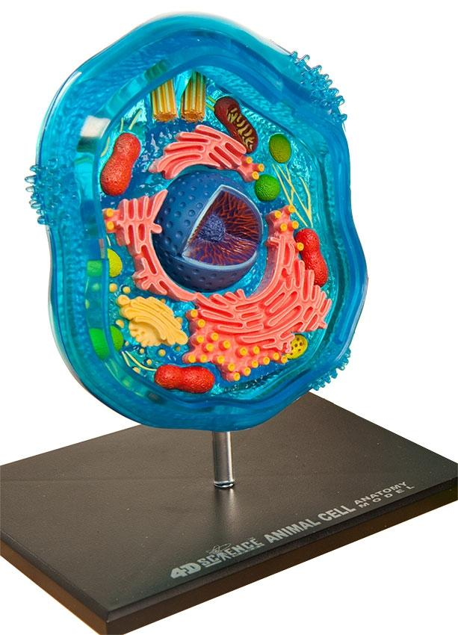

Day 1 - What is a Model?

**Part 1 - Investigate Ideas**

Directions: Your first task is to define what a model is and what it can be used for.

In your group, you will need to come up with a common standardized definition of a “model”.

Your definition should apply to the context of science and society.

Below are some guiding questions to aid your group in thinking about different aspects of models that you have used or heard of. Start here *before* you try to come up with a definition.

**Guiding questions:**

What do you think of when you hear the word model?

When have you used or interacted with a model?

Based on these experiences, what do you think it means to model something?

What is the purpose of modeling?

What forms can models take?

Write down your standardized definition and be ready to explain a rationale for your definition.

**Part 2 - Communicate and Share Findings**

You will share out your group’s definition with the rest of the class. You will also listen to what other groups have shared.

Write down anything that other groups shared that you didn’t think of yourself.

**Part 3 - Apply Your Knowledge**

What type of model might you build to represent each of following?

1. You have to communicate the structure of the solar system to first graders.

2. You have to communicate the structure of an atom to eighth graders.

3. You have to plan out the construction of an amusement park.

4. You have to model an idea.

5. You have to predict spending habits of your customers.

6. You have to convey the voter’s attitudes toward immigration.

7. You have to predict the motion of a pendulum at a given time.

8. You have to show the motion of a child on a swing.