# The Optimal Waffle Cone

**We need your help designing an optimal waffle cone for an extremely finicky friend. With your group, follow the instructions provided below.**

|  |
| --- |
| **Team Captain:** Keep all group members focused together. Encourage everyone to share ideas and listen to each other.  **Facilitator:** Make sure all group members understand each other’s ideas. “Could you explain that again?” “Did you understand what she said?” “Could you draw a picture of your idea?” “So what you’re saying is…”  **Materials manager:** Call me over for group questions. Make sure all materials stay in the middle of the table (scratch paper too). You may need compasses, rulers, tape, and construction paper, textbooks, . . . .  **Recorder/Reporter:** Keep track of ideas on scratch paper **in the middle of the table**. Prepare your group for a group quiz. The more methods you have to explain your ideas, the better. |

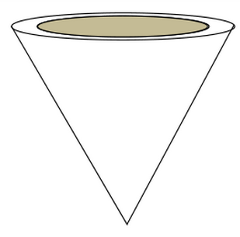*Nicole loves ice cream in a waffle cone, but she can never get the ice cream shop to make them the way she likes them. She wants a cone that holds* ***as much ice cream as possible****, with* ***no ice cream above the top of the cone****.*

*Yes, I know it sounds freakish, but* that’s *Nicole for you. She decided to buy a circular waffle iron that makes waffles 5 inches in diameter to make her own. After making the flat waffle, she cuts a radius of 2.5 in and twists it into a cone. She wants to know the ideal dimensions in order to fit the most ice cream in her cone. (Level to the top of course because it is Nicole, and well,* you know…)

There are several ways you can solve this problem. Spend the first 10 minutes brainstorming methods with your group members. Four brains are better than one. Make sure everyone gets to share ideas and ask questions. The only bad ideas are the ones not shared.

**Step 1** – **Make your plan:** Call me over to check your *plan* when you are ready. I will be looking for details –mathematical details. Will you use graphs? How will you calculate volumes? How will you know it is a max volume?

**Step 2** – **Group Quiz:** Call me over when you feel you have a *solution* that all your group members can explain. I will ask one person to explain for everyone in the group.

**Advanced Credit:** To learn even more, solve the same problem but assume the person ordering the ice cream is a normal person like you or me and would have a half-sphere of ice cream on top of the cone.

**Presentation:** You will create a mini-poster and a “waffle cone” to the dimensions you determine. The following elements need to be included in your poster: Equations for the volume of the ice cream cone with all variables defined. Dimensions of the cone (the actual numbers) that will hold the maximum volume with a clearly labeled drawing. A concise clear explanation for how you determined the volume. ***Graphs and equations*** of the relationship of volume as a function of cone height and/ or cone radius. There are multiple ways to do this. You will be graded on clarity and completeness of your graphs