**BUILDING AN ECOCOLUMN**

For this project, your group will attempt to create a self-sustaining micro-ecosystem.

The purposes of this project are:

* to better understand the challenges of sustainability;
* to model and observe ecological interactions;
* to communicate findings to a scientific audience;
* and to have fun!

This project begins with the construction of your eco-column and preparation for data collection.

**Choosing Partners and Naming Your World**

You will be working in a group on this project over the next several weeks. You must choose partners based on the following criteria:

* Every group must have either 3 or 4 members.
* All students in the class (including absent students) must be in a group.
* Every group member agrees to contribute an equitable amount of the physical and intellectual labor.
* **One group member will be the FACILITATOR and read the** **se instructions.**
* **One group member will be the RESOURCE MANAGER to get materials.**
* **One group member will be the TIMEKEEPER to keep the group on track.**

When you have selected your group members, write all your names here:

1._____________________________ 2._______________________________

3._____________________________ 4._______________________________

You should also consider what you would like to name your eco-column. Remember, you’re essentially designing a tiny world!

Our Eco-column shall be named:_________________________________________

**Part 1: A Whole New World**

**Student Materials**

2 clear 2-Liter soda bottles

Soda bottle cap with hole

Gravel

Soil

Terrestrial plants and/or seeds

String (about a 10 inches)

Scissors

Packing Tape

Masking tape

Index card

Water

**Teacher Materials**

Dechlorinating drops

Box cutter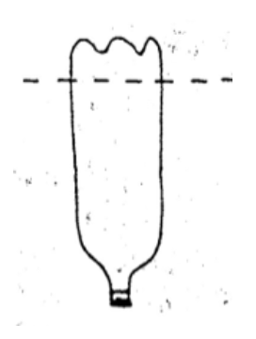

Aquatic plants (Elodea)

**Building the Terrestrial Chamber**

1. To build the terrestrial chamber, begin with a 2-Liter soda bottle.
2. Holding the bottle mouth down, **ask a teacher to start a cut** one inch below the bottom “shoulder” of the bottle using a box cutter (see right). Then use your scissors to cut around the top of the bottle. Set aside bottom. This will be the lid of your terrestrial chamber.
3. Wet your string thoroughly. Take your string and thread both ends through the hole in the cap of the bottle, forming a loop on one side. The loop should be on the “inner” side of the bottle.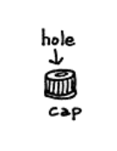

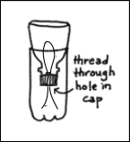

1. Obtain some gravel, about one cup. If the gravel has not been rinsed, wet the gravel before adding it to your terrestrial chamber. Make sure that the loop of string extends up above the gravel.
2. Add some soil, one to two cups. Make sure the loop of string extends up into the soil.
3. Dig a small hole to add your plant or seeds. (If you choose to use seeds, you can decide how many to add...however consider what the seeds need to survive and how that might affect your system!). Pack the soil in gently around the plant/seeds. Water the soil slightly to moisten.
4. **Have your teacher poke a hole with the box cutter.** Cut out a small “window” of plastic slightly below the upper rim of the chamber. Your “window” should be 1 inch by 1 inch. You will use this “window” to access the terrestrial chamber when collecting data with probes. Seal this “window” completely with MASKING TAPE.
5. Have one group member hold the terrestrial chamber upright until the aquatic chamber is complete.

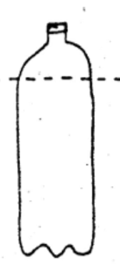

**Building the Aquatic Chamber**

1. To build the Aquatic Chamber, take one 2-Liter bottle.

1. **Ask a teacher to start a cut** just below the top “shoulder” of the bottle using a box cutter (see right). Then use your scissors to cut around the top of the bottle. Set aside top.
2. Obtain 1 to 2 cups of gravel. Rinse the gravel with tap water if it has not been rinsed yet. Add gravel to bottom portion of cut bottle.
3. Fill the water level so that the terrestrial tank sits above the water line and the water wick is partially submerged. Leave at least 2 inches of space between the top of the tank and the water.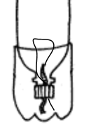
4. **Have a teacher poke a hole with the box cutter**. Cut out a small “window” of plastic slightly above the water line. Your “window” should be 1 inch by 1 inch. You will use this “window” to access the aquatic chamber when collecting data with probes. Seal this “window” completely with MASKING TAPE.
5. **Get an aquatic plant from the teacher.**  Add aquatic plant (Elodea) to add to your aquatic chamber. Record some qualitative observations about the Elodea here.

**7.**  **\*\*\*IMPORTANT\*\*\*\*** **Ask your teacher to add one to two drops** of dechlorinating solution to your aquatic chamber (you do not need more than this). If you forget to add these drops, your aquatic animals will die rapidly. Then, ask your teacher to add one to two drops of aquatic microbes. These drops will inoculate the aquatic chamber with bacteria that will help prevent your aquatic organisms from dying from excess nitrogen.

1. Invert and nest the terrestrial chamber inside the aquatic chamber. Check to see that the strings of the string loop are submerged into the top of the water.

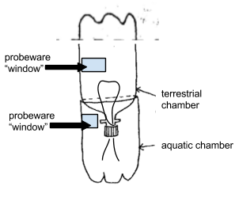

1. Tape the rim of the aquatic chamber to the terrestrial chamber for stability with PACKING TAPE. However, do not tape too tightly, as you will need to remove this tape and open up this chamber later on when we add animals.
2. Nest the cut bottom from the terrestrial chamber and use this to “cap” off the top of the terrestrial chamber. Tape the cap shut. However, do not tape too tightly, as you will need to remove this tape and open up this chamber later on when we add animals.

**Cleaning Up and Helping Out**

After you have completed construction of your eco-column, you will need to clean up your space. Be sure to do all of the following:

* sweep up any stray soil
* return communal tape and scissors to the stations
* recycle any plastic scraps
* help other groups or teachers clean up

**Labeling Your Ecocolumn**

You should also remember to **label your eco-column** by writing all group member’s first names on an index card and taping it to the side of your Ecocolumn.

The last step will be to safely set up your Ecocolumn, preferably near the window light, and out of danger of being knocked.

**Planning for the Future**

If you finish construction early, you should beginning planning for the next stages of design. In your project group, contemplate the following questions.

Later, we will add animals to our columns. What organisms might we want to add to our eco-column?

Given the resource limitations of this ecosystem (space, water, producers, prey, etc.), which organisms are more likely to survive in our eco-column? How many of each organism could survive?

What do you expect to be limiting factors in this ecosystem?

What do you think will pose the greatest challenge for sustaining this ecosystem?

What changes do you expect to observe in your Ecocolumn?