**My Graphing Story**

My graphing story can be seen in the video linked [here](https://docs.google.com/a/summitsanjose.org/file/d/0B4PDImQAvWVlZjllYTEzZTQtM2MyNi00NDA1LTlkMWYtMGNlMzZhNWQ0ZGI4/edit). I decided to look at the following variable as it relates to time: “The baseball’s distance from home plate, in feet.” It became clear that I would need to know some information about the dimensions of a baseball field before diving into my project. I found this visual useful:

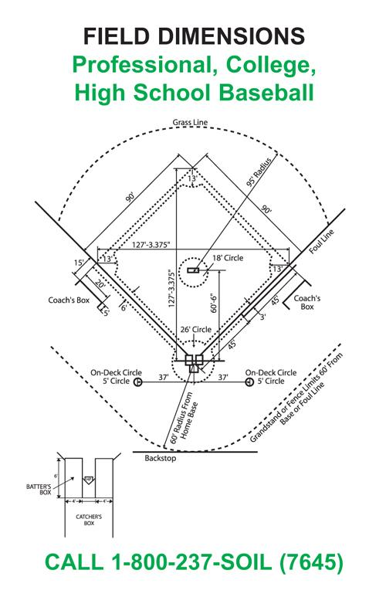

I began plotting my graphing story by identifying some key events that happen in the clip, their timing within the 15 seconds, and the ball’s approximate distance from home plate at that time, using the dimensions above to help me with calculations:

* At 2.2 seconds, the hitter tosses the baseball in the air (approx. distance: 7 feet)
* At 3.2 seconds, the hitter hits the ball (approx. distance: 10 feet)
* At 7.5 seconds, the outfielder (me) catches the ball (approx. distance: 180 feet)
* At 8.5 seconds, the outfielder throws the ball (approx. distance: 180 feet)
* At 10 seconds, the ball bounces in front of home plate (approx. distance: 30 feet)
* At 10.8 seconds, the catcher catches the ball (approx. distance: 5 feet)
* At 13.5 seconds, the catcher flips the ball back to the hitter (approx. distance: 5 feet)
* At 14.2 seconds, the hitter catches the ball (approx. distance: 12 feet)

I translated all of these data points into a table. In the table below, *t* represents time in seconds and *d* represents the ball’s distance from home plate in feet:

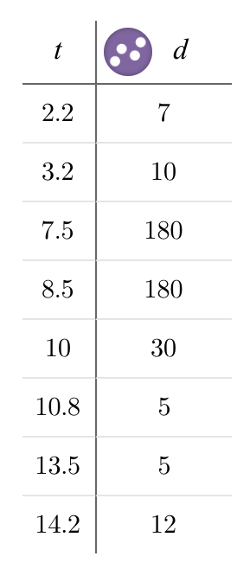

Then, I plotted all of these points onto a graph:

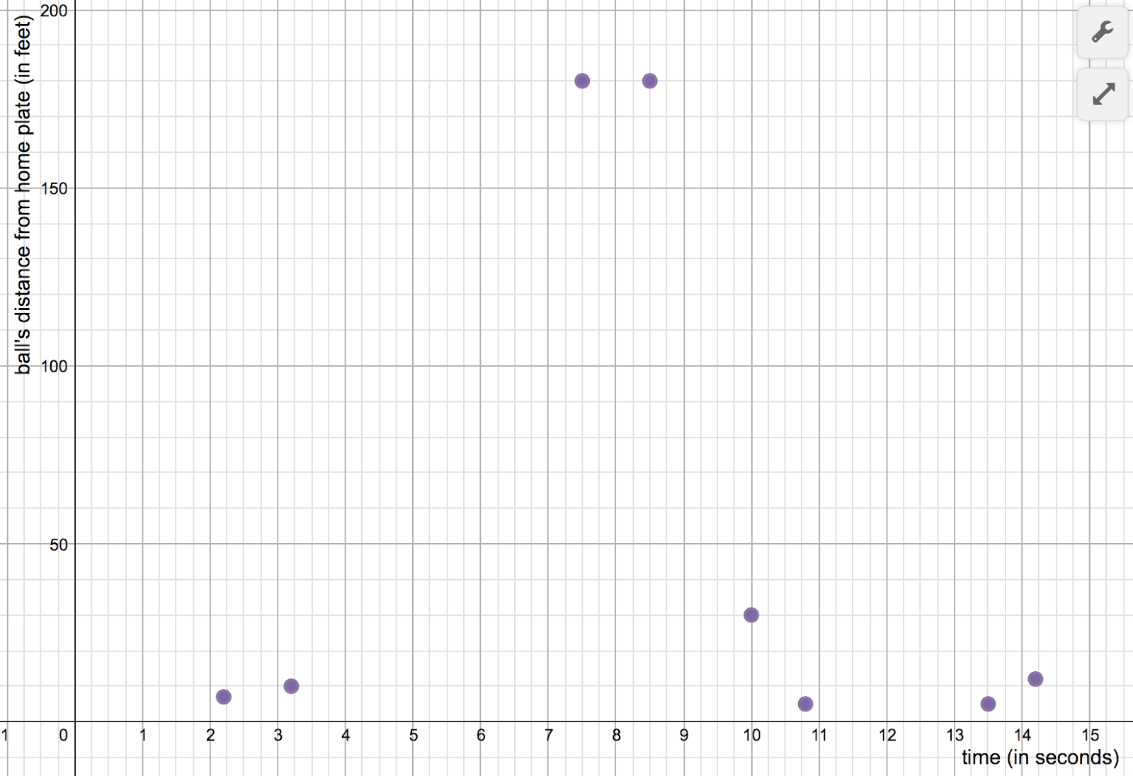

I knew that these points would be included in my graphing story, but there were still a lot of gaps. For my graphing story to be complete, I knew I needed to estimate where the baseball was at *every moment* in those 15 seconds. So I began filling in the gaps logically as best I could with the easier ones first:

* Between 0 and 2.2 seconds, the ball’s distance from home did not change much, so this part of the graph would be basically flat.
* Between 7.5 and 8.5 seconds, the outfielder is holding onto the ball and hasn’t thrown it yet, so again the ball’s distance from home did not change much, so this part is flat too.
* Between 10.8 and 13.5, the catcher is slowly walking away from home plate with the ball, so the ball’s distance from home would increase gradually. That means the graph would be increasing but with almost a flat slope.
* Between 14.2 and 15, the hitter is holding the ball and walking *towards* the plate, so he ball’s distance from home would gradually gradually. That means the graph would be decreasing but with almost a flat slope.

I updated the graph to include the additions above:

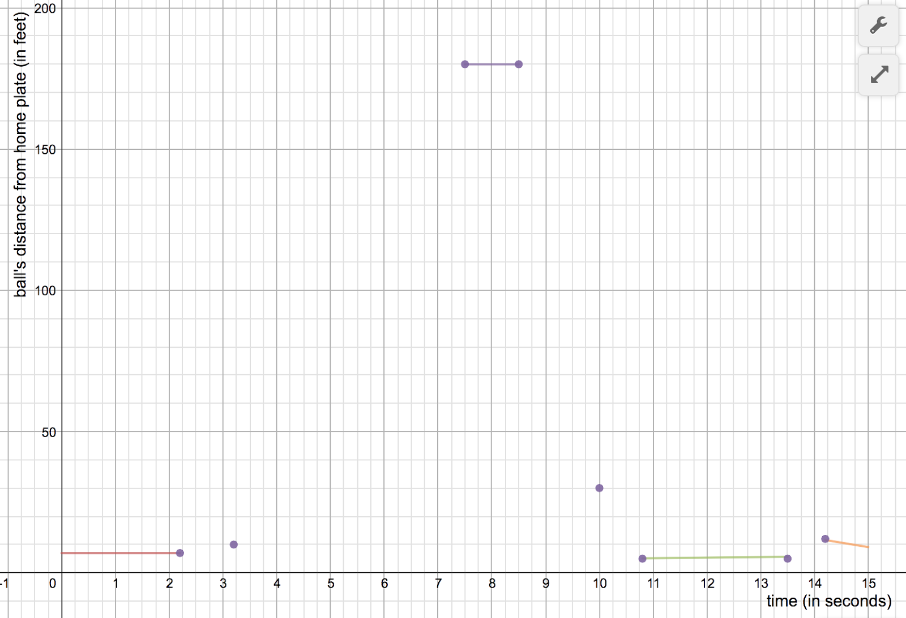

The next parts were tricky and probably a little less accurate, since they all involved a ball that was moving through the air. In connecting the rest of the dots, I did my best to approximate the ball’s distance from home plate as it flew through the air. I updated my graph like so:

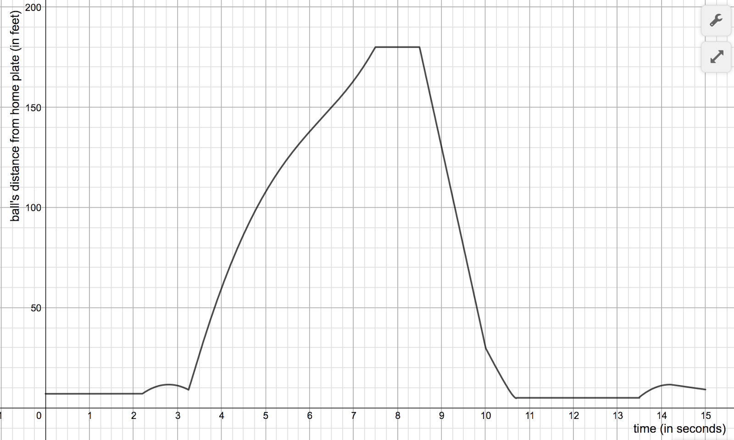

Though the graph above is a precise representation of the ball’s distance from home in the video clip, there are still places where the precision is not perfect. Here are some of the sources of error that I identified, and what I did to account for those sources of error:

* The video I used is on YouTube, which only lists *whole* seconds, not parts of seconds. This made it difficult to pinpoint exactly where crucial moments took place.
* To account for this, I scrolled through the YouTube video very slowly and did my best to estimate the time. In many cases where there wasn’t a clear second-change, I rounded to the nearest .5. In a couple cases, I used my best guess to estimate.
* When the ball is hit (between 3.3 seconds and 7 seconds) the ball goes off the screen, which made it difficult to track its distance to home plate.
* To account for this, I used the point of contact and my estimate for its landing to spot to help me fill in the ball’s possible flight. I used my knowledge of projectiles and quadratic functions to increase the precision.
* Throughout the video, the quality and angle of the video makes it difficult to pinpoint the ball on the field.
* I made estimations at times when I wasn’t sure of the ball’s location, using clues from the field. For instance, I estimated that the ball was caught about 180 feet away, since it looked to be about 10 feet beyond the grass line. The ball’s bounce takes place about halfway between the pitcher’s mound and home plate, so I estimated its distance to be 30 feet.