# Group Names:

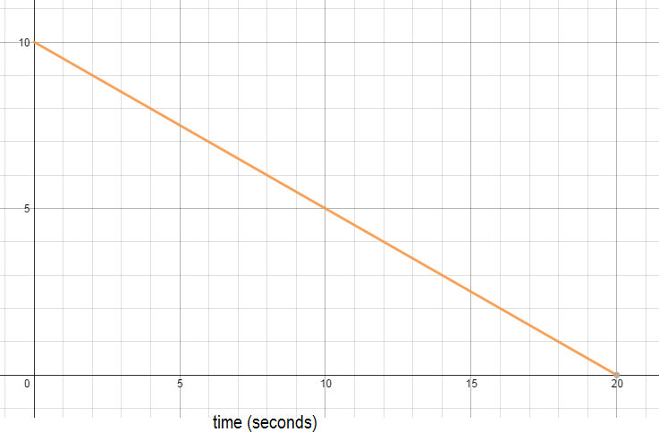**Graph #1**

What situation(s) could this graph represent? Prepare a 1-minute skit to illustrate this graph.

# Graph #2

**Time (seconds)**

What situation(s) could this graph represent? Prepare a 1-minute skit to illustrate this graph.

# Graph #3

# 

What situation(s) could this graph represent? Prepare a 1-minute skit to illustrate this graph.