**Name:**

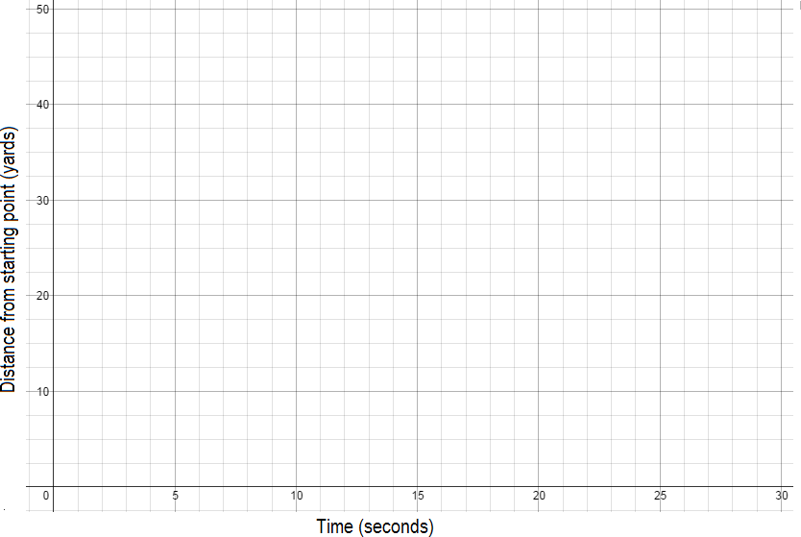The Speedwalker

The Which Way?

The Drop and Give Me

