Making Revisions

**Revision to "Introduction"**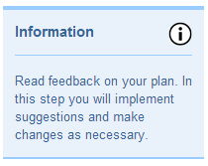

* Make sure your populations are ones you can study with the sample you have access to (the students at your school and the data you collected through polling). You must determine if your data from the students at your school can be generalized to students in all grades, at other schools, cities, states, etc. This will be your population (revise if necessary). Take your quantitative variable into consideration here. If you need to change your population, please do so in this step. Justify your population in connection to your variable of study.

**Revision to "Methods"**

* 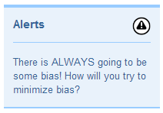**Discuss bias in your sampling method**. What types of error do you expect based on your sampling method? Do you expect your sample to truly represent your population? If not, redesign your random sampling method.
* 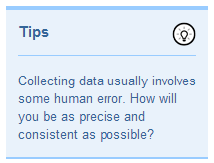**Discuss bias in your data collection method**. What errors do you expect if you collect data as planned? Before continuing, how can you limit the bias in your data due to error that is within your control? How can you word your question in the least biased way possible? Redesign your data collection plan if necessary.
* Use the student list provided by your teacher to actually **determine your random sample from the school**. Type your sample into your appendix.
  + It is recommended that you make a Google Spreadsheet to keep track of the data for your own question and the variable that you will be analyzing.
* Make a plan to collect data. Write down **all steps** you will use to collect data so that ensure that all group members know exactly what data they should collect from whom, when they will do it, and how they will record it. Make sure there is a common practice of recording data and that all group members have access to everything collected.