How To: Write a Topic Sentence/Claim

Every paragraph that you write will start with: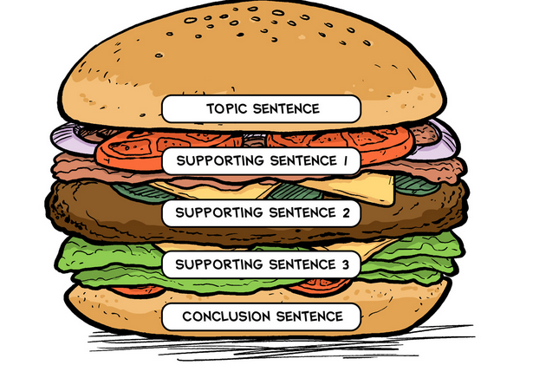

**a topic sentence** a.k.a. **a claim** a.k.a. **a thesis**

This is the main argument of your writing and it always has to have an opinion.

A good claim needs the following:

* **A clear position**
* **Uses the language of the prompt**
* **Presents an argument; has a “because”**

1. **A clear position** - This means that your claim needs to take a stand - it has to be an opinion, not a fact. If someone asks you, “Do you like ice cream?” you probably wouldn’t say “Yes and no.” You would say “Yes, I love ice cream” or “No, ice cream is the most disgusting thing on the planet. The same thing applies to claims - TAKE A STAND.
   1. Which of the following claims takes a clear position on an opinion?
      1. Shakespeare is a writer from the 16th century.
      2. English is the most exciting class offered at Summit.
2. **Uses the language of the prompt** - This means that you are taking the words that are used in the prompt question and flipping them around to use them in your response. For example, if someone asked you “Do you like ice cream?” you would respond “Yes, I like ice cream.” There, you used the words of the question in your response. This helps you make your topic sentence or claim really clear and it also ensures that you are using academic and advanced language.
   1. Example prompt 1: How is Richard Wright influenced by his environment?
      1. Richard Wright is influenced by his environment because he becomes jaded about race relations and racial equality in the American South.
   2. Example prompt 2: What is the primary theme in the novel, *Black Boy?* 
      1. The primary theme in the novel, *Black Boy,* is that a person’s environment determines their success in life.
3. **Presents an argument; has a “because”** - This means that you not only present your clear position or opinion on a topic, but your also support it with an argument. Sometimes, your teacher may allow you to do this in other parts of the essay, but generally, it should be in your topic sentence. For example, instead of just saying “I like ice cream,” you might say “I like ice cream because it is extremely nutritious.”
   1. Which of the following claims presents an argument?
      1. Richard Wright was influenced greatly by his environment.
      2. Richard Wright was influenced greatly by his environment because it changed the way that he viewed whites and white social structures in the South.

*For the most part, a claim/topic sentence should be one sentence (especially if it is for a paragraph). However, once you start writing longer essays, your thesis might expand to two or three sentences.