**Tragedy of Freedom in a Commons – Garrett Hardin**

*Adapted from* <http://www.garretthardinsociety.org/articles/art_tragedy_of_the_commons.html> *by Mr. Hayes*

Picture a public field, owned by no one which has cows owned by 5 different farmers. It is to be expected that each farmer will try to keep as many of their cattle as possible on the \**commons*. Such an arrangement may work reasonably well as long as the number of cattle remains below the \**carrying capacity* of the field. When the carrying capacity is reached, the tragedy of the commons occurs.

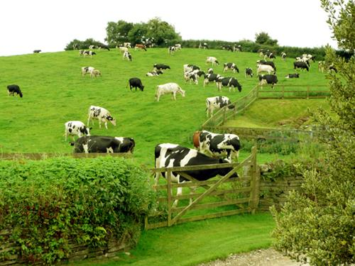

Each farmer wants to maximize their profit, (in other words, they want to make as much money as they can) and they ask themselves, "What is the value *to me* of adding one more cow to my herd?" This has costs and benefits.

1. Since the farmer receives all the profit from the sale of one animal, the positive value is nearly +1.
2. Since all the farmers share the effects of overgrazing, the negative value for any particular decision-making farmer is less than -1.

The rational farmer concludes that the smartest course for the farmer to pursue is to add another animal to the herd. And another; and another.... But this is the conclusion reached by each and every \**rational* farmer sharing the field. **That is the tragedy.** Each farmer is locked into a system that encourages them to increase his herd without limit–in a world that is limited. Each farmer pursues their own best interest in a society that believes in the \**freedom of the commons*. Freedom in a commons brings ruin to all.

Cattlemen using national land demonstrate no more than a simple understanding of the tragedy of the commons, in constantly pressuring federal authorities to increase the number of cattle until overgrazing produces erosion.

The ocean suffers from the tragedy of the commons. Claiming to believe in "the inexhaustible resources of the oceans," fishermen bring species after species of fish closer to extinction.

The National Parks present another example of the tragedy of the commons. At present, they are open to the public. The parks are limited in extent–there is only one Yosemite Valley–whereas population continues to grow. (There is only one Yosemite, but there are more and more people who want to visit it. the more people who visit, the quicker the resources are used. )

What shall we do? We have several options. We might sell the National Parks off as private property. We might keep them as public property, but restrict the number of people who can visit them. The restrictions might be on the basis of wealth. It might be on the basis of merit. It might be by lottery. Or it might be on a first-come, first-served basis. These, I think, are all the reasonable possibilities. They are all objectionable. But we must choose.

<http://www.youtube.com/watch?v=MLirNeu-A8I>

*\*Commons: A public place or resource*

\**Carrying capacity: the number of people, cows or crops or other living organisms, that an area can support without environmental degradation.*

\**freedom of the commons*: *allowing anyone to use public places*

*______________________________________________________________________*

***IN SUMMARY:***People put their cows on a public field. They know their cows will damage the field by eating the grass. They don’t own the field, so they don’t have to pay for the damage. When they sell their cows, they get all the money. **This means each farmer benefits from damaging the land.** Each farmer knows that eventually the field will be too damaged to use, because of all the other farmers with their cows. So each farmer puts as many cows on the land as possible, as quickly as possible, so that they can make money before the land is destroyed by everyone else.

If the farmers worked together, they could decide how many cows each of them could put on the land, so that the land could last longer.

If one of them owned the land, they would benefit from taking care of the land, and could tell the other farmers what to do.

This happens to all kinds of resources: land, water, air, etc.

**Resources are limited, so we need to find ways to limit access to them so that they last longer.**