Know Your Technology!

*Now that we have learned more about these tools, let’s reflect about the potential of each tech tool and how it might be helpful in other contexts.*

# Google Spreadsheets

Additional Resources/ Links to Resources Used in class: [Spreadsheet of sample data](http://tinyurl.com/RiederEating) (make a copy so that you can edit and add formulas as needed)

[Sample data for spreadsheet practice](https://docs.google.com/a/summitps.org/document/d/1DCAmCM147G87xeGSMKN5DXzBRhEmPokRZNH4ksng2f4/edit?usp=sharing) (Handout used in class) [Google Spreadsheets Tutorials](http://tinyurl.com/GSpreadsheetsVids) (linked on the Handout) [Mr. Miller’s Phone Bill (extra data for you to practice with)](https://docs.google.com/spreadsheets/d/1ZCvjTEZF7u-3wMwdeWL_Z30Dtsz5IEZ1xXm4BZzH81o/edit?usp=sharing)

## Google Spreadsheets Technology Reflection

**Individual Task:** Reflect on how you have used this tool today.

|  |
| --- |
| What did you learn to do with Google Spreadsheets today? |
| In what ways was using this tool better than using tools you already knew how to use (like, pencil and paper, or a calculator, or maybe your head)? |
| How do you think this tool will be useful for you in this project, in future projects, and beyond high school? |

# Piktochart

Additional Resources/ Links to Resources Used in class:

[Can’t find your spreadsheet of sample data?](http://tinyurl.com/RiederEating) **(make a copy so that you can edit and add formulas as needed)**

[**Piktochart Tech Slides**](https://docs.google.com/presentation/d/1tV1MEwCl5vedaptS_1WSwK2_DurJRAJAFca13gseY3E/edit?usp=sharing) **(It’s all in the slides!!)**

## Piktochart Technology Reflection

**Individual Task:** Reflect on how you have used this tool today.

|  |
| --- |
| What did you learn to do with Piktochart today? |
| In what ways was using this tool better than using tools you already knew how to use? |
| How do you think this tool will be useful for you in this project, in future projects, and beyond high school? |

Paste in the infographic you created today. I want to see what you know how to do!

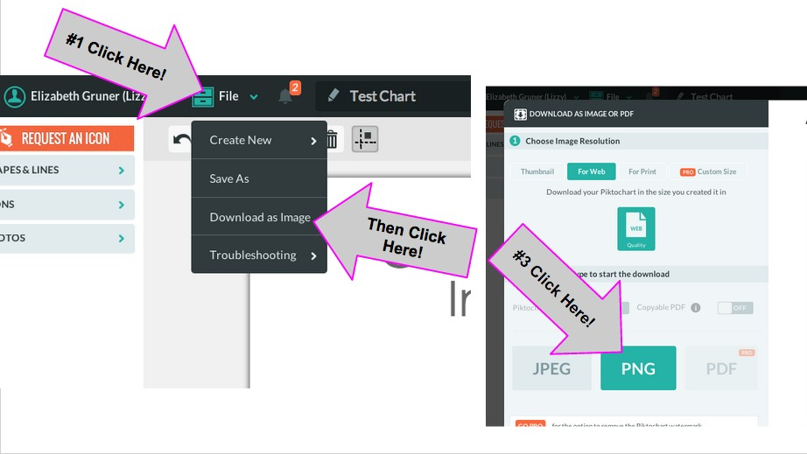**How to download a PNG of your Infographic.**

**Then, upload to this doc by clicking Insert → Image**