**Biodiesel Introduction**

In 2011 Rodolfo Rada took a very long road trip, from Alaska down to his homeland: Patagonia, Chile. This was an impressive road trip by itself, but what made it more impressive was that Rodolfo was driving a car that ran entirely on used vegetable oil from fast food restaurants! Rodolfo used his trip as an opportunity to speak to people and showcase his car (named “Laura Reciclado”, or “Recycled Laura”) to show everyone how biodiesel technology worked. In this project you will explore the idea of sustainable fuels such as biodiesel, synthesize it, and market it. Is biodiesel better than competing fuels such as gasoline, diesel, and ethanol?

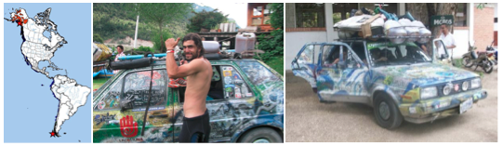

**Background Reading: Different Fuels**

**Gasoline**

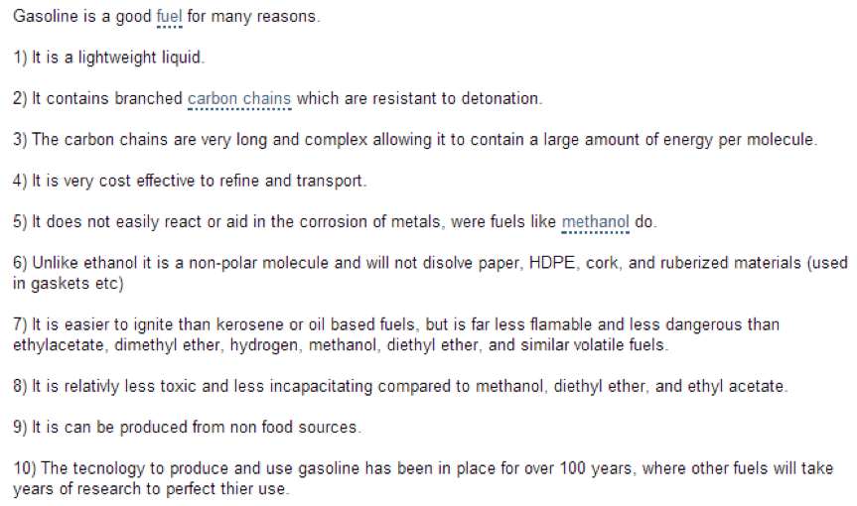

Drawbacks to gasoline:

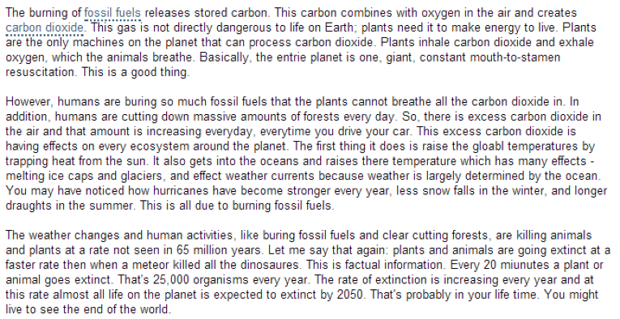

**Diesel**

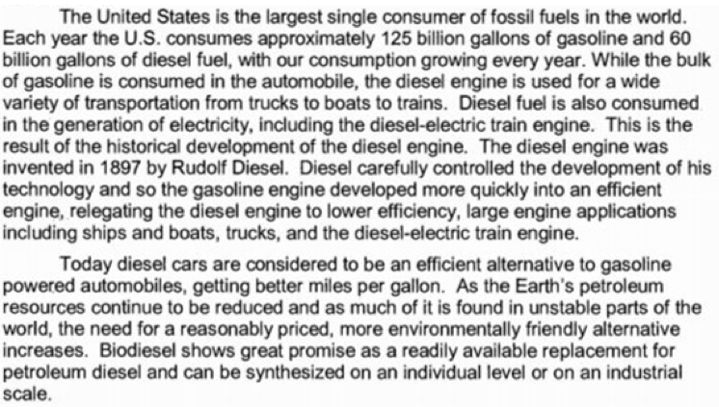

**Ethanol**

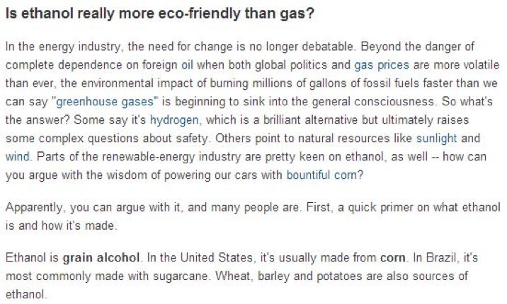

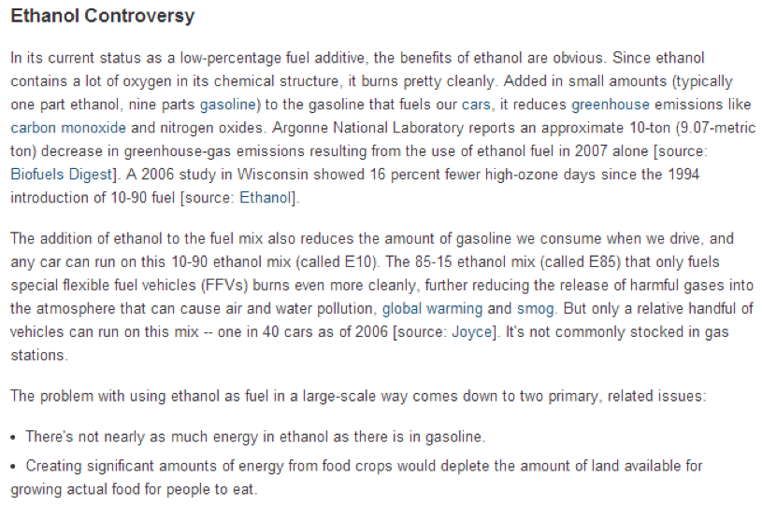**Biodiesel**

