**Subject area/course**: Mathematics/Algebra I   
**Grade level/band**: 9-­‐12

**Task source**: Stanford Center for Assessment, Learning, and Equity (SCALE)

**Heating Degree Days**

# STUDENT INSTRUCTIONS

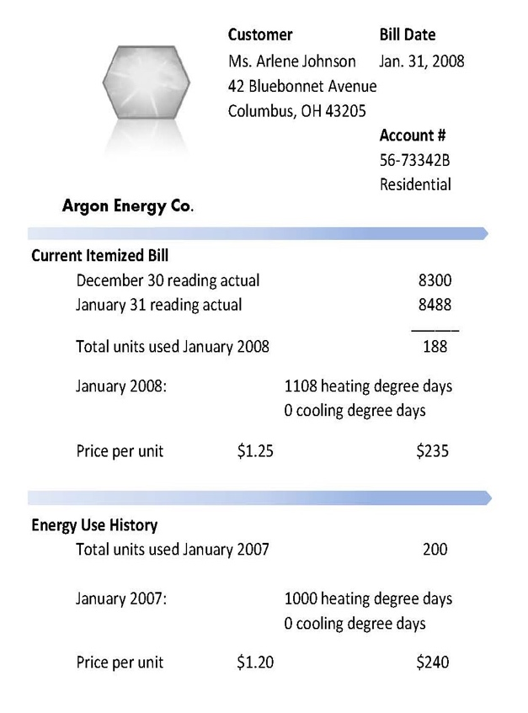

# Task context:

The Johnson family is concerned about the high cost of heating their house during the winter. In an attempt to use less energy and to save money, they hired a contractor to add insulation and sealing around the windows of their house. In this task, you will help the Johnsons determine the cost-­‐ effectiveness of new insulation and sealing for their home, based on the information provided.

To improve the energy efficiency of their house, the Johnson family hired a contractor who installed new insulation and sealed some of their windows. The contractor charged $600 for this work and told Ms. Johnson that her gas bill would go down by "at least 10 percent”.

The Johnson's gas bill in January 2007 was

$240. When Ms. Johnson received the bill for January 2008, she was surprised that the new bill was $235. She called the contractor

because she expected her bill to be 10% less. The contractor told her that January 2008 had been a very cold month and that the gas rates had gone up from last year. The contractor said her bill was probably at least 10% less than it would have been without the new insulation and window sealing.

Ms. Johnson wasn't sure she had saved as much as she had been promised so she decided to review her gas bill. She compared her gas bills and created the table below.

|  |  |  |  |  |
| --- | --- | --- | --- | --- |
| Date | Total Units Used | Heating Degree Days | Price per unit | Total Costs |
| January 2007 |  |  |  |  |
| January 2008 |  |  |  |  |

# Final product:

Prepare an individual written report to the Johnsons of your assessment of the cost-­‐ effectiveness of their new insulation and window sealing. In your report, you must do the following:

* 1. Explain “heating degree days” in your own words so that Ms. Johnson can understand. Refer to the websites given to give you more information. Or you may consult other sources. Be sure to cite your sources.
  2. Help Ms. Johnson fill in the values for the table she created using the gas bill and any other information provided.
  3. The contractor told Ms. Johnson that January 2008 on average was colder than January 2007. Explain whether you agree or disagree with the contractor’s claim using evidence from the data table.

1. Compare Ms. Johnson’s gas bills (January 2007 and 2008), estimate her savings from the new insulation and sealing, and explain your reasoning.
2. Decide whether the insulation and sealing work on the Johnson’s house was cost-­‐ effective by determining the actual percent she saved and comparing it to the promised 10% savings. Provide evidence for your decision.
3. Calculate how long will it take Ms. Johnson to break even on her investment of

$600?

# ADDITIONAL INFORMATION

1. **Knowledge and skills you will need to demonstrate on this task:**

* How to organize data for analysis
* How to construct and compare rates
* How to distinguish between actual costs versus predicted costs
* How to interpret the results to decide if the investment was cost effective

# Materials needed:

* Calculator
* Access to the Internet
* Heating and Cooling Degree Days -­‐ Definitions and Data Sources:
  + Definition and discussion  
    <http://en.wikipedia.org/wiki/Heating_degree_day>
  + Standard for HDDs and CDDs -­‐ <http://www.weather2000.com/dd_glossary.html>
  + National Climatic Data Center -­‐ <http://www.ncdc.noaa.gov/oa/documentlibrary/hcs/hcs.html>

# Time requirements:

Your teacher will provide the timeline and due dates for completing each portion of the task.

# Scoring:

Your work will be scored using the Math Performance Assessment Rubric, Grades 9-­‐12. You should make sure you are familiar with the language that describes the expectations for proficient performance.