By the end of today, you’re in very good shape if you have accomplished the following six things. As you finish each, you should come up to your teacher to get it checked and signed off!
Described the problem in your own words, and identified which two designs you will be working on. | Figured out what it means to find the most efficient design for each of the two types of products.
Tried out many different possible designs for your rectangular-based dish and recorded your trials on the table provided. | Tried out many different possible designs for your square base dish and recorded your trials on the table provided.
Generalized your trials into an equation for the rectangular-based dish that models the quantity you want to optimize. | Generalized your trials into an equation for the square base dish that models the quantity you want to optimize.

Context/Background of Problem – Which Designs Are You Responsible For?

SIGN OFF:

What Does It Mean To Find The Most Efficient Design?

SIGN OFF:
Table to record Rectangular Dish Prototype Dimensions:

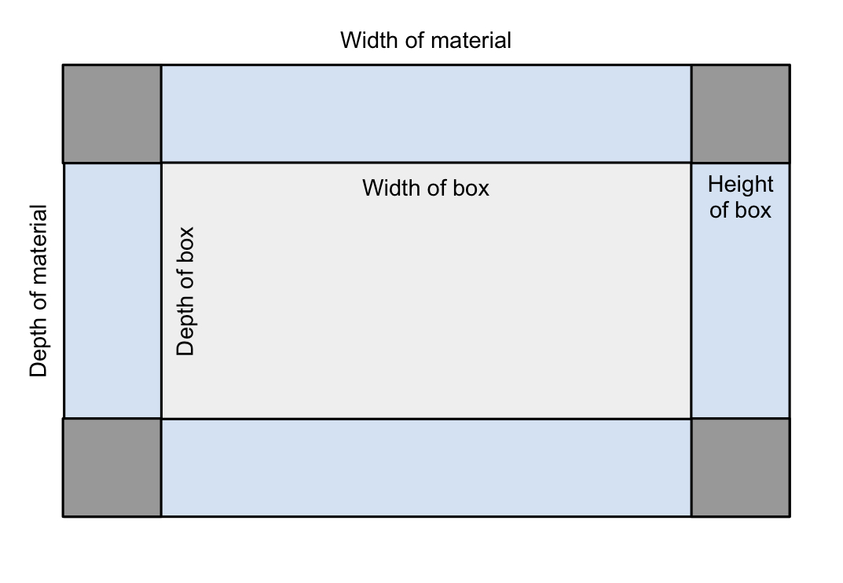 |  | 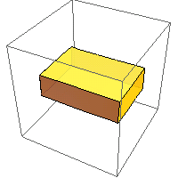

Depth of Material | Width of Material | Depth of Box | Width of Box | Height of Box | Volume of Box | Area of Material

SIGN OFF:
Table to record Square Dish Prototype Dimensions (This portion is more difficult):

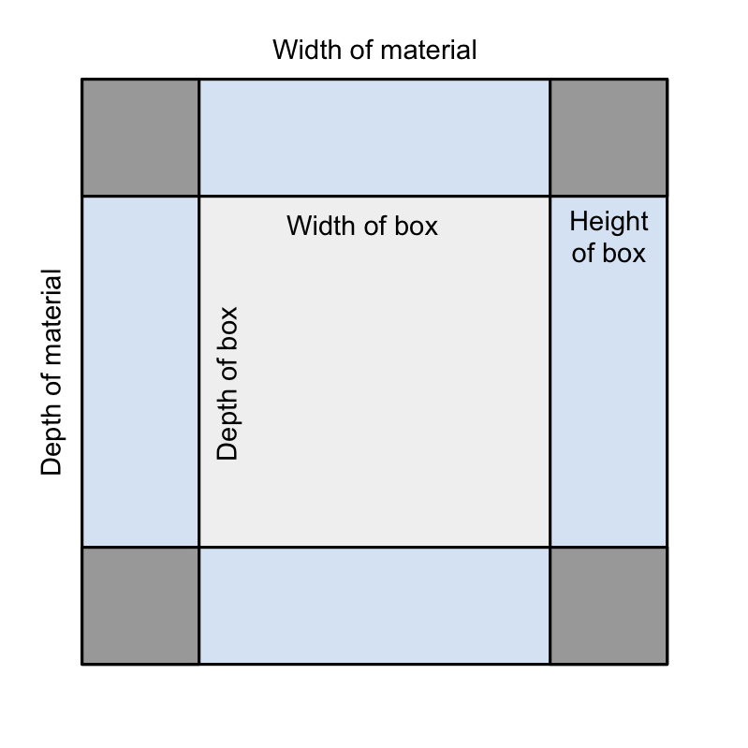 |  | 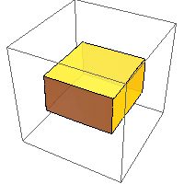

Depth of Material | Width of Material | Depth of Box | Width of Box | Height of Box | Volume of Box | Area of Material

SIGN OFF:
Finding A Generalized Equation For Rectangular Base Dish

SIGN OFF:

Finding A Generalized Equation For Square Base Dish:

SIGN OFF:

