**ALGEBRA 2 - COOLING PROJECT**

tinyurl.com/coolingproject

|  |  |
| --- | --- |
| **Part 1: Pre-Work – Analysis of Graphs** | **Cognitive Skill: None** |

|  |  |
| --- | --- |
| 1. Write an equation that represents the graph below.    Equation: | 2. Why does this graph not represent the speed of a car on a road trip? *There is more than one reason!*    Response: |

|  |  |
| --- | --- |
| **Part 2: Watch the Joulies sales pitch** | **Cognitive Skill: Precision and Accuracy** |
| **Driving Questions: Do you think Joulies will work as advertised? How could we set up an experiment to test your hypothesis?** |  |

Watch the sales pitch for Joulies (video in Show Evidence). Write your initial reactions:

1. What do you think of this product?

2. Do you think it’s possible? Do you think it works? Why or why not?

3. How could we set up an experiment to test your answer?

Write the names of all your group members:

I. Question

* We will investigate the relationship between:
* The question we will try to answer is:

II. Variables

* Our independent variable – we will change:
* Our dependent variable – we will measure:
* Our control variable(s) – we will keep these the same:

III. Materials

* These materials are available to you: temperature probes, cups, teabags, potatoes, water, water heater, microwave, stopwatches, kool aid, jello mix. You may choose to use some or all of them. Additional material requests must be approved by the teacher before moving on.
* List the materials AND number of materials that YOUR GROUP will be using:
  + - * Example: 1 temperature probe, 2 cups, etc.

IV. Experimental Setup

Draw a picture of how you will set up your experiment.

* Include the placement of the multimeter (or temperature probe)
* Put an arrow ( --->) next to the thing you will be changing (your independent variable)

V. Procedure

* Write a procedure for the steps you will follow during your experiment. Be specific! *Recommendation: Record temperature every 5 minutes for 40 minutes (include this step in your procedure)*

*Step 0:* Collect all necessary supplies for our experiment.

*Step 1:*

*Step 2:*

*Step 3:*

*Step 4:*

*Step 5:*

*Step 6:*

**\*\*\*\*\*\*\*\*\*\*\*\*\*\*\*STOP - Your plan must be approved by a teacher before moving to Part 3\*\*\*\*\*\*\*\*\*\*\*\*\*\*\*\*\*\*\***

|  |  |
| --- | --- |
| **Part 3: What should we expect?** | **Cognitive Skill: Data/Info Analysis – Modeling**  ***Make a function that models a real-life situation*** |
| **Driving Question: What kind of data would you expect in a hot drink with or without Joulies?** |  |

1. What would graphs of temperature v. time look like if Joulies work? Make a graph for a drink **with** Joulies and **without** Joulies (create your graphs on Desmos, take screenshots, and paste it into this document). Assume the initial temperature is 160 degrees Fahrenheit.

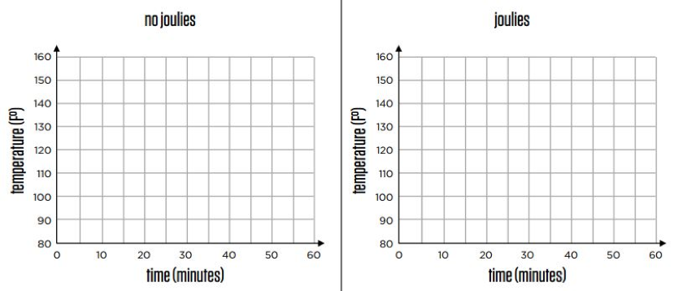2. What assumptions have you made?

3. Watch the video of a regular cup of tea sitting in a room for 60 minutes...Now that you've seen the temperature graph of a regular glass of tea, revise your Joulies graph.

4. If Joulies worked perfectly as advertised, what would the temperature graph look like?

5. Create a function equation that models the regular cup of tea. Then create a function that models a cup of tea WITH Joulies if Joulies worked perfectly as advertised. (Your function equation does not need to be perfectly accurate but it should be an educated guess.)

|  |  |
| --- | --- |
| **Part 4: Your experiment** | **Cognitive Skill: Data/Info Analysis – Modeling**  ***Interpret and analyze the cooling of an object as a function of time*** |
| **Driving Question: You will select an object and, as the object cools, model its temperature as a function of time. Based on your function and model, what is your interpretation and analysis of the cooling of your object.** |  |

Select an object and, as the object cools, model its temperature as a function of time. Use the function in order to interpret and analyze the cooling of your object.

Our independent variable was:

Our dependent variable was:

DATA TABLE

|  |  |
| --- | --- |
|  |  |
| 0 |  |
| 5 |  |
| 10 |  |
| 15 |  |
| 20 |  |
| 25 |  |
| 30 |  |
| 35 |  |
| 40 |  |

GRAPH - Take a screenshot of your graph on Desmos, then paste it into this document. Label all axes.



EQUATION

DATA ANALYSIS

Using evidence from your graph, table, and equation, analyze the cooling of your object as a function of time. In your analysis, respond to the following questions/statements:

***Basic analysis (Level 4):*** *When the independent variable increases, the dependent variable...When the independent variable decreases, the dependent variable...What function family (e.g. linear, quadratic, square root, exponential) does your graph look like?* *Describe your graph’s slope. Is it positive or negative; is it constant or does it change? Describe the relationship between your independent and dependent variables.*

***Advanced analysis (Level 5 and 6):*** *In addition to responding to all the questions in the “basic analysis,” you must also respond to these questions: What are the salient aspects? What are the models? How does your models highlight the salient aspects?* This response should be 2-3 paragraphs in length.

|  |  |
| --- | --- |
| **Part 5: What do others say?** | **Cognitive Skill: Precision and Accuracy**  ***Evaluate the precision and accuracy of someone else’s model*** |
| **Driving Question: What is your evaluation of the data and analysis of your peer’s experiment?** |  |

Exchange your data and analysis with another student. Read through their experiment and data analysis. **Do you agree with their data analysis and model functions? Explain why or why not.**

SUMMARY of a peer’s data and analysis:

EVALUATION of your peer’s data and analysis:

|  |  |
| --- | --- |
| **Part 6: Drinks with Joulies** | **Cognitive Skill: None** |
| **Driving Question: What are your initial reactions after watching the video that shows tea WITH Joulies?** |  |

As a whole class, watch video of temperature of tea WITH Joulies.

|  |  |
| --- | --- |
| **Part 7: Do Joulies work?** | **Cognitive Skill: Writing – Evidence Development**  ***Support your claim using data, graphs, and analysis*** |
| **Driving Question: What is your claim about the cooling of your object, after having conducted your experiment? Support your claim using your data, graphs, and analysis.** |  |

**Watch the video of the cup of tea with Joulies (and reference the still image below). Based on the evidence and your calculations, assess the validity of Joulies’ sales pitch in 2-3 paragraphs.**

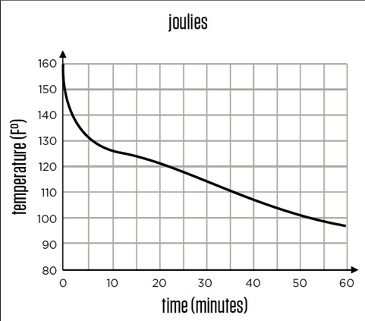

(more space to assess the validity of the Joulies’ sales pitch)