

**Attachment 1**. **Obtaining Regional Daily Temperature Data**

*Note for Task Component A, students are to* ***use actual high/low temperatures****, not daily averages. Archived temperature data may be accessed from the National Weather Service Office serving a region. Once at the regional office website, archived data may be accessed at the National Weather Service by clicking the following tabs:*

* *Climate-Local (on left side),*
* *Observed weather, select the product: preliminary monthly climate data*
* *Select location (example is from Reagan National Airport),*
* *Choose archived data and select a month (example below is from March 2003)*
* *Select go.*

*An example Preliminary Local Climatological Data report from the National Weather Service for Washington D.C., March, 2003 is shown below. The first column is the day of the month, the second column is the high temperature for the day (max) and the third column is the low temperature for the day (min). Temperatures are given in degrees Fahrenheit (°F).*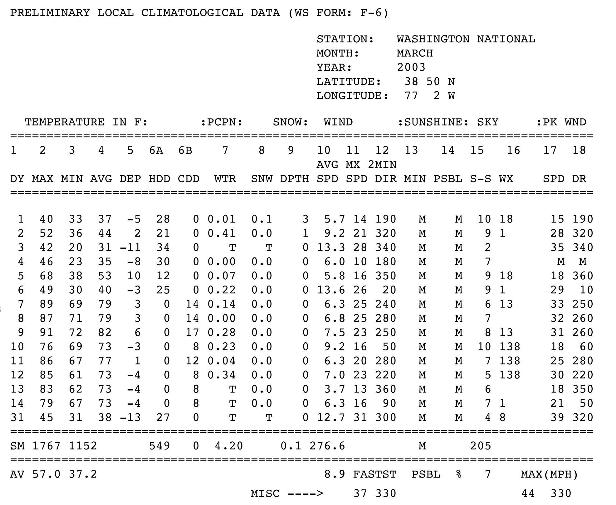

*(National Weather Service;* [*http://www.nws.noaa.gov/climate/f6.php?wfo=lwx*](http://www.nws.noaa.gov/climate/f6.php?wfo=lwx)*- Web page accessed 11-27-2013)*

*Climate data obtained from the NOAA website are rewritten in the table below as a sample data set in a form that could be given to students.*

**Climate Data for Washington, D.C., a Hypothetical School Location**

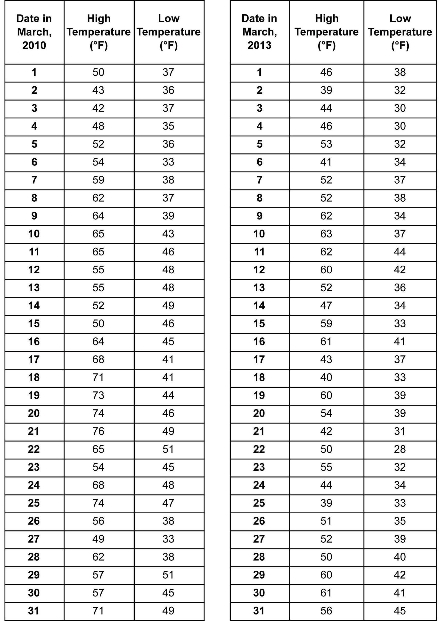

*Teachers: You will need to choose the month and the years, as well as compile the data in a chart for the students. Choose data from a year with higher than average temperatures for the month and from a year with average (or lower) temperatures. The data can be from whichever month you choose, as long as it is the same month for each year. This example shows March 2013, an average to below average year for Washington, D.C., and March 2010, an above average year.*

**Attachment 2. Obtaining Regional Monthly Climatological Data**

*From the Weather Channel’s home page (http://www.weather.com):*

1. *Search for your city.*
2. *Select the monthly tab on the left.*
3. *Select the averages tab below the calendar.*
4. *You can select data in either Fahrenheit or Celsius, table or graph form.*

*Note: There may be advertisements that some might find objectionable at this website, so it might be necessary to provide the students with the data already formatted in a table like the one below.*

**Sample Average Monthly   
Temperature Data   
from Washington, D.C.**

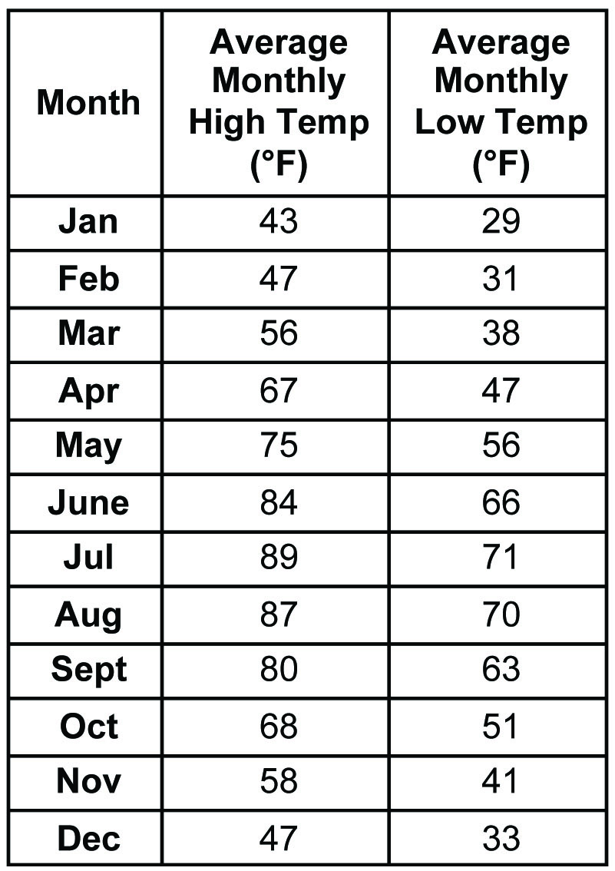

*Source: http://www.weather.com/weather/wxclimatology/monthly/DCA:9 accessed 11-27-2013.*

**Attachment 3. Daily Temperature Graph**

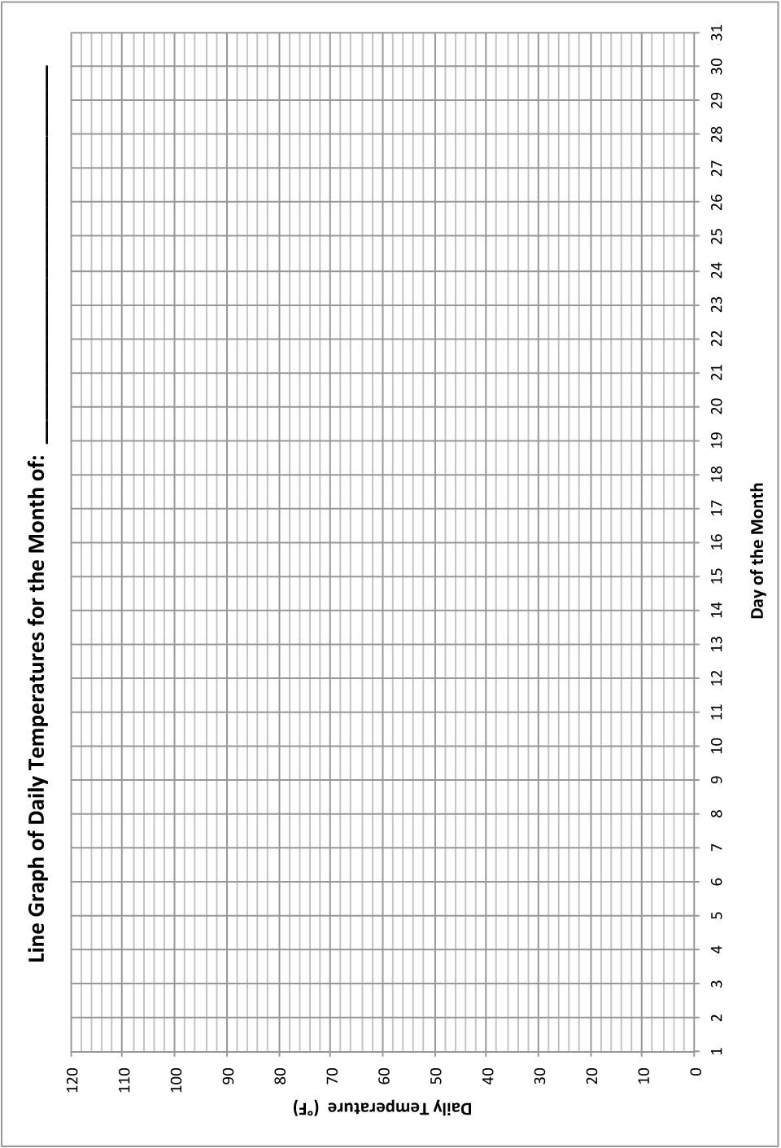*Note: Teachers may choose to have their students design their own plots rather than be given the plot below.*

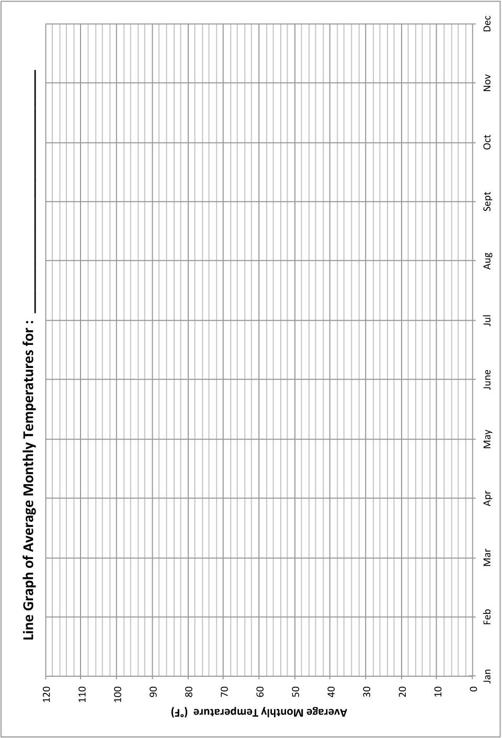**Attachment 4. Average Monthly Temperature Graph***Note: Teachers may choose to have their students design their own plots rather than be given the plot below.*

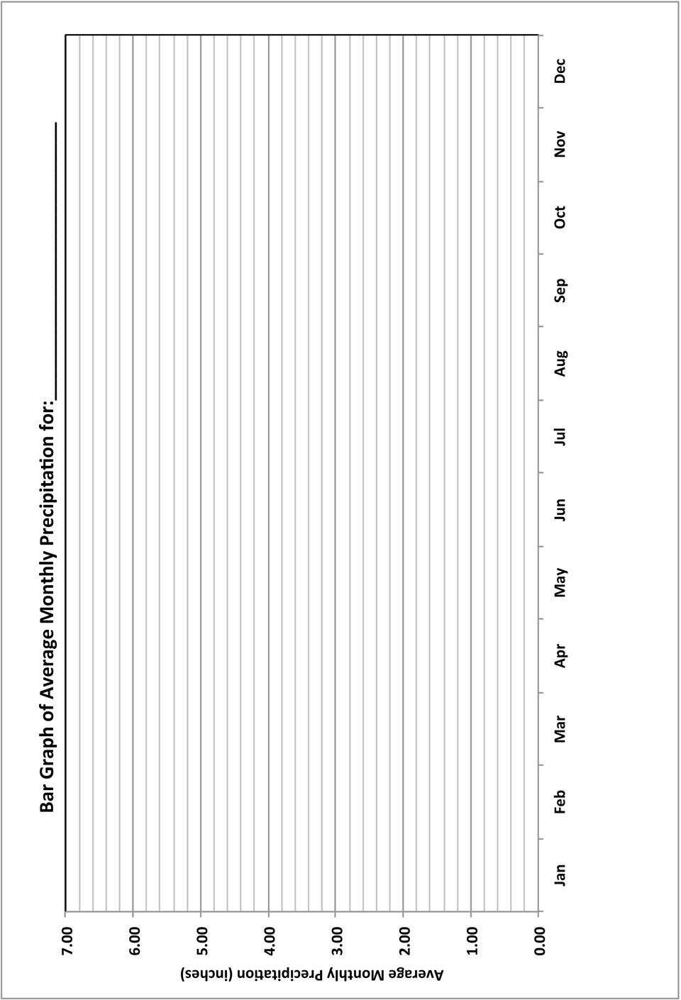**Attachment 5. Average Monthly Precipitation Graph**

*Note: Teachers may choose to have their students design their own plots rather than be given the plot below.*

**Attachment 6. Average Monthly Climate Data from www.weather.com.**

Seattle, Washington San Francisco, California

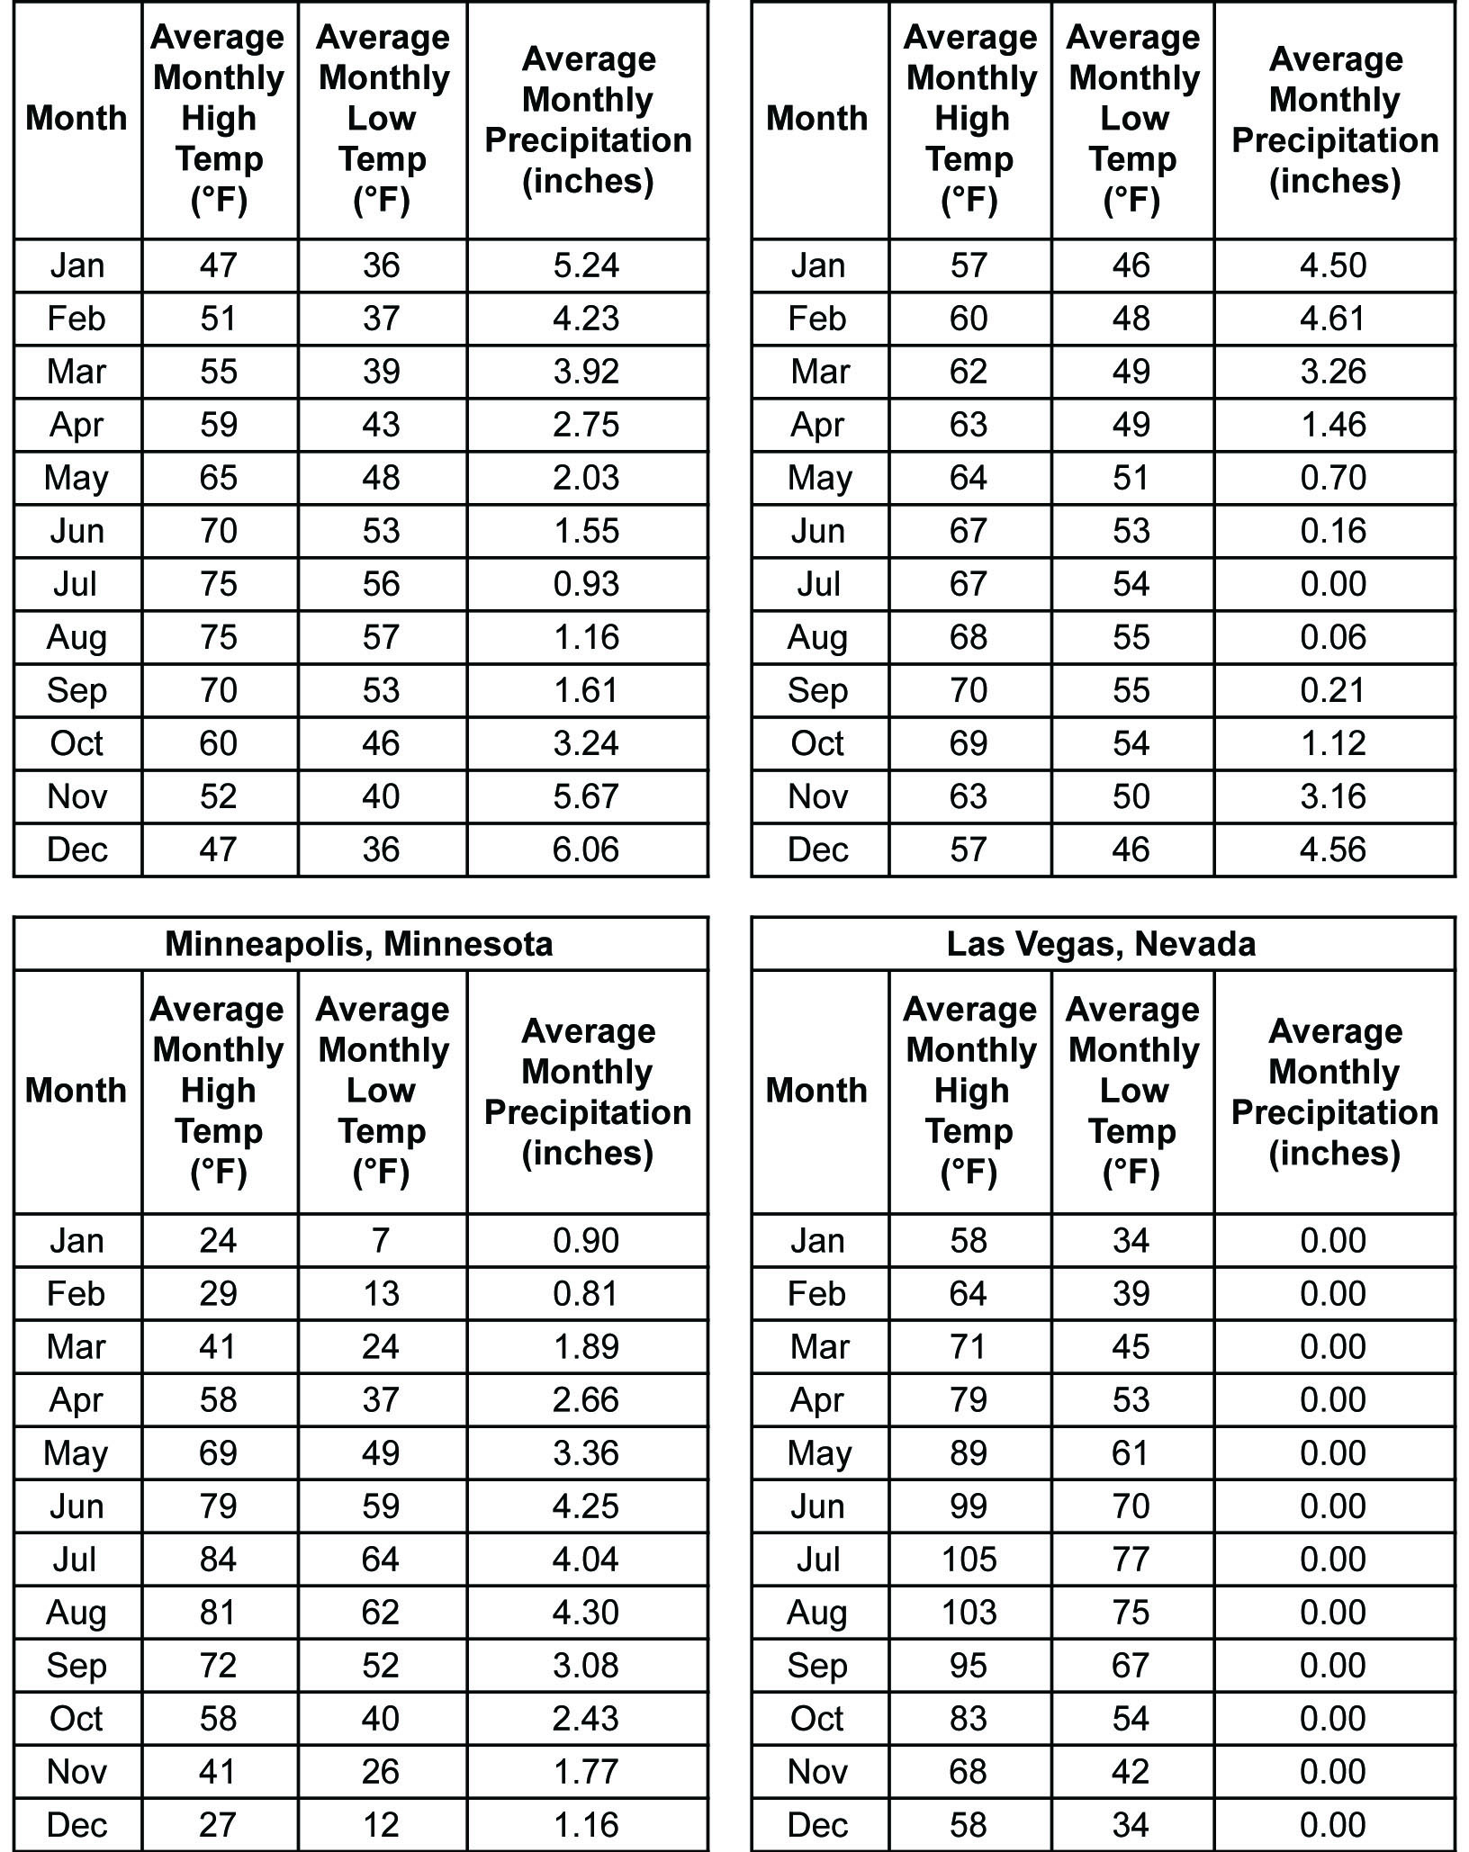

**Attachment 7. Map of the United States Showing the Location of the Four Cities**

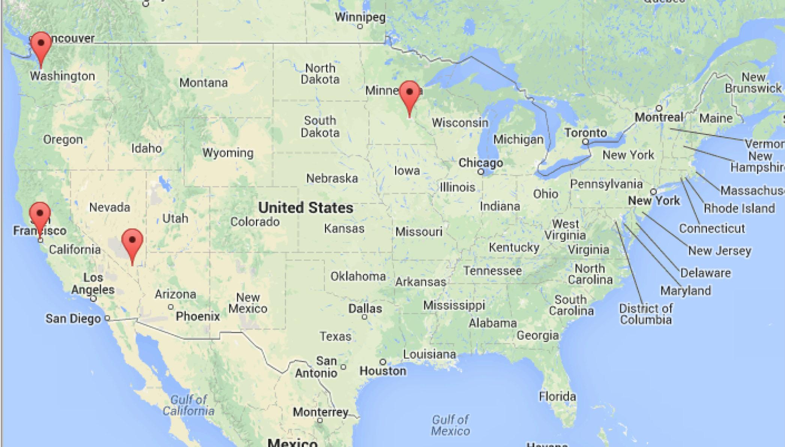*Source: GoogleMapsTM  
Last Accessed: February 5, 2014*

*© 2014 Google, INEGI*

**Attachment 8. Map of Ocean Currents**

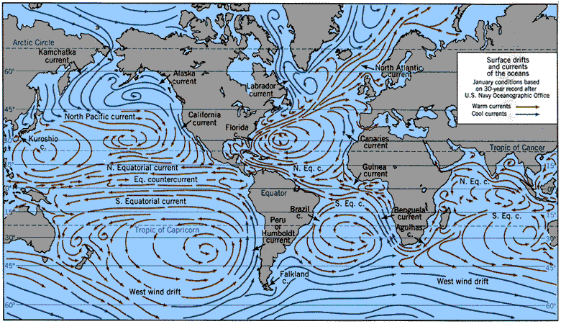

*Image Sources: NASA Goddard Institute for Space Sciences Institute on Climate and Planets, US Navy Oceanographic Office;* [*http://icp.giss.nasa.gov/research/ppa/1997/oceanchars/currents.html*](http://icp.giss.nasa.gov/research/ppa/1997/oceanchars/currents.html)*; Accessed Feb.2014*

*Other images can be found at:*

[*http://media.web.britannica.com/eb-media/62/112362-004-5788B8E2.gif*](http://media.web.britannica.com/eb-media/62/112362-004-5788B8E2.gif)

<http://upload.wikimedia.org/wikipedia/commons/0/06/Corrientes-oceanicas.gif>

C:\Users\abadrinarayan\AppData\Local\Microsoft\Windows\Temporary Internet Files\Content.Outlook\5CLLXMI5\Oceancirculation-altered (2).tif

*Image Source: Modified from Largier, J.L., B.S. Cheng, and K.D. Higgason, eds.*

*(2010). Climate Change Impacts: Gulf of the Farallones and Cordell Bank National Marine*

*Sanctuaries. Report of a Joint Working Group of the Gulf of the Farallones and Cordell Bank*

*National Marine Sanctuaries Advisory Councils, 121pp* [*http://farallones.noaa.gov/manage/climate/pdf/climate_report.pdf*](http://farallones.noaa.gov/manage/climate/pdf/climate_report.pdf) *- Accessed: February 5, 2014*

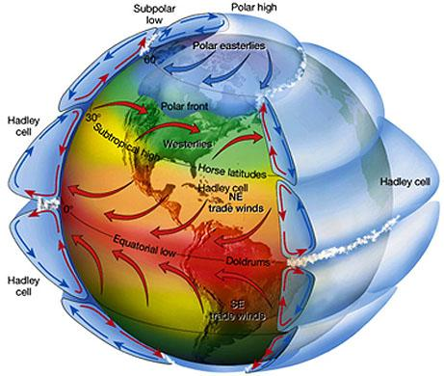

**Attachment 9. Map of the Prevailing Global Wind Directions**

*Source:* *NASA's Remote Sensing Tutorial: The Water Planet - Meteorological, Oceanographic and Hydrologic Applications of Remote Sensing, accessed at:* [*http://serc.carleton.edu/details/images/10044.html*](http://serc.carleton.edu/details/images/10044.html)

[*https://www.fas.org/irp/imint/docs/rst/Sect14/Sect14_1c.html*](https://www.fas.org/irp/imint/docs/rst/Sect14/Sect14_1c.html)

*Last Accessed: February 5, 2014*

Other resources on youtube:

The Coriolis Effect

<https://www.youtube.com/watch?v=i2mec3vgeaI>

<https://www.youtube.com/watch?v=dt_XJp77-mk>

**Attachment 10. Maps Showing the Topography around San Francisco, Las Vegas, and Seattle**

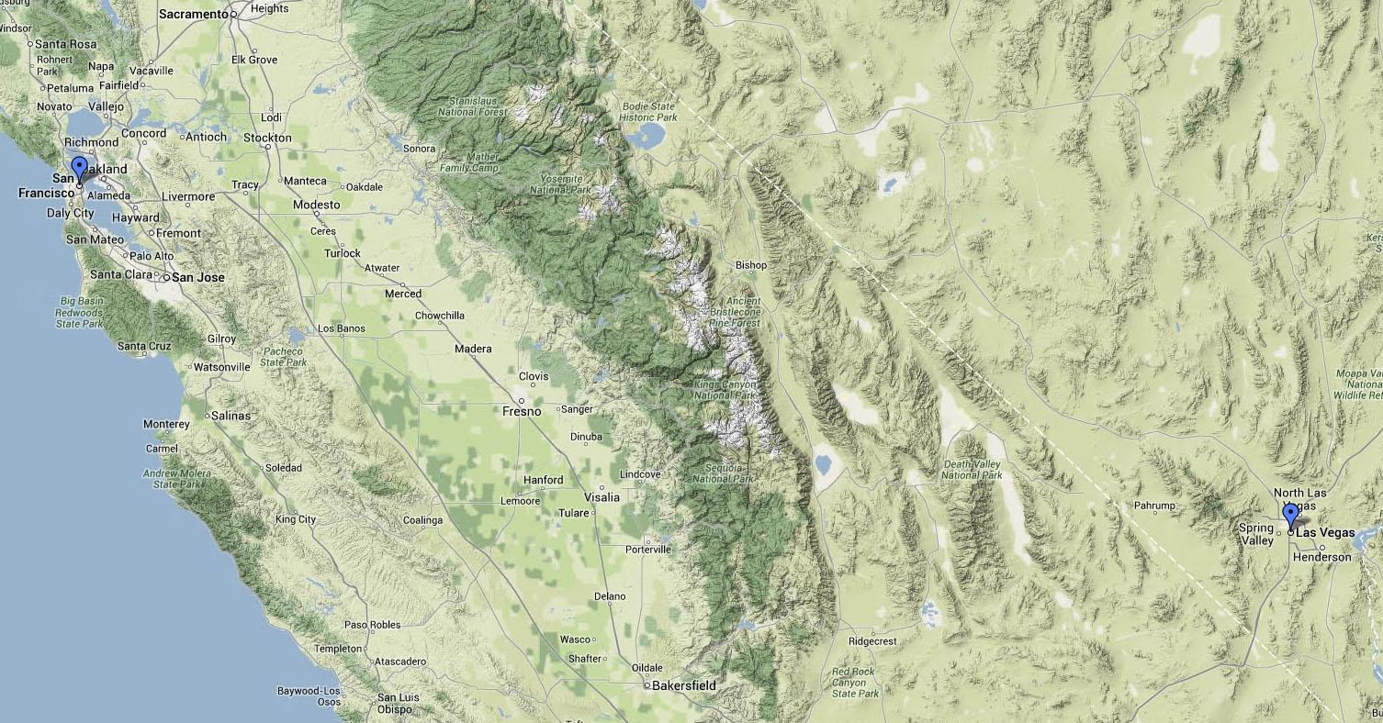

*© 2014 Google, Google Maps*

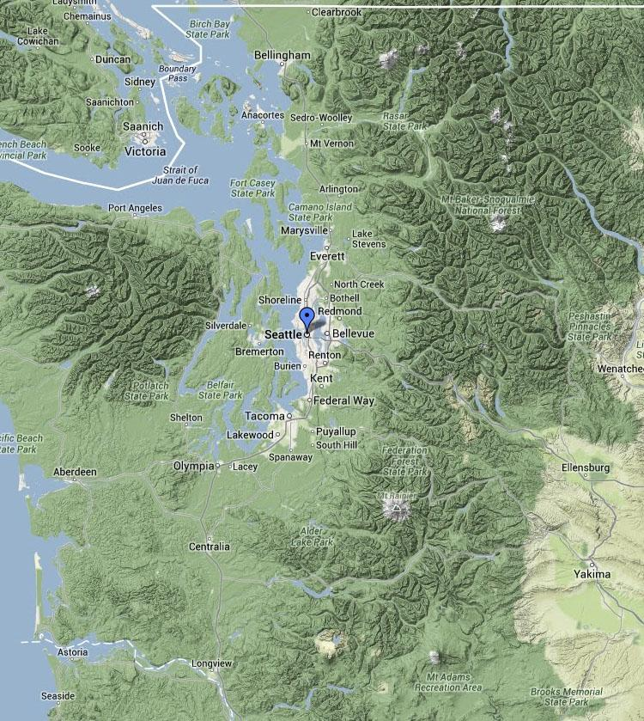

*© 2014 Google, Google Maps*

*Source (both): GoogleMapsTM  
 Last Accessed: February 6, 2014*

**Attachment 11. Map of the Western Continental United States**

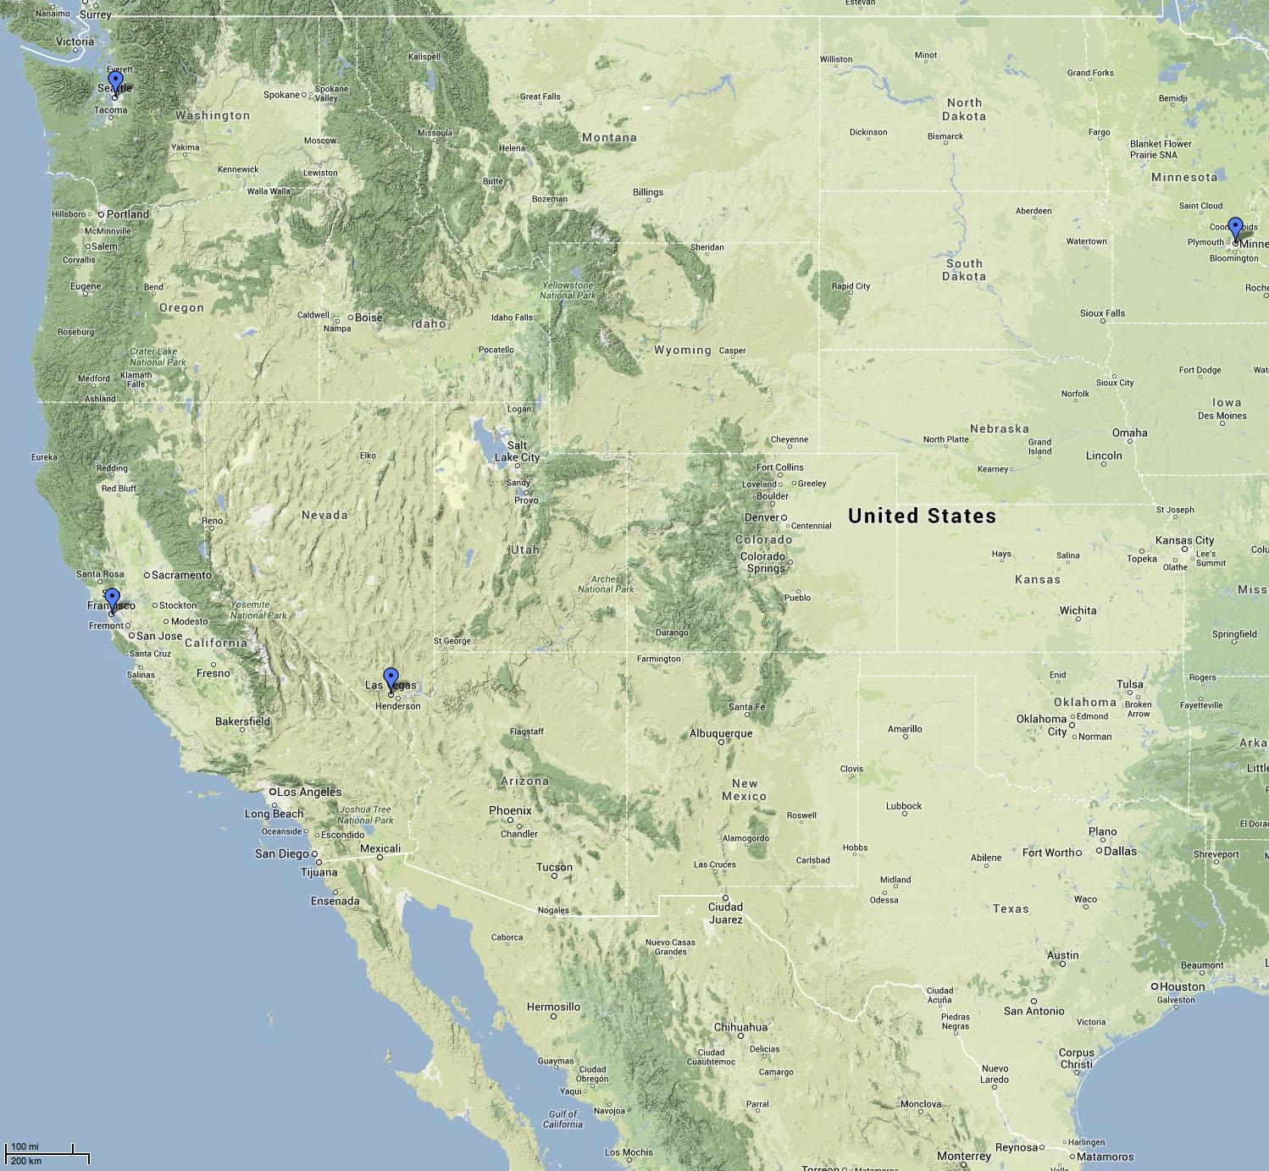

*© 2014 Google, INEGI*

*Source: GoogleMapsTM  
Last Accessed: February 6, 2014*

**Sample Answer Plots:**

