*Cyber-bullying Unit – Activating Background Knowledge*

Guide: cut quotes into strips, have groups of 4 choose one quote randomly from a can/hat/etc. Have students **discuss in** **collaborative** groups for about 5 minutes; then have them **write a reflection** to one quote in their writing journals. Students need to correctly cite the quote with author and quote marks within the written paragraph and answer the attached questions as they write a well-written paragraph.

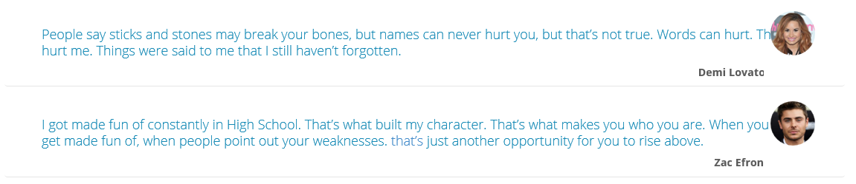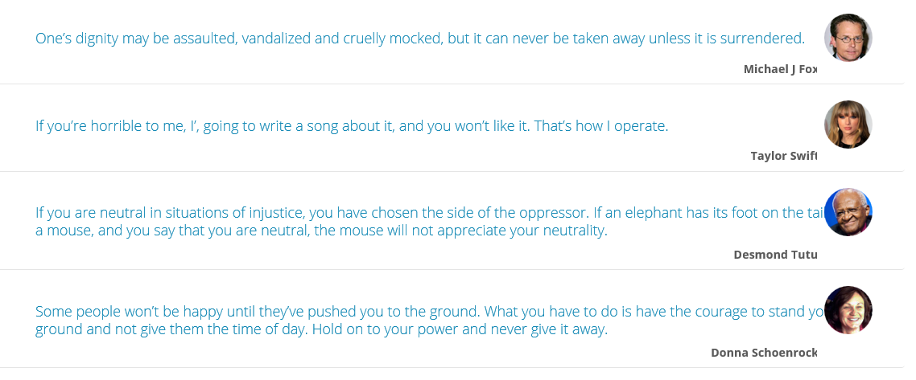

Guided Journal Entry

